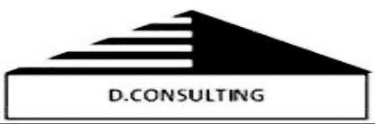


CONSULTANCY TO SUPPORT THE MINISTRY OF TRADE AND TOURISM OF DJIBOUTI TO RESOLVE NON-TARIFF BARRIERS ON THE ETHIOPIA - DJIBOUTI CORRIDOR
RFP No.: PO/20250678

ANNEX 1:

SOFTWARE REQUIREMENTS SPECIFICATION (SRS)
SYSTEM DESIGN SPECIFICATION (SDS)

National Platform for the Management of Non-Tariff Barriers on the Ethiopia–Djibouti Trade Corridor

Client: TradeMark Africa
Country: Djibouti
Project: Promoting regional economic integration in the Horn of Africa through the development of the Djibouti corridor
TABLE OF CONTENTS

List of Figures 9
List of Tables 11
Acronyms and Abbreviations 15
Glossary of Terms 16
1. INTRODUCTION 19
1.1 Purpose of the Document 19
1.2 Background and Rationale 19
1.3 Problem Statement 21
1.4 Project Objectives 24
1.5 System Scope 25
1.6 Business Drivers 26
1.7 Stakeholders 27
1.8 Target Audience 29
1.9 Assumptions and Dependencies 29
1.10 Applicable Standards and References 30
2. BUSINESS AND OPERATIONAL ANALYSIS 31
2.1 Current Situation (AS-IS) 31
2.2 Target Vision (TO-BE) 31
2.3 Institutional Framework 32
2.4 Identified Challenges and Constraints 33
2.5 Business Processes 34
2.6 Trade Corridors and Operational Context 35
2.6.1 Main Crossing Points 35
2.6.2 Trade Flows Concerned 35
2.7 NTB Classification Framework 36
2.7.1 Sanitary and Phytosanitary Measures (SPS) 36
2.7.2 Technical Barriers to Trade (TBT) 36
2.7.3 Customs and Administrative Procedures 36
2.7.4 Licences, Permits and Authorisations 36
2.7.5 Taxes, Fees and Administrative Charges 36
2.7.6 Transport and Logistics 36
2.8 Current Reporting and Resolution Mechanisms 37
2.9 Current Digital Ecosystem 37
2.10 Gap Analysis 38
3. SYSTEM OVERVIEW 40
3.1 General System Description 40
3.2 Functional Objectives of the System 40
3.3 Users and Actors 41
3.4 High-Level Functional Architecture 41
3.4.1. Barrier Reporting 41
3.4.2. Validation and Classification 42
3.4.3. Assignment and Processing 42
3.4.4. Escalation and Monitoring 42
3.4.5. Resolution and Closure 42
3.4.6. Analysis and Reporting 42
3.5 Alignment with the Workstreams 43
3.6 System Keys 43
3.7 High-Level Use Cases 44
4. Business Requirements 46
4.1 Business Requirements Catalogue 46
4.2 Business Functional Objectives 47
4.3 Institutional Governance Requirements 47
4.4 Reporting, Monitoring and Evaluation Requirements 48
4.4.1 Operational Reports 48
4.4.2 Strategic Reports 48
4.4.3 Analytical Reports 48
4.4.4 Gender and Inclusion Reports 48
4.4.5 Executive Dashboards 48
5. Functional Requirements 50
5.1 Methodology for Defining Functional Requirements 50
5.2 Global Catalogue of Functional Requirements 50
5.3 Complaint Management Module 51
5.3.1 Validation Rules 52
5.3.2 Complaint Rules 52
5.3.3 Associated Notification Rules 52
5.4 Workflow Management Module 53
5.5 SMS/USSD Module 53
5.6 Notification Management Module 53
5.7 Analytics and Reporting Module 53
5.8 Dashboard Module 54
5.8.1 Visualisation Requirements 55
5.9 Interoperability Module 55
5.9.1 Integration Requirement 55
5.10 User and Access Management Module 56
5.11 System Administration Module 56
5.12 Audit and Compliance Module 57
5.13 Escalation and SLA Management Module 57
5.14 Case Tracking Module 58
5.15 Accessibility and Mobility Module 58
6. DETAILED USE CASE SPECIFICATIONS 60
UC-01: Report a Non-Tariff Barrier (NTB) via SMS/USSD 60
UC-02: Report an NTB via the Web Portal 61
UC-03: Verify and Validate a Complaint 62
UC-04: Assign a Case to the Competent Institution 63
UC-05: Process a Complaint 64
UC-06: Escalate a Case 65
UC-07: Check the Status of a Case 65
UC-08: Generate Reports and Dashboards 66
UC-09: Administer the NTB Platform 67
7. WORKFLOW SPECIFICATIONS 68
7.1 Workflow Overview 68
7.2 Lifecycle States 68
7.3 Workflow Transitions 69
7.4 SLA Management 70
7.5 Escalation Rules 71
7.6 Multi-Institution Collaboration 71
7.7 Cross-Border Escalation 72
7.8 Workflow Matrix 73
8. NON-FUNCTIONAL REQUIREMENTS 75
8.1 Performance Requirements 76
8.2 Scalability Requirements 76
8.3 Availability Requirements 77
8.4 Reliability Requirements 77
8.5 Security Requirements 77
8.6 Accessibility Requirements 78
8.7 Usability Requirements 78
8.8 Localization and Multilingual Requirements 79
8.9 Backup and Recovery Requirements 79
8.10 Maintainability Requirements 79
8.11 Auditability Requirements 79
8.12 Compliance Requirements 80
8.13 Data Retention Requirements 80
8.14 Logging Requirements 81
8.15 Hosting Requirements 81
9. SYSTEM ARCHITECTURE 84
9.1 Architectural Principles 84
9.2 High-Level Architecture 84
9.3 Multi-Layer Architecture 85
9.4 Deployment Architecture 86
9.5 Infrastructure Architecture 86
9.6 Cloud / Data Center Architecture 87
9.7 Security Architecture 88
9.8 Network Architecture 89
9.9 API Architecture 89
9.10 Integration Architecture 90
9.11 Business Continuity Architecture 90
10. DATA ARCHITECTURE 92
10.1 Data Governance Principles 92
10.2 Logical Data Model 93
10.3 Physical Data Model 94
10.4 Entity Relationship Diagrams (ERD) 94
10.5 Data Dictionary 95
10.6 Master Data 97
10.7 Metadata Standards 97
10.8 Data Validation Rules 97
10.9 Data Retention Policies 98
10.10 Data Archiving 99
11. INTEROPERABILITY AND INTEGRATION 100
11.1 Integration Principles 100
11.2 External Systems 100
11.3 API Specifications 100
11.4 Authentication Standards 101
11.5 Data Exchange Formats 101
11.6 Synchronization Methods 101
11.7 Error Handling 101
11.8 Retry and Recovery Logic 101
12. SECURITY AND CYBERSECURITY 102
12.1 Security Principles 102
12.2 IAM (Identity and Access Management) 102
12.3 RBAC Model 102
12.4 MFA Requirements 102
12.5 Encryption Standards 102
12.6 Audit Logging 103
12.7 Vulnerability Management 103
12.8 Penetration Testing 103
12.9 SIEM and Monitoring 103
12.10 Incident Response 103
12.11 Security Compliance 103
13. REPORTING AND ANALYTICS 105
13.1 Dashboard Requirements 105
13.2 KPI Framework 105
13.3 Reporting Catalogue 105
13.4 Export Requirements 106
13.5 Geographic Analysis 106
14. TESTING AND QUALITY ASSURANCE 107
14.1 Testing Strategy 107
14.2 Unit Testing 107
14.3 Integration Testing 107
14.4 System Testing 107
14.5 Security Testing 107
14.6 UAT 108
14.7 Performance Testing 108
14.8 Test Environment 108
14.9 Defect Management 108
14.10 Acceptance Criteria 109
15. DEPLOYMENT AND DEVOPS 110
15.1 Deployment Strategy 110
15.2 Environment Strategy 110
15.3 CI/CD Pipeline 111
15.4 Version Control 111
15.5 Release Management 111
15.6 Rollback Procedures 112
15.7 Monitoring and Observability 112
16. CHANGE MANAGEMENT AND CAPACITY BUILDING 113
16.1. User Training 113
16.2 Monitoring and Performance Indicators 113
16.3. User Documentation 113
16.4. Communication and Adoption 114
17. OPERATIONS, SUPPORT, AND MAINTENANCE 115
17.1 Support Model 115
17.2 SLA Framework 115
17.3 Incident Management 115
17.4 Maintenance Procedures 115
17.5 Backup Procedures 115
17.6 DR Procedures 116
17.7 Sustainability Strategy 117
18. IMPLEMENTATION ROADMAP 118
18.1 Implementation Phasing 118
18.2 Pilot Deployment 118
18.3 Rollout Strategy 118
18.4 Milestones 118
18.5 Dependencies 119
18.6 Risks and Mitigation 119
19. CONCLUSION 120
APPENDICES 121
Appendix A – Detailed Data Dictionary 121
A.1 Table: Complaints (NTB Complaints) 121
A.2 Table: Case History (Case History) 123
A.3 Table: NTB_Categories (Barrier Categories) 124
A.4 Table: ESCALATIONS 124
A.5 Table: SLA Tracking 125
A.6 Table: USERS 125
A.7 Table : ROLES 126
A.8 Table: INSTITUTIONS 126
A.9 Table: CORRIDORS 127
A.10 Table: LOCATIONS 127
A.11 Table : WORKFLOW_HISTORY_COMPLAINT 127
A.12 Table : ATTACHMENTS 128
A.13 Table : NOTIFICATIONS 128
A.14 Table: AUDIT_LOGS 129
Appendix B – API Catalogue 129
B.1 Complaint Management API 130
B.2 Workflow and Escalation API 130
B.3 Analytics and Reporting API 131
B.4 User and Authentication API 132
B.5 Notifications and Regional Integration API 132
B.6 Standardised Error Codes 133
Appendix C – Workflow State Matrix 133
Appendix D – UML Diagrams 138
D.1.1 Main Use Case Diagram 138
D.1.2 Use Case Diagram – Report a Non-Tariff Barrier (NTB) via SMS/USSD 139
D.1.3 Use Case Diagram – Report an NTB via the Web Portal 140
D.1.4 Use Case Diagram – Report an NTB via the Web Portal 141
D.1.5 Use Case Diagram – Assign a Case to the Competent Institution 142
D.1.6 Use Case Diagram – Process a Complaint 143
D.1.7 Use Case Diagram – Escalate a Case 144
D.2 Sequence Diagram 145
D.3 Activity Diagram: Lifecycle of an NTB Case 150
D.4 Diagram of the main classes 152
Appendix E – Report Catalogue 154
Appendix F – Security Matrix 157
Appendix G – Requirements Traceability Matrix (RTM) 159
Appendix H – Test Cases 160
Appendix I – Infrastructure Sizing 163
I.1 Initial Load Assumptions 163
I.2 Server Sizing (Production Environment) 163
I.3 Storage Sizing 164
I.4 Network Bandwidth 165
Appendix J – Wireframes and Mockups 165
Appendix K – SLA Matrix 174
K.1 SLA by Processing Stage 174
K.2 SLA by NTB Category 175
K.3 Alert Thresholds and SLA Notification Mechanisms 176
Appendix L – Integration Mapping 177
L.2 Requirements Common to All Integrations 178
L.3 Version Management and Regional Compatibility 178

List of Figures
Figure 1: Manual Process 23
Figure 2: Lack of centralisation visibility 23
Figure 3: Absence of automation - Delayed resolution 24
Figure 4: Lack of coordination 24
Figure 5: Methodology for defining the functional requirements 51
Figure 6: Workflow - Normal and Standard Case 70
Figure 7: Workflow - Incomplete Case 70
Figure 8: Workflow - Rejection 71
Figure 9: Workflow - Hierarchical Escalation 71
Figure 10: Workflow - Case Reopening 71
Figure 11: Regional escalation flow 74
Figure 12: System architecture 85
Figure 13: Multi-layer architecture 86
Figure 14: Deployment architecture 87
Figure 15: Security architecture of the system 90
Figure 16: Integration architecture 91
Figure 17: Simplified lifecycle workflow 137
Figure 18: Use case diagram of the NTB platform 139
Figure 19: Report a Non-Tariff Barrier (NTB) by SMS/USSD 140
Figure 20: Report an NTB via the Web portal 141
Figure 21: Verify and validate a complaint 142
Figure 22: Assign a case to the competent institution 142
Figure 23: Process a complaint 144
Figure 24: Escalate a case 145
Figure 25: Sequence diagram: submission and validation of a Web complaint 146
Figure 26: Report an NTB by SMS/USSD 148
Figure 27: Report an NTB via Web portal 148
Figure 28: Verify and validate a complaint 149
Figure 29: Automatic assignment of a case 149
Figure 30: Processing of a complaint 150
Figure 31: Activity diagram: lifecycle of an NTB case 151
Figure 32: Main class diagram of the NTB platform 153

List of Tables
Table 1: Summary of the main findings from the survey on non-tariff barriers (NTBs) and the effectiveness of processing mechanisms in Djibouti. 22
Table 2: Mapping of the main stakeholders of the NTB management mechanism 29
Table 3: Comparison between the current state (AS-IS) and the target state (TO-BE) of the national NTB management mechanism 33
Table 4: Distribution of the roles and responsibilities of the stakeholders involved in the national NTB management mechanism 34
Table 5: Limitations of the main existing systems in managing non-tariff barriers (NTBs) at regional and continental level 38
Table 6: Comparative analysis of the current situation (AS-IS) and the target situation (TO-BE) of the non-tariff barrier (NTB) management mechanism, highlighting the main functional and organisational gaps 40
Table 7: Mapping of the external, institutional and technical actors involved in the non-tariff barrier (NTB) management mechanism 40
Table 8: Catalogue of use cases of the non-tariff barrier (NTB) management system 46
Table 9: List of the business requirements of the non-tariff barrier (NTB) management system 48
Table 10: Functional architecture of the non-tariff barrier (NTB) management system, presenting the main application modules and their key functions in the processing, monitoring, coordination and oversight of cases 52
Table 11: List of the detailed functional requirements of the NTB management system 52
Table 12: Data validation rules of the NTB management system 53
Table 13: Business rules of the NTB management system 53
Table 14: Matrix of events and notifications of the NTB management system 53
Table 15: Description of the dashboards of the NTB management system 55
Table 16: Interoperability matrix of the NTB management system 56
Table 17: Technical interoperability requirements of the NTB management system 56
Table 18: User management module of the NTB management system 57
Table 19: Content of the audit log of the NTB management system 58
Table 20: Compliance and audit requirements of the NTB management system 58
Table 21: Requirements relating to the SLAs (Service Level Agreements) of the NTB management system 58
Table 22: Life cycle of NTB cases in the non-tariff barrier management system 70
Table 23: Target processing times for NTB cases 72
Table 24: Matrix of the escalation levels of the NTB management system 72
Table 25: Hierarchy of the escalation levels of the NTB management system 72
Table 26: State transition matrix of the NTB case life cycle 76
Table 27: Status definition table of the NTB case life cycle 76
Table 28: Performance requirements of the NTB management system 77
Table 29: Capacity and load indicators of the NTB management system 78
Table 30: Availability requirements (SLA) of the NTB management system 78
Table 31: Security measures of the NTB management system 79
Table 32: Performance and usability indicators of the NTB management system 80
Table 33: Data retention policy of the NTB management system 82
Table 34: Business continuity objectives of the NTB management system 92
Table 35: Conceptual data model of the NTB management system 94
Table 36: Logical architecture of the database schemas of the NTB management system 95
Table 37: Description of the relationships between the main tables of the NTB management system 96
Table 38: Data dictionary of the NTB management system 97
Table 39: Data repository of the NTB management system 98
Table 40: Governance and traceability metadata of the NTB management system data 98
Table 41: Data validation rules of the complaint management system 98
Table 42: User data and authentication validation rules of the NTB management system 99
Table 43: Attachment validation rules of the NTB management system 99
Table 44: Integration validation rules of the NTB management system 99
Table 45: Data retention policy of the NTB management system 100
Table 46: Purge and archiving rules of the NTB management system 100
Table 47: UAT user acceptance test matrix 109
Table 48: Scope of components covered by the backup strategy of the NTB management system 117
Table 49: Service continuity level of the NTB management system 117
Table 50: Risk matrix of the NTB management system project 120
Table 51: Detailed specification of the data model of the “Complaints” table 122
Table 52: Specification of the data model of the “Case_History” table 124
Table 53: Specification of the data model of the “NTB_Category” table 125
Table 54: Structure of the escalations table of the NTB management system 125
Table 55: Specification of the SLA tracking data model 126
Table 56: Specification of the data model of the “Users” table 127
Table 57: Specification of the data model of the “Roles” table 127
Table 58: Specification of the data model of the “Institutions” table 127
Table 59: Specification of the data model of the “Corridors” table 128
Table 60: Specification of the data model of the “Locations” table 128
Table 61: Specification of the data model of the “Workflow_history_complaint” table 128
Table 62: Specification of the data model of the “Attachments” table 129
Table 63: Specification of the data model of the “Notifications” table 129
Table 64: Specification of the data model of the “Audit_logs” table 130
Table 65: Technical interoperability and architecture standards of the NTB management system 130
Table 66: Specification of the API endpoints of the NTB management system 131
Table 67: Specification of the NTB management system API endpoints dedicated to case assignment 132
Table 68: Specification of the analytics and reporting API endpoints of the NTB management system 132
Table 69: Specification of the security and user management API endpoints of the NTB management system 133
Table 70: Specification of the communication and integration API endpoints of the NTB management system 134
Table 71: API response codes of the NTB management system 134
Table 72: State transition of the NTB management system 135
Table 73: Events and automations of the NTB management system 138
Table 74: Management rules of the workflow engine of the NTB management system 138
Table 75: Functional sequence identification of the NTB management system 138
Table 76: Flow identification of the NTB management process 152
Table 77: UML class identification of the NTB management system 154
Table 78: Report catalogue of the NTB management system 155
Table 79: Access control (RBAC) of the NTB management system 159
Table 80: Requirements traceability of the NTB management system 160
Table 81: Test case catalogue of the NTB management system 163
Table 82: Sizing and load indicators of the NTB management system 164
Table 83: Technical infrastructure sizing of the NTB management system 164
Table 84: Estimated Storage Requirements and Growth Projections 165
Table 85: Bandwidth requirements specification of the NTB management system 166
Table 86: Public home page of the NTB portal - Description 167
Table 87: NTB submission form (step 2/4) - Description 167
Table 88: Figure J.3 — National Focal Point dashboard (Kanban view) - Description 168
Table 89: Figure J.4 — Institutional dashboard — Agent (sortable SLA list) - Description 169
Table 90: Figure J.5 — NMC dashboard (real-time indicators) - Description 170
Table 91: Figure J.6 — MTT executive dashboard - Description 171
Table 92: SMS / USSD interface — menu tree *555# - Description 172
Table 93: Analytical module and exports - Description 173
Table 94: System administration panel – Description 174
Table 95: SLA timeframes of the NTB management system 175
Table 96: NTB category configuration of the NTB management system 176
Table 97: SLA alerts of the NTB management system 177
Table 98: Integration interfaces of the NTB management system 178

Acronyms and Abbreviations

Acronym | Meaning | Description
API | Application Programming Interface | Interface enabling communication between different systems and applications
ASYCUDA | Automated System for Customs Data | Computerised system used for managing customs operations
NTB | Non-Tariff Barriers | Regulatory or administrative barriers affecting trade beyond customs duties
CI/CD | Continuous Integration / Continuous Deployment | Automated process for integrating, testing and deploying applications
COMESA | Common Market for Eastern and Southern Africa | Regional organisation facilitating trade between member countries
DPCS | Djibouti Port Community System | Digital platform integrating port and logistics stakeholders
JSON | JavaScript Object Notation | Standard format for exchanging data between systems
JWT | JSON Web Token | Secure token-based authentication mechanism
KPI | Key Performance Indicator | Performance indicator used to measure the effectiveness of the system
M&E | Monitoring and Evaluation | Monitoring and evaluation of the system's performance and impacts
MTT | Ministry of Trade and Tourism | Ministry of Trade and Tourism of Djibouti
NMC | National Monitoring Committee | Body responsible for overseeing the NTB management mechanism
NTFC | National Trade Facilitation Committee | National body coordinating trade facilitation policies
OAuth2 | Open Authorization 2.0 | Standard secure authorisation protocol for applications
RBAC | Role-Based Access Control | Access management model based on user roles
REST | Representational State Transfer | Standard architecture for web services and APIs
SDS | System Design Specification | Document describing the technical and functional design of the system
SLA | Service Level Agreement | Commitment defining the maximum processing, response and resolution times applicable to the various case categories.
SMS | Short Message Service | Mobile messaging service allowing the submission or consultation of cases without an Internet connection.
SPS | Sanitary and Phytosanitary Measures | Sanitary and phytosanitary measures related to product safety
TBT | Technical Barriers to Trade | Technical standards and requirements that may affect trade
TLS | Transport Layer Security | Protocol for securing communications over the Internet
ETL | Extract, Transform, Load | Process for extracting, transforming and loading data into analytical environments.
MFA | Multi-Factor Authentication | Authentication method based on several verification factors.
UAT | User Acceptance Testing | Tests carried out by users to validate the system
USSD | Unstructured Supplementary Service Data | Mobile communication technology enabling access to interactive menus without an Internet connection.
AfCFTA | African Continental Free Trade Area | Agreement aiming to create a common market in Africa

Glossary of Terms
Term | Definition
Non-Tariff Barrier (NTB) | Any measure, procedure, requirement or practice other than a customs duty that may restrict, delay or complicate cross-border trade.
NTB Complaint | Formal report made by an economic operator concerning a barrier encountered during a commercial or logistical operation.
Trade Corridor | Logistics axis linking production, transit and consumption areas across several countries. Within the framework of the project, this primarily refers to the Djibouti–Ethiopia corridor.
Economic Operator | Any natural or legal person involved in international trade, in particular importers, exporters, carriers, freight forwarders and cross-border traders.
Complainant | User who submits a complaint relating to a non-tariff barrier.
National Focal Point (NFP) | Officer or unit designated to ensure the reception, validation, monitoring and coordination of NTB cases at the national level.
National Monitoring Committee (NMC) | Body responsible for overseeing the operation of the national NTB management mechanism, ensuring case monitoring and compliance with procedures.
Steering Committee | Strategic body providing direction, governance and overall monitoring of the project and the NTB mechanism.
Responsible Institution | Public administration or body competent to process and resolve a given NTB complaint.
Workflow | Structured set of steps, rules and transitions enabling the processing of a complaint from its submission to its closure.
Workflow Engine | Software component responsible for automating the assignment, monitoring, validations, escalations and status changes of cases.
Case Lifecycle | Set of successive states of a complaint: Draft, Submitted, Under Validation, Validated, Assigned, In Processing, Resolved, Closed, etc.
Escalation | Automatic or manual mechanism for transferring a case to a higher level when an SLA deadline is exceeded or additional intervention is required.
Reassignment | Transfer of a case to another institution or another officer when necessary.
Notification | Automatic message sent to users or institutions by email, SMS or portal when a workflow event occurs.
Dashboard | Graphical interface for visualising performance indicators, statistics and the status of cases in real time.
Reporting | Production of operational, analytical and strategic reports from the system's data.
Interoperability | Ability of the system to exchange data with other national or regional platforms in a secure and standardised manner.
OpenAPI | Documentation standard for describing APIs in a structured and interoperable way.
Authentication | Process for verifying the identity of a user before access to the system.
Authorisation | Mechanism determining the actions a user is permitted to perform according to their role.
Audit Log | Traceability log recording all actions performed in the system.
Traceability | Ability to reconstruct the complete history of operations performed on a case or a data item.
Logging | Systematic recording of the technical and functional events of the system.
Metadata | Descriptive information associated with a data item to facilitate its identification, management and use.
Master Data (Reference Data) | Set of structuring and shared data used throughout the system (NTB categories, institutions, statuses, corridors, etc.).
Data Warehouse | Specialised database intended for analysis, reporting and the production of decision-making indicators.
Web Portal | Browser-accessible interface for declaring, monitoring and managing NTB cases.
Short Code | Simplified number used to access the platform's SMS or USSD services.
AfCFTA NTB Mechanism | Continental platform for reporting and handling Non-Tariff Barriers within the framework of the African Continental Free Trade Area.
AfCFTA | African Continental Free Trade Area aimed at facilitating intra-African trade.
COMESA | Common Market for Eastern and Southern Africa.
IGAD | Intergovernmental Authority on Development.
TradeMark Africa (TMA) | Regional organisation supporting trade facilitation and the development of trade corridors in Africa.
WCAG 2.1 | International standard defining the accessibility requirements for web content.
TLS 1.3 | Encryption protocol protecting data exchanged over networks.
AES-256 | Encryption algorithm used to secure stored data.
ISO/IEC 27001 | International standard relating to information security management.
Tier III Data Centre | Hosting infrastructure offering high availability through redundancy of critical equipment.
Cloud Computing | Model for delivering computing resources on demand via the Internet.
Disaster Recovery (DR) | Set of mechanisms enabling the resumption of activities after a major incident.
Business Continuity | Ability of the system to maintain its services despite failures, incidents or disasters.
High Availability | Ability of the system to remain operational with minimal service interruption.
CI/CD (Continuous Integration / Continuous Deployment) | Methodology automating the integration, testing and deployment of applications.
DevOps | Approach combining software development and IT operations to accelerate production releases and improve service quality.

INTRODUCTION

The purpose of this document is to define, in a clear, structured and comprehensive manner, the functional, technical and operational requirements of Djibouti's national platform for the management of Non-Tariff Barriers (NTBs). It constitutes the common reference framework for all stakeholders involved in the design, development, deployment, validation, operation and continuous improvement of the system.

This document also specifies the solution's scope of intervention, the expected architectural principles, the interoperability requirements, as well as the security, performance, traceability and governance constraints. It aims to ensure a shared understanding of the business needs, institutional objectives and expected outcomes, while serving as a working basis for the technical design and operational implementation.

Purpose of the Document

- Purpose of the SRS/SDS
The purpose of this SRS/SDS is to transform the business and institutional needs described in the Inception report into precise, testable requirements that can be used by the implementation team. It constitutes the contractual and technical reference basis for ensuring that the solution meets the project's objectives.

- Intended Use
The document is intended to be used as a support for technical framing, design, functional validation, development, acceptance testing and compliance monitoring. It should also serve as a reference for evaluating the contractor's deliverables and for validation by the supervisory authorities.

- Scope of Application

The scope of application covers the collection, management, monitoring, escalation, analysis and reporting of NTBs, as well as integration with relevant institutional and regional systems. The system must also support multichannel interactions, in particular via Web, SMS and USSD, in order to ensure broad accessibility for both formal and informal economic operators.

Background and Rationale

The project context is that of a commercial environment in which non-tariff barriers persist, affecting the smooth flow of trade between Djibouti–Ethiopia and logistics competitiveness. Despite the existence of systems such as ASYCUDA and DPCS, Djibouti does not yet have a centralised and structured digital mechanism for managing NTBs.

- Trade Corridor Context
The Djibouti–Ethiopia corridor is one of the most strategic trade routes in the Horn of Africa and represents Ethiopia's main maritime gateway to international markets. Approximately 95% of Ethiopia's foreign trade passes through Djibouti's port infrastructure, making this corridor an essential lever for economic growth, regional integration and the security of both countries' supply chains.

The corridor relies on a multimodal network made up of several strategic infrastructures linking the Djiboutian ports to the main Ethiopian economic centres. Trade is carried out in particular via the road corridors passing through the Galafi, Dewele and Balho border posts, as well as via the electrified Djibouti–Addis Ababa railway.

- Non-Tariff Barriers Environment in Djibouti
Despite the significant investments made in port, logistics and digital infrastructure, economic operators continue to face various non-tariff barriers (NTBs) affecting the smooth flow of trade along the national and cross-border corridors.

The NTB environment in Djibouti is marked by administrative, procedural, regulatory and inter-institutional coordination constraints.

These barriers require a better-structured national reporting and processing mechanism.

- Existing Institutional Environment
The institutional framework for NTB management in Djibouti relies on several public and private actors involved in trade facilitation, trade regulation and the management of logistics corridors.

The Ministry of Trade and Tourism is the national authority responsible for coordinating trade facilitation and regional integration policies. It is called upon to act as the national focal point for the NTB management mechanism, ensuring inter-institutional coordination, case monitoring and communication with regional NTB processing mechanisms.
The competent sectoral administrations, in particular the customs, port, sanitary, phytosanitary, technical and regulatory authorities, are involved in the operational processing of complaints falling within their respective areas.

The private sector is the main user of the mechanism. It includes importers, exporters, cross-border traders, freight forwarders, carriers, logistics operators, consular chambers and professional associations that are directly affected by NTBs and participate in reporting the barriers encountered.
Technical and financial partners, in particular TMA, provide strategic and technical support aimed at strengthening institutional capacities, improving trade facilitation and supporting regional integration.

- Existing Systems (ASYCUDA, DPCS)

The ASYCUDA system (Automated System for Customs Data, or SYDONIA in French) is the platform for managing customs procedures. It enables the electronic management of declarations, the processing of customs formalities, the control of goods and the production of statistics relating to import and export operations.
The DPCS (Djibouti Port Community System) is a single-window-type digital platform intended for Djibouti's port and logistics ecosystem. Its role is to integrate, coordinate and simplify all import, export and transit procedures via ports, airports, railways and logistics corridors, by facilitating data exchange and interoperability between the various public and private trade and transport actors.

Problem Statement

As indicated in the diagnostic report on NTBs, the current management of NTBs in Djibouti suffers from a lack of unification, visibility, awareness, training, institutional coordination and automation. Despite the existence of regional NTB notification platforms (COMESA/Tripartite and AfCFTA), these systems remain largely unknown.

This low uptake of regional tools directly contributes to the persistence of a situation in which economic operators face a multiplicity of administrative, regulatory and operational barriers that generate significant delays, additional costs and a loss of competitiveness. In the absence of effective and coordinated use of reporting mechanisms, NTB management procedures remain fragmented and inefficient, which prevents rapid, transparent and coordinated handling of claims.

KEY FINDINGS
Lack of awareness of official mechanisms | 71% are unaware or do not know
Dissatisfaction with the resolution of NTBs | 79% dissatisfied
Average time | 2 to 3 months
Lack of information and complex procedures | 70% cited as major obstacles
Predominance of the manual channel | Strong dependence on paper-based exchanges
Frequent NTBs | Sanitary and phytosanitary measures (SPS), complex customs procedures and licence or special-authorisation requirements.
Table 1: Summary of the main findings from the survey on non-tariff barriers (NTBs) and the effectiveness of processing mechanisms in Djibouti.
- Current Institutional Gaps

The current institutional framework for NTB management presents several structural weaknesses that limit its effectiveness and its ability to meet the needs of economic operators. The field surveys conducted in May 2026 showed that there is:
- Low visibility of existing mechanisms.
- Lack of communication and coordination
- Responsibilities not clearly defined
- Overlapping responsibilities
- Regional mechanisms (COMESA/Tripartite, AfCFTA) little used at the national level.

- Manual processes
Furthermore, a significant proportion of the processes related to NTB management still relies on manual exchanges, paper documents, informal communications and non-standardised administrative procedures. Information often circulates between several institutions without a unified digital mechanism to ensure its traceability and real-time sharing.
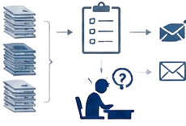
Figure 1: Manual Process
This reliance on manual procedures generates
- High risks of data-entry errors,
- Duplication of information,
- Loss of documents and longer processing times.
- Unreliable data on the nature and frequency of barriers.

- Lack of visibility
The various stakeholders currently have no centralised platform providing a consolidated view of all NTB cases being processed.







Information on the progress of complaints, the actions taken, the responsible institutions, processing times and the results obtained is often scattered across several entities and information systems.
Figure 2: Lack of centralisation visibility

This lack of visibility results in:
- A lack of transparency in the NTB processing and resolution process, limiting stakeholders' visibility into case progress, the actions taken and institutional responsibilities;
- A limited capacity to oversee and steer the mechanism, owing to the absence of a consolidated view for monitoring performance, processing times and the responsibilities of the institutions concerned;
- Decision-making insufficiently grounded in reliable, consolidated data, reducing the authorities' ability to identify the structural causes of NTBs and to prioritise reforms;
- A constraint on the ability of institutional officials to act, due to the lack of consolidated information accessible in a timely manner;
- Difficulty in regularly producing reliable indicators needed to identify recurring barriers, assess their economic impact, measure the effectiveness of interventions and guide trade facilitation policies;
- An inability to automatically generate periodic reports and monitoring dashboards, particularly on resolution times, the institutions involved, the types of NTB reported and the trends observed.

Delayed resolution
The absence of automated mechanisms for case management, deadline tracking, notifications and escalation contributes to longer NTB resolution times. Complaints may remain unprocessed for long periods owing to the lack of standardised procedures, clearly assigned responsibilities or systematic follow-up mechanisms.



Figure 3: Absence of automation - Delayed resolution
Complaint received
Pending / No follow-up
Prolonged delays

This situation increases:
- Uncertainty for economic operators,
- Logistics and administrative costs,

The delays caused by non-tariff barriers have a direct impact:
- On the competitiveness of the Djibouti–Ethiopia corridor
- On storage costs,
- On waiting times at borders

- Fragmented coordination
NTB management involves the participation of multiple public and private actors, including customs administrations, port authorities, control bodies, sectoral ministries, carriers, freight forwarders and organisations representing the private sector. However, exchanges between these actors often remain siloed.




Figure 4: Lack of coordination

The lack of structured data sharing and the weak synchronisation of operational processes limit the effectiveness of the actions taken to resolve the identified barriers. This fragmentation has a direct impact on:
- The ability of institutions to implement a coordinated approach to NTB management
- The ability to ensure consistent case processing at national and regional level.
In view of these constraints, the establishment of a national digital NTB management platform appears to be a strategic necessity. Such a solution will make it possible to centralise the reporting of barriers, automate processing workflows, improve inter-institutional coordination, strengthen transparency and produce reliable data for performance monitoring and public policy development.

Project Objectives

1.4.1 General Objective
In accordance with the guidelines set out in the Inception report, the project aims to:
- Develop and deploy a scalable, intuitive and standards-compliant digital NTB platform (Web + SMS).
- Establish digital sovereignty by strengthening and taking ownership of national ICT capacities.
- Foster interoperability with COMESA, AfCFTA, ASYCUDA and port community systems.
- Promote inclusive access for marginalised and rural traders and women through a multilingual, mobile-oriented design.

1.4.2 Specific Objectives
- Develop an online reporting mechanism allowing users to submit their complaints via a web interface.
- Provide a unique short code for use across the various mobile networks available in Djibouti for the SMS/online reporting mechanism.
- Develop an online NTB reporting module that is easy to use and adaptable to all screen sizes.
- Set up a web interface that will centralise all complaints and make it easy to respond to/act on reported non-conformities.
- Provide analysis of reported NTBs using modern analytics tools.
- Design interactive dashboards allowing the national focal point to view reported NTBs and communicate directly with the complainant.
- Ensure automatic follow-up of issues and prompt the parties concerned to act.
- Provide for a ticket management process or mechanism defining how NTB issues are to be handled.
- SMS responses and interactions must be carried out via the dashboard.
- Complaints received must be reviewed by the designated national focal point(s), who verify their authenticity and convert them into a case.
- Set up a notification mechanism by email, SMS or push notification.
- Add a search function to facilitate the tracking of complaints filed by traders, etc.
- Add a gender-tracking component to enable analysis of reported NTBs by gender.
- Enhance the system's analytical capabilities by drawing on parameters such as institutions, frequently reported non-tariff barriers (NTBs) and other parameters deemed relevant. This will enable the National Monitoring Committee (NMC) and its members to analyse and publish reliable, real-time information on the status of NTBs in order to support policy decisions and reports intended for the regional NTB forum.
- Provide alternative user interfaces that can be used by visually impaired people.
- Ensure full traceability of cases from submission through to closure.
- Automate the classification, assignment, tracking and escalation of complaints.
- Improve coordination between the Ministry of Trade, the competent institutions and the NMC.
- Implement integration with other bodies as defined in the requirements documents – via application programming interfaces (APIs) and enterprise service buses (ESBs).

System Scope

The Djibouti corridor system comprises a network of road and rail routes together with the associated border posts linking Djibouti to Ethiopia, the country's main trading partner, and to Somalia (Somaliland region). This corridor constitutes a strategic axis for regional trade and international exchanges transiting through Djibouti's port infrastructure.
In this context, the present project aims to establish a national digital NTB management platform intended to support the identification, reporting, processing, monitoring and resolution of barriers affecting trade flows along national and cross-border corridors.
The system scope is defined in order to specify the functionalities covered by the solution as well as the areas excluded from the present phase of the project.

1.5.1 In Scope

The platform must cover, in particular, the following elements:
- NTB complaint management
- Type of NTB concerned:
- Complex customs procedures and delays
- Technical standards / certification
- Licences, quotas or special authorisations
- Non-transparent fees and charges
- Absence/non-compliance with official procedures
- Corruption / illegitimate demands
- SPS measures (sanitary / phytosanitary)

- Workflow and case processing
- Monitoring and reporting
- Geographic coverage
- Djibouti–Ethiopia road corridor via Galafi;
- Djibouti–Ethiopia road corridor via Dewele;
- Djibouti–Ethiopia road corridor via Balho;
- Users concerned
- Ministry of Trade and Tourism;
- National Monitoring Committee (NMC);
- Competent sectoral administrations;
- Customs and port authorities;
- Freight forwarders and customs brokers;
- Carriers and logistics operators;
- Importers and exporters;
- Formal and informal cross-border traders;
- System technical administrators.

1.5.2 Out of Scope
The following elements are not covered by the present phase of the project:
- Operational management of customs procedures
- Port and logistics management
- Specialised regulatory control
- Sanitary, phytosanitary or veterinary inspections;
- Conformity certification;
- Issuance of regulatory authorisations;
- Specialised technical controls.
The platform will only track complaints related to these procedures, without replacing the business systems of the competent authorities.
- Financial management
- General institutional document management

Business Drivers
The project's business drivers translate the strategic priorities of the Republic of Djibouti in terms of trade facilitation, digital transformation, regional integration and public administration modernisation. They guide the design and implementation of the platform in order to generate measurable gains in operational efficiency, institutional transparency and commercial competitiveness.

- Trade facilitation
Reduce the administrative, procedural and regulatory barriers affecting trade along the Djibouti–Ethiopia corridor and the other national corridors. The platform must help accelerate complaint processing, improve the fluidity of cross-border operations, lower transaction costs and strengthen the competitiveness of economic operators.

- Transparency and traceability
Guarantee full visibility into the life cycle of NTB cases through real-time tracking, action history logging, automated notification mechanisms and dashboards accessible to authorised stakeholders. This transparency aims to strengthen economic operators' confidence in NTB resolution mechanisms.

- Regional integration
Ensure the alignment of the national mechanism with regional and continental NTB management frameworks, notably those of COMESA and the African Continental Free Trade Area (AfCFTA). The system must enable the automated exchange of information and the harmonised escalation of cases to regional platforms in accordance with the interoperability protocols in force.

- Compliance with service levels
Put in place mechanisms to measure, monitor and enforce case processing times at each stage of the workflow. The deadline-tracking, automatic follow-up and escalation features will help reduce resolution times and improve institutional performance.

- Institutional accountability
Strengthen the accountability of the institutions involved in NTB processing through the clear assignment of responsibilities, the tracking of completed actions, the production of performance indicators and the availability of complete audit trails. The platform must promote results-based governance and data-driven decision-making.

- Digital inclusion and accessibility
Guarantee equitable access to the reporting mechanism for all economic actors, including small and medium-sized enterprises, cross-border traders, women traders, informal-sector operators and persons with disabilities. This objective will be supported by multilingual interfaces, SMS/USSD channels and accessibility features compliant with international standards.

- Digital transformation of public administration
Progressively replace manual, fragmented procedures with integrated, standardised and automated digital processes that improve operational efficiency, data quality and the steering capacity of the institutions concerned.

- Data-driven governance
Provide decision-makers with reliable, consolidated and actionable data in order to measure the impact of NTBs, identify recurring constraints, guide reforms and monitor the performance of trade facilitation mechanisms.

Stakeholders
The implementation and operation of the platform involves a set of institutional, technical and operational actors whose responsibilities, interests and levels of influence vary according to their role in the national NTB management mechanism.
Stakeholder category | Institution / Actor | Role in the NTB ecosystem | Level of influence
Policy and strategy oversight | Ministry of Trade and Tourism | National custodian of the NTB mechanism; oversight of the NMC; policy coordination | High
Policy and strategy oversight | National Monitoring Committee (NMC) | Oversight of case validation, assignment, monitoring and resolution | High
Operational border agencies | Directorate General of Customs and Indirect Taxes | Authorising authority; implementation of procedures | High
Operational border agencies | Port authority, DPCS, DPFZA and terminal operators | Port operations; documentation and handling of goods | High
Operational border agencies | Standards and SPS authorities | Monitoring of TBT/SPS compliance | Medium-  High
Operational border agencies | Permit-issuing and regulatory bodies | Issuance of permits and licences | Medium-  High
Private sector and operators | Importers and exporters | Declarants and primary beneficiaries of the NTB mechanism | Medium
Private sector and operators | Djiboutian Freight Forwarders Association  Clearing Agents Association (CAA) | Daily interactions with customs and port procedures | Medium
Private sector and operators | Carriers and logistics operators | Corridor movement actors | Medium
Private sector and operators | National Union of Djiboutian Women (Union Nationale des Femmes Djiboutiennes – UNFD) and other associations of women traders and micro, small and medium-sized enterprises | Vulnerable and under-represented operators | Low to medium (high interest)
Private sector and operators | Djibouti Chamber of Commerce | Aggregators of private-sector concerns | Medium
Regional and continental bodies | COMESA Secretariat (NTB Unit) | Regional escalation and monitoring | Medium-  High
Regional and continental bodies | AfCFTA Non-Tariff Barriers Coordination Unit | Continental reporting and escalation | Medium to high
Regional and continental bodies | IGAD/COMESA Secretariat | Harmonisation of regional trade policies | Medium
Digital and telecommunications actors | Ministry of Communication/Agency Djiboutian ICT Regulatory | Technical governance; hosting standards | Medium to high
Digital and telecommunications actors | Djibouti Telecom | Provisioning of short codes; SMS gateway | Medium to high
Digital and telecommunications actors | Hosting/data-centre providers | Infrastructure support | Medium
Development partners | TradeMark Africa | Oversight; technical advice | High
Table 2: Mapping of the main stakeholders of the NTB management mechanism

Target Audience

This document is intended for all stakeholders involved in the design, development, operation, governance and evaluation of the national NTB management system.
The main audiences concerned are:
- The Ministry of Trade and Tourism;
- The members of the National Monitoring Committee (NMC);
- The sectoral administrations involved in NTB processing;
- The customs and port authorities;
- Business experts and trade facilitation specialists;
- Software architects and technical teams;
- Developers, integrators and system administrators;
- Cybersecurity and data protection officers;
- Testing, validation and quality assurance teams;
- Teams responsible for training, change management and user support;
- Technical and functional auditors;
- Teams responsible for maintenance and operation after deployment.

The document will also serve as a reference for the development, integration, user acceptance testing (UAT), go-live, maintenance and future evolution phases of the system.

Assumptions and Dependencies
The success of the project rests on several technical, organisational and institutional assumptions and dependencies.

Assumptions
- Continued commitment of the Government of Djibouti to implementing the national NTB management mechanism;
- Active participation of the institutions that are members of the national framework;
- Designation of operational focal points in each institution concerned;
- Availability of the human resources needed to process cases;
- Buy-in from economic operators to the reporting mechanism;
- Availability of digital and telecom infrastructure throughout the territory;
- Active participation of stakeholders in the design and validation workshops and in user testing;
- Adoption of standard operating procedures (SOPs) by the participating institutions;
- Maintenance of a regulatory framework that supports the digitalisation of administrative processes.

Dependencies
- Availability of integration interfaces with ASYCUDA, COMESA, AfCFTA and PCS.
- Provision of SMS and USSD services by telecom operators;
- Availability of a secure hosting infrastructure meeting service availability and continuity requirements;
- Quality, consistency and availability of the data exchanged between systems;
- Validation of business requirements by the Technical Working Group (TWG);
- Completion of the planned training and capacity-building activities;
- Availability of the funding needed for the development, deployment and maintenance of the platform.

Applicable Standards and References

The design, development, deployment and operation of the platform must comply with the standards, norms and regulatory frameworks applicable to government systems and regional trade facilitation mechanisms.

Technical and development standards
- IEEE 29148 – Systems and Software Requirements Engineering ;
- IEEE 1016 – Software Design Description ;
- OpenAPI Specification (OAS 3.x) for API documentation and standardisation;
- REST Architectural Style for integration services;
- JSON and XML for inter-system data exchanges.

Information security and cybersecurity
- ISO/IEC 27001 – Information Security Management System;
- ISO/IEC 27002 – Information security controls;
- OWASP Application Security Verification Standard (ASVS) ;
- OWASP Top 10 ;
- OAuth 2.0 for secure authentication and authorisation;
- TLS 1.3 for encryption of communications;
- AES-256 for protection of stored data.

Accessibility and user experience
- WCAG 2.1 level AA;
- Human-Centered Design principles;
- Responsive Design for multi-device access (computer, tablet, smartphone).

BUSINESS AND OPERATIONAL ANALYSIS

2.1 Current Situation (AS-IS)
Analysis of the surveys carried out in May 2026 among trade and logistics actors (importers, traders and freight forwarders) highlights an operational environment heavily impacted by Non-Tariff Barriers (NTBs). The results show that these barriers are not isolated incidents but structural constraints that durably affect the smooth flow of trade along the Djibouti–Ethiopia corridor.

Limitations of the current arrangement
As described in section 1.3, the current model relies essentially on manual exchanges (letters, telephone calls, physical visits) and on non-harmonised institutional procedures.

2.2 Target Vision (TO-BE)
The target model defines the desired future state of Djibouti's national Non-Tariff Barriers (NTB) management mechanism by the time the national digital platform is fully in production.
The aim is to transform a system that is currently fragmented, largely manual and poorly coordinated into an integrated, transparent, interoperable and performance-oriented digital arrangement enabling the effective detection, reporting, processing, monitoring and resolution of NTBs across the entire Djibouti–Ethiopia corridor.
The target model aims to support the national objectives of trade facilitation, regional integration, improvement of the business climate and strengthening of the corridor's logistics competitiveness.

In the target state, the system must provide the following business capabilities:

Centralised NTB management
- Single registration of NTB reports;
- Standardised classification according to the COMESA and AfCFTA reference frameworks;
- Automatic assignment to the competent institution;
- Complete management of the case life cycle;
- History logging of decisions and corrective actions.

Proactive performance management
- Real-time monitoring of processing times;
- Automatic SLA control;
- Hierarchical escalation mechanisms;
- KPI performance indicators;
- Analysis of corridor bottlenecks.

Production of decision-support data
- National consolidation of incidents;
- Mapping of blocking points;
- Identification of recurring trends;
- Measurement of the economic impact of NTBs;
- Automatic production of strategic reports.
Regional integration
- Integration with the COMESA NTB, AfCFTA, ASYCUDA and PCS mechanisms;
- Interoperability with systems;
- Secure sharing of cross-border data;
- Harmonisation of classifications and procedures.

Domain | Current situation (AS-IS) | Target objective (TO-BE)
NTB reporting | Fragmented and little known | National digital single window
Average resolution time | 2 to 3 months | < 30 jours
Traceability | Very limited | 100% of cases tracked
Notifications | Absent | Real time
User satisfaction | Low (79% dissatisfaction) | ≥ 85% satisfaction
Awareness of the mechanism | < 10 % | > 70 %
Statistical production | Manual | Automated
Regional interoperability | Limited | COMESA and AfCFTA integrated
Accessibility | Mainly physical | Web + Mobile + SMS
Service availability | Not measured | ≥ 99.9%
Table 3: Comparison between the current state (AS-IS) and the target state (TO-BE) of the national NTB management mechanism

2.3 Institutional Framework
NTB management involves several public and private actors operating at different levels of the trade corridor.

The future arrangement will be structured around multi-stakeholder governance ensuring the coordination of actions and the accountability of the institutions concerned.

Actor | Responsibilities
Ministry of Trade | Strategic steering of the national NTB mechanism
National Monitoring Committee (NMC) | Coordination, arbitration and oversight
Competent sectoral administrations (Customs, Agriculture, Health, Transport, Ports, etc.) | Handling of barriers related to customs procedures
SPS authorities | Management of sanitary and phytosanitary measures
Port authorities and corridor managers | Management of port and logistics issues
Customs authority
Ministry of Transport | Coordination of corridor issues
Consular chambers | Representation of the private sector
Economic operators (importers, exporters, carriers, freight forwarders) | Reporting and monitoring of barriers
Formal and informal cross-border traders | Declare the barriers encountered at borders; report operational difficulties.
Women traders and representative organisations (UNFD, professional associations) | Represent the specific needs of women traders; promote the use of the NTB mechanism by women entrepreneurs
Djibouti Telecom and telecom operators | Provide the connectivity infrastructure required by the platform; ensure SMS and notification services
TradeMark Africa (TMA) | Provide technical and financial assistance; support the development and deployment of the platform; strengthen institutional capacities; support trade facilitation reforms; contribute to the monitoring and evaluation of the project.
COMESA | Ensure the alignment of the national mechanism with the regional NTB reporting system; facilitate the exchange of cross-border information.
AfCFTA | Ensure consistency with continental NTB management mechanisms; promote African trade integration
System administrators and ICT teams | Ensure the technical operation of the platform; manage users and access rights; maintain IT security; ensure backups and service continuity
Table 4: Distribution of the roles and responsibilities of the stakeholders involved in the national NTB management mechanism

2.4 Identified Challenges and Constraints

Despite the existence of several trade facilitation initiatives and high-performing digital systems, a number of constraints still limit the effectiveness of NTB management in Djibouti.

The main challenges identified are as follows:
- Existing operational and technical challenges
- Absence of a centralised national mechanism enabling the coordinated reporting, monitoring and resolution of NTBs;
- Low awareness among economic operators of the existence of regional NTB management mechanisms;
- Low use of regional reporting platforms despite their availability;
- Absence of harmonised procedures and standardised timeframes for processing complaints;
- Limited technical capacities and human resources to ensure the monitoring and resolution of cases;
- Difficulties in accessing existing mechanisms for informal traders, SMEs and operators located in border areas;
- Low availability of consolidated data enabling performance monitoring and the evaluation of the impact of the actions taken;
- Lack of integration between existing national systems and regional NTB management mechanisms;
- Insufficient reporting, statistical analysis and performance indicator tracking tools.

Administrative challenges
- Multiplicity of control procedures;
- Excessive documentation;
- Non-harmonised regulatory requirements;
- Divergent interpretations of regulatory texts.

Organisational challenges
- Limited coordination between administrations;
- Absence of a single processing mechanism;
- Lack of visibility into ongoing cases;
- Poor flow of information between actors.

Human challenges
- Low awareness of reporting mechanisms;
- Significant need for training;
- Resistance to change;
- Lack of a structured reporting culture.

Regional challenges
- Complexity of cross-border exchanges;
- Heterogeneity of regulations;
- Poor information sharing between countries;
- Difficulties in escalating regional barriers.

The establishment of an integrated national platform aims to address these challenges by providing an accessible, transparent, traceable and interoperable mechanism that durably improves NTB management and strengthens the competitiveness of Djiboutian trade.

2.5 Business Processes

2.5.1 Current Process
The handling of an NTB generally follows the steps below:
- Identification of the barrier by the economic operator;
- Informal search for a solution;
- Direct contact with the administration concerned;
- Manual transmission of additional information;
- Internal administrative processing;
- Communication of the decision;
- Closure of the case without a structured monitoring mechanism.

2.5.2 Target Process
The platform will make it possible to automate and standardise the life cycle of a complaint:
- Submission of the report;
- Automatic validation of the submitted data;
- Classification of the NTB;
- Assignment to the responsible institution;
- Analysis and processing;
- Status update;
- Notification of the declarant;
- Escalation if deadlines are exceeded;
- Validation of the resolution;
- Closure and archiving;
- Satisfaction assessment.

2.5.3 Service Level Management (SLA)
Each case will be subject to:
- A response time;
- A maximum processing time;
- An automatic follow-up mechanism;
- A hierarchical escalation in the event of delay.

2.6 Trade Corridors and Operational Context

As presented in section 1, Djibouti occupies a major geostrategic position within the Horn of Africa and constitutes the main regional logistics corridor linking international markets to the landlocked countries of the region. In particular, the country represents Ethiopia's main maritime gateway in and out, as Ethiopia depends on the Djibouti–Ethiopia corridor to move most of its imports and exports.

The corridor handles:
- The transit of the majority of Ethiopian foreign trade;
- Regional exchanges between the countries of the Horn of Africa;
- The supply of strategic regional markets.

2.6.1 Main Crossing Points
The functional scope covers, in particular:
- The associated logistics zones;
- The Djibouti–Galafi road corridor;
- The Djibouti–Ethiopia rail corridor;
- The Galafi border posts;
- The Dewele border posts;

2.6.2 Trade Flows Concerned
The main flows concerned include:
- Food products;
- Agricultural products;
- Industrial products;
- Electronic products;
- Vehicles and spare parts;
- Pharmaceutical products;
- Products subject to SPS control.

2.7 NTB Classification Framework
In order to ensure the harmonisation of processing and reporting, NTBs will be classified in accordance with the COMESA and AfCFTA reference frameworks.

2.7.1 Sanitary and Phytosanitary Measures (SPS)
- Sanitary controls;
- Phytosanitary certificates;
- Veterinary inspections;
- Sanitary restrictions.

2.7.2 Technical Barriers to Trade (TBT)
- Technical standards;
- Certification requirements;
- Conformity controls;
- Type approvals.

2.7.3 Customs and Administrative Procedures
- Customs clearance delays;
- Excessive documentary requirements;
- Redundant procedures;
- Multiple controls.

2.7.4 Licences, Permits and Authorisations
- Import permits;
- Special authorisations;
- Quotas;
- Quantitative restrictions.

2.7.5 Taxes, Fees and Administrative Charges
- Excessive levies;
- Non-transparent fees;
- Unforeseen costs.

2.7.6 Transport and Logistics
- Transit restrictions;
- Roadside controls;
- Congestion;
- Operational limitations.

Hierarchical classification
Each report may be associated with:
- A category;
- A subcategory;
- A severity level;
- A location;
- A responsible institution.

2.8 Current Reporting and Resolution Mechanisms
The study reveals the existence of NTB reporting mechanisms whose visibility remains very limited among economic operators. The survey results show that a large proportion of importers, traders and freight forwarders are unaware of the existence of digital NTB reporting mechanisms.

Despite this low awareness of formal mechanisms, economic operators continue to report the difficulties they encounter through traditional and informal channels, mainly by
- Direct contact with customs;
- Administrative counters;
- Official letters;
- Telephone;
- Emails;
- Interventions by professional associations.

Observed limitations
The main shortcomings identified are:
- Absence of a centralised platform;
- Low visibility of existing mechanisms;
- Absence of transparent monitoring;
- Unpredictable timeframes;
- Weak institutional coordination;
- Lack of consolidated statistics.

Need for transformation
The future system must constitute a digital single window enabling:
- The structured registration of complaints;
- Transparent monitoring;
- Automated escalation;
- Consolidated reporting;
- The production of national and regional indicators.

2.9 Current Digital Ecosystem
Several little-known IT systems are already in use in Djibouti's logistics and trade chain.

Identified systems and their limitations
System | Main function | Limitations for NTB management
ASYCUDA | Management of customs operations | • Coverage limited to customs procedures.  • Does not allow structured reporting of NTBs encountered before, during or after customs clearance.  • Absence of a complaint-processing workflow and resolution tracking.
Port Community Systems (PCS/DCPS) | Port and logistics management | • Focused on port and logistics operations.  • Does not cover the entire corridor through to the border posts and final destinations.  • Absence of a module dedicated to the identification, reporting and resolution of NTBs.  • Limited visibility into regulatory, SPS or administrative blockages encountered outside the port.  • Few analytical features on trade barriers.
COMESA NTB tools | Regional NTB management | • Low level of awareness and use by Djiboutian economic operators.  • Interface oriented mainly towards regional mechanisms rather than local operational issues.
AfCFTA NTB platform | Continental NTB management | • Mechanism designed mainly for intra-African trade at continental level.  • Low uptake by local operators and SMEs.  • Does not replace a national mechanism for the operational processing of complaints.  • Little visibility into the corrective actions carried out at national level.  • Absence of direct integration with national case-tracking systems.
Table 5: Limitations of the main existing systems in managing non-tariff barriers (NTBs) at regional and continental level
The analysis carried out in the diagnostic report highlights:
- Weak integration between systems;
- Predominantly manual data exchanges;
- The absence of a common NTB reference framework;
- Limited cross-cutting reporting capacities.

Target orientation
The NTB platform must act as an integration hub enabling the secure flow of information between national and regional systems.

2.10 Gap Analysis
Domain | Current situation (AS-IS) | Target situation (TO-BE) | Gap
Reporting | Fragmented and manual | Centralised and digital | High
Case monitoring | Limited or non-existent | Real-time and traceable | High
Notifications | Absent | Automatic multi-channel | High
Institutional coordination | Weak | Collaborative workflow | High
Reporting | Manual and partial | Real-time dashboards | High
Interoperability | Very limited | Standardised APIs | High
Accessibility | Restricted channels | Web, Mobile, SMS/USSD | High
Multilingualism | Very limited | Full multilingual | Medium to high
SLA management | Absent | Automated deadline control | High
Governance | Poorly structured | Indicator-driven governance | High
Table 6: Comparative analysis of the current situation (AS-IS) and the target situation (TO-BE) of the non-tariff barrier (NTB) management mechanism, highlighting the main functional and organisational gaps

SYSTEM OVERVIEW

3.1 General System Description

The proposed system is a National Digital Platform for the Management of Non-Tariff Barriers (NTBs) intended to centralise, automate and strengthen the process of reporting, processing, monitoring and resolving the non-tariff barriers affecting trade along the Djibouti corridor and throughout the national trade system.
This platform constitutes the national reference mechanism enabling economic operators, public administrations and regional institutions to collaborate within a single, secure and transparent digital environment.

The system addresses the main shortcomings identified during the diagnostic assessment and field surveys, in particular:
- The low visibility of existing mechanisms;
- The fragmentation of institutional responsibilities;
- The absence of case traceability;
- The prolonged processing times;
- The weakness of case monitoring and escalation;
- The lack of consolidated data for public policy development;
- The weak integration between national and regional mechanisms.

The solution will rest on a modular, scalable and interoperable architecture enabling its progressive integration with other existing systems.
The system will be accessible via:
- A secure web portal;
- A responsive mobile interface;
- SMS/USSD services for users with limited connectivity;
- API interfaces for partner systems.

The platform will simultaneously serve as an operational complaint-management tool, an instrument of institutional coordination and a decision-support system based on reliable and up-to-date data.

3.2 Functional Objectives of the System

The national Non-Tariff Barriers (NTB) management platform pursues the following strategic functional objectives, aligned with the national priorities of trade facilitation and regional integration:
- Centralise NTB reporting: provide a single, accessible entry point for all economic operators of the corridor.
- Automate case processing: manage the complete life cycle from submission through to closure, via standardised workflows.
- Ensure traceability and transparency: log all actions and enable each stakeholder to track the processing status of their cases in real time.
- Strengthen inter-institutional coordination: automatically route cases to the competent institutions and facilitate collaboration between administrations.
- Manage service levels (SLAs): define, monitor and enforce processing times at each stage of the workflow, with automatic escalation in the event of overrun.
- Produce reliable decision-support data: generate performance indicators, dashboards and statistical reports for national and regional authorities.
- Guarantee universal accessibility: offer multi-channel access (Web, SMS/USSD, API) suited to all users, including operators with low connectivity.
- Ensure regional interoperability: enable the automated exchange of data with the COMESA and AfCFTA regional mechanisms as well as with the national ASYCUDA and DPCS systems.

3.3 Users and Actors

External actors | Roles
Economic operators: Importers, Exporters, Freight forwarders, Carriers  Cross-border traders : Formal, informal | Reporting of complaints, tracking and consultation of complaints.
Institutional actors
Ministry of Trade | Monitor NTB trends, policy gaps and the history of escalations at national level
National Monitoring Committee (NMC) | Oversee resolution workflows.
Customs Authority | Handling of customs barriers  Implementation of corrective measures  Feedback on cases
SPS authorities | Management of sanitary and phytosanitary barriers  Conformity control  Sectoral technical coordination
Port authorities and corridor managers | Management of logistics constraints  Handling of port issues  Corridor coordination
Technical actors
System administrators | Platform administration, Configuration, Security, Maintenance
ICT teams | Technical support, Infrastructure management, trainer
Table 7: Mapping of the external, institutional and technical actors involved in the non-tariff barrier (NTB) management mechanism

3.4 High-Level Functional Architecture

At an overall level, the system ensures the complete management of an NTB's life cycle from its reporting through to its resolution and archiving.
The general operation is organised around the following steps:

3.4.1. Barrier Reporting
An economic operator, a cross-border trader, a carrier or any other authorised actor submits a complaint concerning a barrier encountered.
The report can be made via:
- Web portal;
- Smartphone;
- SMS;
- USSD;

3.4.2. Validation and Classification
The system checks the submitted information and proceeds with:
- The validation of the mandatory data;
- The classification of the barrier;
- The assignment of a unique case number;
- The automatic identification of the competent authority.

3.4.3. Assignment and Processing
The case is automatically forwarded to the responsible institution:
- Customs;
- Ministry of Trade;
- Ministry of Transport;
- SPS authorities;
- Port authorities;
- Other competent bodies.

The designated officials take charge of the case in accordance with standardised procedures.

3.4.4. Escalation and Monitoring
The system ensures:
- The tracking of the actions taken;
- Automatic notifications;
- Deadline reminders;
- Escalation mechanisms;
- Inter-institutional coordination.

3.4.5. Resolution and Closure
Once the corrective measure has been implemented:
- The resolution is documented;
- The complainant is informed;
- The case is closed;
- A satisfaction assessment may be carried out.

3.4.6. Analysis and Reporting
The consolidated data is used to produce:
- Performance indicators;
- Decision-support dashboards;
- Statistics;
- National reports;

3.5 Alignment with the Workstreams
The national system for reporting, monitoring and resolving Non-Tariff Barriers (NTBs) constitutes the main instrument for the operational implementation of the project's two strategic pillars.
Its functional architecture, governance model and analytical capabilities have been designed to ensure full consistency between the institutional objectives defined in Workstream 1 and the technological requirements set out in Workstream 2.
The alignment between the two Workstreams makes it possible to create an integrated ecosystem combining institutional governance, digital transformation and continuous improvement of the performance of the Djibouti corridor.

Through the combination of the institutional reforms of Workstream 1 and the technological capabilities of Workstream 2, the platform will contribute to:
- Strengthening the transparency of NTB processing;
- Improving inter-institutional coordination;
- Increasing private-sector participation;
- Reducing the time taken to resolve barriers;
- Improving the quality of trade facilitation data;
- Strengthening national steering capacities;
- Supporting the COMESA and AfCFTA regional mechanisms;
- Improving the competitiveness of the Djibouti corridor;
- Promoting a more predictable, inclusive and efficient business environment.

The system thus constitutes the operational cornerstone of the national NTB management mechanism and a strategic lever for the modernisation of trade facilitation in Djibouti.
This approach ensures that the platform is not only an IT tool, but also a national mechanism for governance, coordination and continuous improvement of trade facilitation on the Djibouti corridor.

3.6 System Keys
The system will offer the following major functional capabilities.
Report management
- Creation of NTB complaints with a unique identifier
- Upload of supporting documents
- Multi-channel submission
Case management
- Automatic assignment of cases
- Life-cycle management
- Complete history logging
- Status management
- Reassignment and transfer
Automated workflow
- Intelligent routing
- Automatic escalation
- Deadline management
- Notifications and alerts
- Hierarchical validation
Institutional collaboration
- Inter-departmental comments
- Secure information sharing
- Collaborative case management
- Multi-actor coordination
Reporting
- Present real-time dashboards and indicators, such as the number of complaints, resolution rates and processing times.
- Enable stakeholders to filter data by gender, region, period, NTB type or reporting channel.
- Graphs, tables and data tables are available for download in multiple formats for policy briefs, presentations or regional consultations.
User management
- Secure authentication
- Role management
- Access control
- Profile management
- Activity logging
Interoperability
- Secure REST APIs
- AfCFTA integration
- ASYCUDA integration
- COMESA integration
- DPCS AND CUSTOMS integration

Security and compliance
- Data encryption
- Complete audit
- Consent management
- Anonymisation of sensitive data
- Regulatory compliance

3.7 High-Level Use Cases
This section presents a summary view of the main use cases of the national platform for reporting and resolving Non-Tariff Barriers (NTBs). These use cases describe the major interactions between the various actors of the system and the services provided by the platform. The detailed specifications of each use case are presented in chapter 6.
ID | Use case | Primary actor | Objective
UC-01 | Report an NTB by SMS/USSD | Economic operator | Declare a non-tariff barrier via mobile phone
UC-02 | Report an NTB via the Web portal | Economic operator | Submit a complaint and provide supporting documents
UC-03 | Check and validate a complaint | NTB national focal point | Check the admissibility of the report
UC-04 | Assign a case | NTB system | Automatically route the case to the competent institution
UC-05 | Process a complaint | Responsible institution | Analyse and resolve the reported barrier
UC-06 | Escalate a case | NTB system / NMC | Ensure compliance with processing deadlines
UC-07 | Consult the status of a case | Complainant | Track the progress of a complaint
UC-08 | Generate reports and dashboards | Analysts and decision-makers | Produce indicators and analyses
UC-09 | Administer the platform | System administrator | Configure and maintain the system
Table 8: Catalogue of use cases of the non-tariff barrier (NTB) management system

Business Requirements

4.1 Business Requirements Catalogue

The table below presents the main business requirements identified from the diagnostic assessment and the consultations with stakeholders.
ID | Business Requirement | Priority | Source
BR-001 | Provide a single national mechanism enabling the centralised reporting of NTBs on the Djibouti corridor. | Critical | TMA
BR-002 | Allow complaints to be filed through several channels (Web, SMS, Mobile). | Critical | TMA
BR-003 | Guarantee the accessibility of the mechanism to SMEs, cross-border traders and informal-sector actors. | Critical | Field study 2026
BR-004 | Ensure full traceability of the life cycle of NTB cases. | Critical | NMC / Ministry of Trade
BR-005 | Reduce NTB processing and resolution times through workflow automation. | Critical | NMC / Ministry of Trade / Diagnostic
BR-006 | Automatically assign cases to the competent institutions according to their nature. | High | NMC
BR-007 | Implement a mechanism for the automatic escalation of overdue cases. | High | NMC
BR-008 | Provide real-time visibility into the status of cases to authorised stakeholders. | High | Sectoral ministries
BR-009 | Produce reliable national statistics on reported NTBs. | High | Government of Djibouti
BR-010 | Ensure integration with the COMESA NTB, AfCFTA NTB and ASYCUDA regional mechanisms. | Critical | TMA/NMC/COMESA / AfCFTA/ Ministry of Trade
BR-011 | Allow the standardised categorisation of NTBs according to regional standards. | High | TMA
BR-012 | Ensure the collection of data disaggregated by gender, sector, region and operator type. | High | TMA
BR-013 | Offer monitoring dashboards for national institutions. | High | NMC
BR-014 | Provide advanced analysis and reporting capabilities. | High | Ministry of Trade
BR-015 | Guarantee the confidentiality of complainants and the protection of personal data. | Critical | National regulations
BR-016 | Automatically generate follow-up notifications to users. | High | End users
BR-017 | Provide a complete history of the exchanges related to each case. | High | TMA/NMC/ Ministry of Trade
BR-018 | Ensure the availability of the system 24/7. | High | MTT
BR-019 | Provide interfaces accessible to persons with disabilities. | Medium | WCAG 2.1 standards
BR-020 | Allow two-way communication between complainants and institutions. | High | Economic operators
BR-021 | Ensure interoperability with national systems. | High | Economic operators
BR-022 | Provide a scalable environment able to support extension to other regional corridors. | Medium | Government
BR-023 | Support the monitoring and evaluation activities of the national NTB programme. | High | TMA / Government
Table 9: List of the business requirements of the non-tariff barrier (NTB) management system

4.2 Business Functional Objectives

The functional objectives translate the operational needs of the national NTB management mechanism and define the expected outcomes of the future system.
- Facilitate the reporting of barriers
- Improve case management and monitoring (receipt, validation, classification, assignment, processing, escalation, closure and archiving).
- Reduce resolution times by putting in place (delay alerts, deadline reminders)
- Strengthen transparency by making visible the status of cases, processing times, responsible institutions and the results obtained.
- Support decision-making

4.3 Institutional Governance Requirements
The national NTB management mechanism rests on a clearly defined governance framework in order to ensure the accountability, coordination and effectiveness of the resolution process.
- Institutional governance (already mentioned in section 2.3)
- Management of responsibilities (already specified in section 3.5)
- Institutional accountability:
- Data governance (standardisation of data, validation of information, secure archiving and historical retention of cases).
- Performance governance: The system must track institutional performance indicators such as: number of cases received, number of cases resolved, resolution rate, average processing time, average resolution time, user satisfaction.

4.4 Reporting, Monitoring and Evaluation Requirements
The platform must provide advanced reporting capabilities enabling national and regional authorities to monitor the evolution of non-tariff barriers and the effectiveness of resolution mechanisms. There will be 4 types of report:

4.4.1 Operational Reports
The system must automatically produce:
- Open cases;
- Closed cases;
- Overdue cases;
- Escalated cases;
- Cases by institution;
- Cases by corridor;
- Cases by NTB category.

4.4.2 Strategic Reports
The system must generate:
- Monthly reports;
- Quarterly reports;
- Annual reports;
- Sectoral reports;
- Regional reports.

4.4.3 Analytical Reports
The system must allow the analysis of:
- Trends;
- Recurring causes;
- Resolution times;
- The performance of administrations.

4.4.4 Gender and Inclusion Reports
The system must produce indicators disaggregated by:
- Timeframes,
- Costs,
- The predictability of procedures,
- Compliance constraints,
- The frequency and recurrence of barriers
- Impacts broken down by gender.

4.4.5 Executive Dashboards
Dynamic, role-based dashboards must enable the main stakeholders, notably the MTT, the National Monitoring Committee and TMA, to track cases, assess performance and manage escalation processes and to visualise in real time:
- Reporting volumes;
- Resolution rates;
- The institutions concerned;
- The critical points of the corridor;
- The key performance indicators (KPIs).

Functional Requirements

5.1 Methodology for Defining Functional Requirements

The functional requirements were developed from the results of the diagnostic study, the consultations held with public and private stakeholders, the strategic objectives of the national non-tariff barrier (NTB) management mechanism, and the requirements expressed in the project's terms of reference.
The approach adopted rests on a user-centred, process-oriented methodology, ensuring that the platform meets the real operational needs of the actors of the Djibouti trade corridor. This methodology combines:

Specification of the functional requirements serving as the basis for the design and development of the system.

Guarantee compliance and interoperability.
Validate the needs and obtain institutional consensus.
Transform the expressed needs into structured business requirements.
Surveys of importers, exporters, freight forwarders and carriers.
Identify gaps, constraints and opportunities for improvement.

Diagnostic study and field needs
Analysis of existing mechanisms
Consultation and validation of stakeholders
Formalisation of business needs
Reference frameworks and standards
Functional Requirements
Figure 5: Methodology for defining the functional requirements

5.2 Global Catalogue of Functional Requirements
The national NTB reporting and resolution platform is structured around several integrated functional modules covering the entire life cycle of a non-tariff barrier.
Module | Main function
Complaint management | Registration and processing of reports
Workflow management | Routing and processing of cases
SMS/USSD | Reporting and tracking via mobile phones
Notifications | Automatic alerts and communications
Reporting and analytics | Production of indicators and statistics
Dashboards | Real-time visualisation
Interoperability | Exchanges with external systems
User management | Access control and authentication
Administration | System configuration
Audit and compliance | Traceability and control
Escalation and SLA | Management of processing deadlines
Case monitoring | Consultation of case status
Table 10: Functional architecture of the non-tariff barrier (NTB) management system, presenting the main application modules and their key functions in the processing, monitoring, coordination and oversight of cases

Each module operates autonomously while sharing a common database and centralised security mechanisms.

5.3 Complaint Management Module
The complaint management module constitutes the operational core of the system. It enables the registration, validation, processing and closure of non-tariff barriers reported by users.
ID | Requirement | Priority | Acceptance Criteria
CM-001 | Allow the submission of an NTB via the web portal | H | A complete form is available and functional
CM-002 | Allow the submission of an NTB via SMS | H | Messages are recorded automatically
CM-003 | Generate a unique case number | H | Each complaint receives a unique identifier
CM-004 | Associate an NTB category | H | Category mandatory before validation
CM-005 | Attach supporting documents | H | Upload accepted according to permitted formats
CM-006 | Record the location of the issue | H | Mandatory field
CM-007 | Identify the corridor concerned | H | Corridor selectable
CM-008 | Associate the declarant's gender | M | Data used in statistics
CM-009 | Allow the tracking of the case | H | Real-time status consultation
CM-010 | Allow comments to be added | M | History recorded
CM-011 | Allow the closure of a case | H | Closure validated by the competent authority
CM-012 | Reopening of a closed case | M | Reopening tracked in the logs
CM-013 | Log all actions | H | All changes are retained
Table 11: List of the detailed functional requirements of the NTB management system

5.3.1 Validation Rules

The system must apply the following validation rules:
Validation Rules | Description
VR-01 | The complaint description is mandatory.
VR-02 | The NTB category must be selected before submission.
VR-03 | The location of the issue must be provided.
VR-04 | The telephone number or email address must be valid when the user wishes to receive notifications.
VR-05 | Attachments must comply with the permitted formats: PDF, JPG, PNG, DOCX
VR-06 | The maximum file size must not exceed the limit defined by the administrator.
VR-07 | The system must prevent the creation of obvious duplicates.
Table 12: Data validation rules of the NTB management system

5.3.2 Complaint Rules
Business Rules | Description
BR-01 | Each complaint must be associated with a single main NTB category.
BR-02 | Each complaint automatically receives a unique number.
BR-03 | A complaint may only be closed by the responsible institution.
BR-04 | Any status change must be recorded in the audit log.
BR-05 | A complaint must be assigned to a responsible institution within the timeframes defined by the SLAs.
BR-06 | Closed cases remain archived for the legal retention period.
Table 13: Business rules of the NTB management system

5.3.3 Associated Notification Rules
The system must automatically notify the parties concerned upon the following events:
Event | Notification
New complaint | Email/SMS
Validation of the case | Email/SMS
Assignment to an institution | Email
Status change | Email/SMS
Automatic escalation | Email
Closure of the case | Email/SMS
Reopening of the case | Email
Table 14: Matrix of events and notifications of the NTB management system

5.4 Workflow Management Module
This module automates the routing and processing of cases.
- Automatic creation of workflows;
- Assignment according to NTB category;
- Manual or automatic reassignment;
- Deadline tracking;
- Management of intermediate validations;
- Automatic escalation in the event of overrun;
- Complete monitoring of the case life cycle;
- Generation of a decision history.

5.5 SMS/USSD Module

The SMS/USSD module ensures the inclusion of users without internet access. It is an SMS gateway integration via SMPP or API (for example, Twilio/Sinch), enabling low-tech NTB reports and status queries via a short code, accessible on all networks in Djibouti.
- NTB reporting by SMS;
- Status consultation via SMS;
- Receipt of SMS notifications;
- Support for national mobile networks;
- Use of a unique short code;
- Multilingual USSD menus;
- Automatic acknowledgement of receipt;
- Synchronisation with the central platform.

5.6 Notification Management Module
The module ensures the automatic dissemination of communications.
- Notifications by email and SMS;
- Delay alerts;
- Automatic reminders;
- Closure messages;

5.7 Analytics and Reporting Module
This module transforms operational data into decision-support information.
- Real-time statistics;
- Tracking of resolution times;
- KPI indicators;
- Analysis by NTB category;
- Analysis by corridor;
- Analysis by gender;
- Geographic analysis;
- PDF export;
- Excel export;

Main indicators
- Number of complaints received;
- Resolution rate;
- Average processing time;
- Frequency and recurrence of barriers
- Impacts broken down by gender ;

5.8 Dashboard Module

The dashboard module constitutes the main interface for steering and overseeing the national NTB management mechanism.
It enables the various actors to access relevant information in real time according to their institutional role.

The main objective is to transform operational data into actionable decision-support information in order to improve institutional responsiveness and performance monitoring.

Functions | Type of dashboard | Expected
DB-001 | National dashboard | - The total number of complaints;  - The number of open complaints;  - The number of complaints in progress;  - The number of closed complaints;  - The resolution rate;  - The average processing times;  - Cases exceeding the SLA.
DB-002 | Institutional dashboard | - The cases assigned to it;  - Pending cases;  - Urgent cases;  - Overdue cases;  - Performance statistics.
DB-003 | NMC dashboard | - Overall performance;  - Critical cases;  - Recurring trends;  - The most heavily solicited institutions;  - Cases requiring arbitration.
DB-004 | Decision-makers' dashboard | Decision-makers must have strategic indicators enabling them:  - To identify the most affected sectors;  - To identify recurring NTBs;  - To measure economic impacts;  - To assess the effectiveness of the reforms undertaken.  - The cartographic visualisation of NTBs;  - The identification of critical areas;  - The analysis of affected corridors.
Table 15: Description of the dashboards of the NTB management system

5.8.1 Visualisation Requirements
The system must offer:
- Dynamic charts;
- Histograms;
- Pie charts;
- Interactive maps;
- KPI indicators;
- Exportable analytical tables.

5.9 Interoperability Module
The interoperability module ensures the automated exchange of information with national and regional partner systems through the use of secure APIs. The survey diagnostic demonstrated a 94% need for integration with two systems, namely:
- The Customs system
- The DPCS system

Planned integrations
INT-001 | DPCS | Tracking of NTB incidents related to port operations
INT-002 | Customs | Tracking of NTB incidents related to customs operations.
INT-003 | COMESA NTB System | Automatic transmission of NTB cases related to Djibouti
INT-004 | AfCFTA NTB | Automatic transmission of NTB cases related to Djibouti
INT-005 | ASYCUDA | Automatic transmission of NTB cases related to Djibouti
Table 16: Interoperability matrix of the NTB management system

5.9.1 Integration Requirement
ID | Requirement
INT-R01 | Secure REST APIs
INT-R02 | OAuth 2.0 authentication
INT-R03 | OpenAPI documentation
INT-R04 | Complete logging
INT-R05 | Two-way synchronisation
INT-R06 | Management of integration errors
INT-R07 | Data consistency control
INT-R08 | Encryption of exchanges
Table 17: Technical interoperability requirements of the NTB management system

5.10 User and Access Management Module
This module controls authentication, authorisation and the management of the life cycle of user accounts.
Functions | Type of management | Expected
UM-001 | Account management | - Creation;  - Modification;  - Suspension;  - Deactivation;  - Logical deletion of accounts.
UM-002 | Role management | - System administrator;  - Institutional administrator;  - National focal point;  - Institutional officer;  - NMC member;  - NTFC member;  - Economic operator;
UM-003 | Access control | - Role-based access control (RBAC);  - Restrictions by institution;  - Restrictions by feature;  - Restrictions by hierarchical level.
UM-004 | Authentication | - Username/password;  - Multi-factor authentication (MFA)
UM-005 | Session management | - Control simultaneous connections  - Manage the automatic expiry of sessions after 30 minutes of inactivity
Table18: User management module of the NTB management system

5.11 System Administration Module
The administration module enables the general configuration of the platform.
- Management of NTB categories;
- Management of institutions;
- Management of corridors;
- Management of SLAs;
- Configuration of notifications;
- Management of message templates;
- Language management;
- Configuration of workflows;
- Management of reference lists;
- Configuration of integrations.
- Management of data and configuration backups

5.12 Audit and Compliance Module
The audit module guarantees the complete traceability of the operations carried out in the platform.

The system must record:
Records | Audit description
AR-01 | The date and time of creation
AR-02 | The user who performed the action
AR-03 | The changes made
AR-04 | Status changes
AR-05 | Institutional assignments
AR-06 | Case consultations
AR-07 | Logical deletions
AR-08 | Escalation operations
Table 19: Content of the audit log of the NTB management system

ID | Compliance description
AC-001 | Timestamping of all events
AC-002 | Retention of logs
AC-003 | Inability to modify the logs
AC-004 | Secure export of logs
AC-005 | Regulatory archiving
AC-006 | Search within the logs
Table 20: Compliance and audit requirements of the NTB management system

5.13 Escalation and SLA Management Module
This module ensures compliance with the processing deadlines defined by the competent authorities.
ID | SLA type | Description
SLA-001 | Deadline management | Each NTB category must be associated with a reference processing time.
SLA-002 | Automatic alerts | The system must send preventive delay alerts (one week before the deadline), reminders and overrun notifications.
SLA-003 | Automatic escalation | When a deadline is exceeded:  - The case is flagged;  - The line manager is notified;  - The NMC may be alerted.
SLA-004 | Performance monitoring | The system must calculate:  - Average processing time;  - Average resolution time;  - Timeframes by institution.
Table 21: Requirements relating to the SLAs (Service Level Agreements) of the NTB management system

5.14 Case Tracking Module
The module enables the complete monitoring of the life cycle of an NTB case, in particular:
- Status consultation;
- History of actions;
- History of communications;
- Tracking of assignments;
- Viewing of attached documents;
- Consultation of remaining timeframes;
- Consultation of the decisions taken.
A case may have different states such as:
- Submitted
- Under validation
- Assigned
- In processing
- Escalated
- Resolved
- Closed
- Archived
The system must clearly display the current state as well as the complete history of transitions.

5.15 Accessibility and Mobility Module

This module guarantees universal access to the platform regardless of the equipment used or the abilities of users.

Digital accessibility via the web browser
- Design compliant with WCAG 2.1
- Keyboard navigation, screen reader support
- Enabling/disabling font scaling and contrast

Mobility
- Responsive for the various screens (desktop, tablet, phone)

Multilingualism and audio
The following languages must be supported:
- French;
- Arabic;
- Somali;
- Afar;
- Amharic.
- English
- Audio instructions for users with low reading skills (optional)
- Integration of text-to-speech (for visually impaired users)

Digital accessibility via SMS/USSD
For users with limited connectivity or digital skills, the SMS/USSD feature will serve as a fallback solution, enabling the reporting and tracking of complaints via simple mobile phones.

DETAILED USE CASE SPECIFICATIONS

UC-01: Report a Non-Tariff Barrier (NTB) via SMS/USSD

Objective
Enable an economic operator with a mobile phone to quickly report a Non-Tariff Barrier without internet access.

Primary actor
- Economic operator (importer, exporter, carrier, freight forwarder, cross-border trader)

Secondary actors
- NTB management system
- Telecom operator

Preconditions
- The SMS/USSD service is operational.
- The short number is available.
- The user has mobile network coverage.
- The NTB categories are configured in the system.

Trigger
The user encounters a Non-Tariff Barrier and wishes to report it.

Main flow
- The user dials the USSD code or sends an SMS to the short number.
- The system displays the reporting options.
- The user selects the category of the issue.
- The system requests the necessary information:
  - Location;
  - Type of barrier;
  - Description;
  - Date of occurrence.
- The user transmits the requested information.
- The system validates the entered data.
- The system records the complaint.
- A unique case number is generated.
- The system sends a confirmation containing:
  - Reference number;
  - Date of registration;
  - Tracking instructions.

Alternative flows

A1 – Incomplete information
- A mandatory piece of information is missing.
- The system requests the missing data.
- The user completes the information.
- Processing resumes.

A2 – Network unavailable
- The network connection is interrupted.
- The system informs the user.
- The submission may be resumed later.

Postconditions
- The complaint is recorded in the database.
- The initial status is set to "Submitted".
- The tracking number is communicated to the complainant.

UC-02: Report an NTB via the Web Portal
Objective
Enable economic operators to declare an NTB and attach documentary evidence via a secure digital interface.

Primary actor
- Economic operator

Secondary actors
- NTB system

Preconditions
- The user has internet access.
- The portal is accessible.
- The user has an active account or uses the authorised submission mode.

Trigger
The user wishes to register a new complaint.

Main flow
- The user accesses the NTB portal.
- They authenticate.
- They select "New complaint".
- The system displays the form.
- The user provides:
  - Operator profile;
  - Country concerned;
  - Location of the incident;
  - Date;
  - NTB category;
  - Detailed description.
- The user uploads the supporting documents.
- The system checks the consistency of the information.
- The system records the complaint.
- A unique number is generated.
- The system sends a notification by email and SMS.

Alternative flows

A1 – Invalid data
- A mandatory piece of data is incorrect.
- The system displays the errors.
- The user corrects the information.

A2 – Upload refused
- The file exceeds the permitted size.
- The system refuses the document.
- The user submits a compliant file.

Postconditions
- The complaint is created.
- The supporting documents are recorded.
- The case is ready for verification.

UC-03: Verify and Validate a Complaint

Objective
Ensure that only admissible complaints are integrated into the official processing mechanism.

Primary actor
- NTB national focal point

Secondary actors
- NTB system
- Complainant

Preconditions
- A complaint exists in the system.
- The focal point has the necessary rights.

Trigger
A new complaint is received.
Main flow
- The focal point accesses the dashboard.
- The system displays the complaints to be verified.
- The focal point consults the case.
- They check:
  - Completeness;
  - Authenticity;
  - Relevance.
- The focal point validates the complaint.
- The system automatically classifies the case.
- The system triggers the assignment.
- The status becomes "Validated".

Alternative flows
A1 – Insufficient information
- The focal point requests additional information.
- The status becomes:
"Additional information required".
- The complainant receives a notification.
A2 – Inadmissible complaint
- The complaint is rejected.
- The reason is recorded.
- A reasoned notification is sent.

Postconditions
- The complaint is validated or rejected.
- The decision is tracked in the system.

UC-04: Assign a Case to the Competent Institution

Objective
Automatically route the case to the authority responsible for its resolution.
Primary actor
- NTB system
Secondary actors
- NMC
- Sectoral administrations
Preconditions
- The complaint is validated.
- The routing rules are configured.

Trigger
Validation of the case.

Main flow
- The system analyses:
  - NTB category;
  - Sector;
  - Location;
  - Corridor.
- The rules engine identifies the responsible institution.
- A processing task is created.
- The case is assigned.
- The notifications are sent:
  - Responsible institution;
  - NMC;
  - Complainant.
- The status becomes "Assigned".
- The deadline counter starts.

Postconditions
- The case is officially assigned.
- The processing deadlines are tracked.

UC-05: Process a Complaint

Objective
Analyse the reported barrier and implement the necessary corrective measures.

Primary actor
- Responsible institution

Secondary actors
- NMC
- Complainant
- Partner institutions

Preconditions
- The case is assigned.
- The officers have the required authorisations.

Trigger
Receipt of an assigned case.

Main flow
- The officer opens the case.
- They examine the available elements.
- The status becomes:
"Under analysis".
- The investigations are carried out.
- The corrective measures are defined.
- The actions are executed.
- The results are recorded.
- The complainant is informed.
- A decision is taken:
  - Resolved;
  - Partially resolved;
  - Not resolved.
- The case is closed.

Postconditions
- An official decision is recorded.
- The actions taken are documented.
- The case is closed or kept active.

UC-06: Escalate a Case

Objective
Ensure compliance with processing deadlines and the mobilisation of the appropriate hierarchical levels.

Primary actor
- NTB system

Secondary actors
- NMC
- Responsible institution
- Ministry of Trade
- NTFC

Preconditions
- The case is in processing.
- The deadlines are configured.

Trigger
Overrun of a deadline or manual intervention.

Main flow
- The system monitors the deadlines.
- A threshold is exceeded.
- An alert is generated.
- The case moves to the status:
"Escalated".
- The officials are notified.
- The case is given priority.
- The NMC examines the situation.
- The corrective measures are decided.
- Processing resumes.

Postconditions
- The delay is officially reported.
- The competent officials are mobilised.
- The escalation history is retained.

UC-07: Check the Status of a Case
Objective
Enable the complainant to track the progress of their complaint in real time.
Primary actor
- Complainant
Preconditions
- The case exists.
- The reference number is available.
Trigger
Request to consult the case.
Main flow
- The complainant accesses the portal or the SMS service.
- They authenticate or enter their reference number.
- The system searches for the case.
- The information is displayed:
  - Status;
  - Responsible institution;
  - History;
  - Actions carried out;
  - Expected timeframes.
- The consultation is recorded.
Postconditions
- The complainant has up-to-date information.
- The operation is logged.

UC-08: Generate Reports and Dashboards

Objective
Produce indicators and analyses enabling the strategic steering of the NTB mechanism.

Primary actor
- Analyst
- Decision-maker

Secondary actors
- NMC
- Ministry of Trade
Preconditions
- The data is available.
- The access rights are granted.

Trigger
Request to consult or generate a report.

Main flow
- The user accesses the analytics module.
- They select the desired filters.
- The system calculates the indicators.
- The dashboards are generated.
- The results are displayed in the form of:
  - Charts;
  - Maps;
  - Tables;
  - KPIs.
- The data can be exported.
Postconditions
- The reports are available.
- The information supports decision-making.

UC-09: Administer the NTB Platform

Objective
Configure, secure and maintain the operational functioning of the platform.

Primary actor
- System administrator

Secondary actors
- ICT team
Preconditions
- The user has a valid administrator profile.

Trigger
A configuration or maintenance operation is required.

Main flow
- The administrator logs in.
- The system checks the privileges.
- The administrator carries out the necessary operations:
  - User management;
  - Role management;
  - Management of institutions;
  - Configuration of workflows;
  - Management of NTB categories;
  - Configuration of escalations;
  - Configuration of notifications;
  - API management;
  - Multilingual configuration.
- The system validates the changes.
- The changes are recorded.
- The operations are logged.

Postconditions
- The settings are updated.
- Access is secured.
- All actions are tracked for audit and compliance.

WORKFLOW SPECIFICATIONS

7.1 Workflow Overview

The national Non-Tariff Barriers (NTB) management mechanism rests on a structured digital workflow ensuring the standardised, transparent and traceable processing of each case throughout its life cycle. As presented in the sections on the functional architecture (Section 5) and institutional governance (Section 4), the platform constitutes the central point of coordination between economic operators, the competent national institutions and the regional NTB management mechanisms.
The main objective of the workflow is to automate the operations of receipt, qualification, assignment, processing, monitoring, escalation and closure of cases in order to reduce resolution times, improve institutional accountability and produce reliable data for steering trade facilitation policies.

Each report follows a standardised path defined by business rules, clearly assigned institutional responsibilities and processing times measured by service level agreements (SLAs). The transitions between the various steps are driven by the platform's workflow engine and are fully logged in order to guarantee the integrity of the process.

The workflow also supports:
- Multi-institutional processing;
- Requests for additional information;
- Automatic escalation mechanisms;
- Hierarchical validation procedures;
- Escalation to the COMESA and AfCFTA regional mechanisms when necessary.

The entire process is designed to operate both via the web portal and via the SMS/USSD channels in order to guarantee equitable accessibility for all users.

7.2 Lifecycle States

Each NTB case progresses through a set of predefined states enabling its progress to be tracked precisely.
These states constitute the official reference framework for the life cycle of a case within the system.

Code | State | Description
LS-01 | Submitted | Report officially transmitted to the system
LS-02 | Under validation | Verification of the admissibility of the case by the focal point
LS-03 | Rejected | Inadmissible or incomplete case
LS-04 | Additional information requested | Additional information required
LS-05 | Assigned | Case forwarded to the competent institution
LS-06 | In processing | Analysis and processing in progress
LS-07 | Awaiting external input | Awaiting information or action from a third party
LS-08 | Escalated | Case forwarded to a higher level
LS-09 | Resolved | Solution proposed and validated
LS-10 | Closed | Case officially closed
LS-11 | Reopened | Case reopened following a dispute or new information
LS-12 | Archived | Case retained for historical and statistical purposes
Table 22: Life cycle of NTB cases in the non-tariff barrier management system

The system must guarantee that a case can be in only one active state at a time. Each state change automatically generates an update of the audit log as well as a notification to the parties concerned.

7.3 Workflow Transitions

The transitions define the rules for moving from one state to another.
Each transition is conditioned by business rules, specific authorisations and, in certain cases, by the validation of a responsible institution.

Normal and standard case

Figure6: Workflow - Normal and Standard Case

Special case: Incomplete case

Figure 7: Workflow - Incomplete Case

Special case: Rejection

Figure 8: Workflow - Rejection

Special case: Hierarchical escalation

Figure 9: Workflow - Hierarchical Escalation

Special case: Reopening of a case

Figure 10: Workflow - Case Reopening
General transition rules

- Every transition must be associated with an identified user.
- Every change must be timestamped.
- Justifying comments are mandatory for rejections and escalations.
- Critical transitions require explicit validation.
- The associated notifications must be triggered automatically.
- The SLA deadlines are recalculated at each status change.

7.4 SLA Management
In order to ensure the effective and predictable processing of NTBs, the system incorporates a mechanism for managing Service Level Agreements (SLAs).
The SLAs define the maximum timeframes allowed for each stage of the processing process.
The timeframes can be defined according to:
- The NTB category;
- The responsible institution;
- The priority level;
- The corridor concerned;
- The escalation level.
Stage | Target time
Initial validation | 2 working days
Institutional assignment | 10 working minutes
First response | 1 working day
Standard processing | 2 working days
Complex processing | 4 working days
Regional escalation | 15 working days
Table 23: Target processing times for NTB cases

The system must:
- Automatically calculate the deadlines;
- Monitor overruns;
- Produce preventive alerts;
- Generate compliance reports;
- Display the performance indicators on the dashboards.

7.5 Escalation Rules
The escalation mechanism makes it possible to ensure the processing of cases that exceed the planned deadlines or that require intervention at a higher level. We specify 4 types of escalation, namely:

Time-based escalation | Triggered automatically when an SLA deadline is exceeded.
Hierarchical escalation | Transfer of the case to a higher level within the institution concerned.
Multi-institutional escalation | Transmission to another institution when the resolution requires additional intervention.
Strategic escalation | Referral to the National Monitoring Committee (NMC) for complex or sensitive cases.
Table 24: Matrix of the escalation levels of the NTB management system

Escalation will have different levels according to the type of escalation:
Level 1 | Officer responsible for processing
Level 2 | Institutional official
Level 3 | Management of the institution
Level 4 | National Monitoring Committee
Level 5 | Regional mechanism
Table 25: Hierarchy of the escalation levels of the NTB management system

7.6 Multi-Institution Collaboration
Many NTBs simultaneously involve several public administrations and control bodies.
The workflow must therefore enable structured inter-institutional collaboration.

Operating principles

Each institution retains responsibility for the actions within its area of competence while participating in a shared case.

The system must enable:
- The multiple assignment of a case;
- The simultaneous consultation of information;
- The secure sharing of documents;
- The addition of institutional comments;
- The coordination of corrective actions;
- The consolidated tracking of contributions.

Institutions concerned
This collaboration may concern, in particular:
- Customs;
- Port authorities;
- SPS authorities;
- Sectoral ministries;
- Control bodies;
- Corridor managers;
- Consular chambers;
- Regulatory agencies.

Coordination
A principal case officer is designated in order:
- To coordinate the actions;
- To track the deadlines;
- To consolidate the responses;
- To prepare the closure of the case.

7.7 Cross-Border Escalation
Some non-tariff barriers have a regional or cross-border dimension requiring intervention beyond the national framework.
The system must enable the escalation of these cases to the competent regional mechanisms.

Cases concerned
Regional escalation may be used when:
- The barrier concerns several States;
- The problem results from a regional agreement;
- The resolution exceeds national competences;
- Regional mediation is required.

Regional integration
In accordance with the interoperability requirements described in Section 5.9, the system must be able to:
- Transmit cases to the COMESA mechanism;
- Transmit cases to the AfCFTA NTB platform;
- Synchronise statuses;
- Retrieve regional decisions;
- Consolidate the tracking information.

Figure 11: Regional escalation flow

7.8 Workflow Matrix
The workflow matrix defines the operational responsibilities of each actor during the processing cycle of an NTB case.
Current status | Action | Next status | Responsibility
New | Submission of the complaint via Web, SMS or USSD | Submitted | Importer, Exporter, Carrier, Freight forwarder, Chamber of Commerce, Professional association
Submitted | Verification of the completeness of the case | Under validation | NMC
Under validation | Case validated | Validated | NMC
Under validation | Insufficient information | Additional information required | NMC
Additional information required | Provision of the requested information | Under validation | Declarant
Validated | Classification of the NTB and identification of the competent institution | Assigned | NMC
Assigned | Transmission to the responsible institution | Under analysis | Competent institution
Under analysis | Examination of the case and investigation | In processing | Competent institution
In processing | Request for additional information | Additional information required | Competent institution
In processing | Identification of an additional institution concerned | Co-processing | NMC / Responsible institution
Co-processing | Inter-institutional coordination | In processing | Institutions concerned
In processing | Implementation of corrective measures | Resolution proposed | Responsible institution
Resolution proposed | Verification of the corrective measures | Under review | NMC
Under review | Resolution accepted | Resolved | NMC
Under review | Resolution contested | Reopened | NMC / Declarant
Reopened | Reassignment for additional processing | In processing | Responsible institution
In processing | Overrun of the level 1 SLA deadline | Level 1 escalation | Automatic system
Level 1 escalation | Notification of the line manager | Level 2 escalation | System / NMC
Level 2 escalation | Notification of the management of the institution concerned | Level 3 escalation | System / NMC
Level 3 escalation | Referral to the National Monitoring Committee | NMC arbitration | NMC
NMC arbitration | Corrective or institutional decision | In processing | NMC / Institution concerned
Resolved | Confirmation of the declarant's satisfaction | Closed | Declarant / NMC
Resolved | No response after a predefined period | Closed automatically | System
Closed | Archiving of the case | Archived | System
In processing | Barrier falling under another COMESA member State | COMESA regional escalation | NMC
COMESA regional escalation | Transmission via the COMESA NTB API | Under regional processing | COMESA NTB Unit
Under regional processing | Regional resolution obtained | Resolved regionally | COMESA
In processing | Barrier falling under the AfCFTA | AfCFTA escalation | NMC
AfCFTA escalation | Transmission to the continental mechanism | Under continental processing | AfCFTA NTB Unit
Under continental processing | Continental resolution obtained | Resolved continentally | AfCFTA
Closed | Automatic generation of statistics and indicators | Reported | Analytics system
Table 26: State transition matrix of the NTB case life cycle
Status Legend
Status | Description
New | Report initiated by the user
Submitted | Case recorded in the system
Under validation | Verification of the admissibility of the case
Validated | Case accepted for processing
Assigned | Responsible institution identified
Under analysis | Preliminary analysis of the case
In processing | Corrective measures in progress
Co-processing | Intervention of several institutions
Resolution proposed | Solution proposed by the institution
Under review | Verification of the solution
Resolved | Barrier removed or addressed
Reopened | Case reactivated following a dispute
Level 1 to 3 escalation | Follow-up and oversight mechanisms
NMC arbitration | Institutional arbitration by the NMC
COMESA regional escalation | Transmission to the COMESA regional mechanism
AfCFTA escalation | Transmission to the AfCFTA continental mechanism
Closed | Case officially closed
Archived | Retention for audit and reporting
Reported | Integrated into the statistics and dashboards
Table 27: Status definition table of the NTB case life cycle

NON-FUNCTIONAL REQUIREMENTS
The non-functional requirements define the characteristics of quality, performance, security, availability and governance that must be met by the national platform for reporting and resolving Non-Tariff Barriers (NTBs). Unlike the functional requirements presented in Section 5 – Functional requirements, these requirements do not describe what the system must do but specify how it must operate in order to guarantee its robustness, reliability, security and durability in a multi-actor institutional environment.

Given the strategic nature of the national NTB mechanism, its interconnection with the COMESA and AfCFTA regional systems, and its use by public and private actors distributed across the entire Djibouti trade corridor, the platform must comply with high standards of service quality, cybersecurity, accessibility and digital governance.

8.1 Performance Requirements
Performance requirement | Target value
Average time to display a page with data | ≤ 3 seconds
Response time for a search | ≤ 2 seconds
Time to submit a complaint | ≤ 5 seconds
Time to generate a standard report | ≤ 10 seconds
Time to send a notification | ≤ 60 seconds
Processing time for an API transaction | ≤ 3 seconds
Table 28: Performance requirements of the NTB management system

Additional performance
- Optimisation of database queries.
- Caching of frequently consulted data.
- Compression of web content.
- Optimisation for low-bandwidth networks.
- Progressive loading of analytical dashboards.
- Asynchronous processing of heavy operations.
It must maintain its performance even in the event of a significant increase in the volume of NTB cases.

8.2 Scalability Requirements
The platform must be designed according to a scalable architecture enabling it to support the future growth of the national NTB mechanism as well as its potential extension to other trade corridors.
The system must enable:
- The increase in the number of users without service interruption;
- The addition of new participating institutions;
- The integration of new trade corridors;
- The addition of new NTB categories;
- The future integration of additional regional services.

Indicator | Initial capacity
Registered users | 20 000+
Archived complaints | 1 000 000+
Simultaneous sessions | 1 000+
Monthly notifications | 500 000+
Daily API calls | 100 000+
Table 29: Capacity and load indicators of the NTB management system

8.3 Availability Requirements

The platform constitutes a critical national trade facilitation service.
It must be permanently accessible in order to guarantee the continuity of the reporting mechanism.

Requirement | Value
Minimum annual availability | 99,7 %
Target availability | 99,9 %
Maximum planned downtime | 4 hours/month
Maximum unplanned downtime | < 24 hours/year
Table 30: Availability requirements (SLA) of the NTB management system

8.4 Reliability Requirements

The system must guarantee the integrity, reliability and consistency of the data throughout the life cycle of NTB cases.
- No data loss during normal operations.
- Atomic and consistent transactions.
- Systematic validation of the entered data.
- Protection against duplicates.
- Automatic error-recovery mechanisms.
- Database consistency control.
- Secure handling of network interruptions.

8.5 Security Requirements

Data security and integrity will be guaranteed by the adoption of internationally recognised standards, notably ISO/IEC 27001, and compliance with the applicable national regulations.
Cybersecurity constitutes a fundamental requirement of the system given the sensitivity of the information exchanged between public administrations, economic operators and regional platforms.

Domain | Security measures
Access security | Strong authentication.  Secure password management.  Multi-factor authentication  Automatic expiry of inactive sessions.
Access control | Role-based management (RBAC).  Principle of least privilege.  Segregation of responsibilities.  Control of administrative access.
Data protection | TLS 1.3 encryption for communications.  AES-256 encryption of sensitive data.  Protection against SQL injection.  Protection against XSS attacks.  Protection against CSRF attacks.  Filtering of uploaded files.
Monitoring | Logging of security events.  Automatic alerts.  Periodic security audit.  Periodic penetration testing.  Regular monitoring
Table 31: Security measures of the NTB management system

8.6 Accessibility Requirements

The platform must guarantee equitable access to all users, including persons with disabilities and populations with a low level of digital literacy.
- Screen reader compatibility.
- Full keyboard navigation.
- High contrast.
- Adjustable font size.
- Responsive display.
- Text alternatives to images.
- Accessible semantic structure.
- Full mobile compatibility.

The platform must also offer the mechanisms described in Section 5.15 – Accessibility and mobility module.

8.7 Usability Requirements

The adoption of the system depends heavily on its ease of use and its ergonomics
- Intuitive interface.
- Consistent navigation.
- Minimal number of steps.
- Simple terminology.
- Contextual help.
- Explicit error messages.
- Guided processes.

Criterion | Target result
Success rate for submitting a complaint | ≥ 95%
Average user learning time | < 30 minutes
User satisfaction | ≥ 85%
Table 32: Performance and usability indicators of the NTB management system

8.8 Localization and Multilingual Requirements

Given the regional nature of the corridor, the system must be multilingual by design.
- French
- Arabic
- English
- Somali
- Afar
- Amharic

It will support:
- Full translation of the interface.
- Centralised management of language resources.
- User language selection.
- Full Unicode support.
- Translation of notifications.
- Multilingual SMS/USSD support.

8.9 Backup and Recovery Requirements

Continuity of operations requires a robust backup strategy with version management and disaster recovery plans to prevent any loss of data. To this end, the system will benefit from:
- Automated daily backups every night.
- Weekly backup automated every weekend.
- Monthly backup automated every month.

8.10 Maintainability Requirements

The system must be able to evolve easily throughout its life cycle.
- Modular architecture.
- Complete documentation.
- Clear separation of components.
- Documented API.
- Centralised configuration management.
- Automated deployment.
- Code versioning.
- Automated tests.

8.11 Auditability Requirements
All critical operations must be traceable.
- User logins.
- Creation of cases.
- Modifications of cases.
- Status change.
- Assignments.
- Escalations.
- Data exports.
- Administrative modifications.
- External integrations.

Information recorded
- User.
- Date and Time.
- IP address.
- Action performed.
- Old value.
- New value.

These required elements complement the mechanisms described in Section 5.12 – Audit and compliance module.

8.12 Compliance Requirements

The platform must comply with the applicable national and international regulatory requirements.

Compliance reference frameworks
- Open interoperability standards and secure APIs to enable integration with national and regional systems as defined in the requirements.
- Recognised standards for data protection.
- National data protection laws.
- Standards, accessible via the web and SMS
- National data protection rules.
- ISO/IEC 27001 standard and national legislation.
- WCAG 2.1 standards.
- OpenAPI standards.
- COMESA NTB guidelines.
- AfCFTA interoperability requirements.

8.13 Data Retention Requirements

The data must be retained in accordance with administrative obligations and analytical needs.

Retention policy
Type of data | Minimum duration
Closed NTB cases | 10 years
Audit logs | 10 years
System logs | 5 years
Backups | 12 months
Consolidated statistics | Unlimited
Table 33: Data retention policy of the NTB management system

8.14 Logging Requirements

The system must generate complete logs according to privileges enabling technical and functional oversight.

The required logs are as follows:
- Application logs.
- Security logs.
- API integration logs.
- System logs.
- Database logs.
- SMS/USSD logs.
The logs must be retained securely, synchronised by timestamp and exportable for the traceability of events.

8.15 Hosting Requirements
The hosting infrastructure constitutes a critical component of the national Non-Tariff Barriers (NTB) management mechanism, as it guarantees the continuous availability of the service, data security, operational resilience and interoperability with national and regional platforms. Given the strategic nature of the information processed, the hosting environment must comply with international best practices in cybersecurity, service continuity and digital governance.

The platform must be deployed on a secure, redundant and scalable infrastructure capable of supporting the progressive increase in the volume of users, reports and data exchanges with partner systems.

The adopted architecture may be hosted either:
- On an enterprise-grade international cloud platform (Microsoft Azure Government, AWS GovCloud or equivalent),
- In a national or regional data centre certified Tier III or higher, guaranteeing high levels of availability and security.

The hosting environment must make it possible to:
- Guarantee permanent availability of the system;
- Ensure the continuity of operations in the event of hardware or software failure;
- Protect sensitive data against unauthorised access;
- Ensure compliance with the national digital sovereignty requirements;
- Enable secure integration with partner systems;
- Facilitate maintenance operations and future developments;
- Support the performance requirements defined in section 8.1;
- Guarantee the resilience needed for the critical operations of the NTB mechanism.

The system must support PostgreSQL as the main database in accordance with the technical architecture defined in the inception report. The databases must be hosted in a secure environment incorporating:

- Synchronous replication of data;
- Automated backups;
- Data encryption;
- Network segmentation;
- Strict access control;
- Continuous monitoring.

The hosting environment must implement several levels of protection:

Network security
- Next-generation firewall (NGFW);
- Network segmentation;
- Access control lists;
- Filtering of inbound and outbound traffic;
- Secure VPN for administrator access.

Application security
- Web Application Firewall (WAF);
- Protection against OWASP Top 10 attacks;
- Limitation of login attempts;
- Anti-DDoS protection;
- API control.

Data security
- TLS 1.3 encryption in transit;
- AES-256 encryption at rest;
- Secure key management

In accordance with the requirements defined in section 8.9 – Backup and recovery requirements, the hosting environment must incorporate backup:
The restoration procedures must be tested at least once every six months.

The infrastructure must enable the secure exposure of the services needed for integration with:
- The COMESA NTB regional system;
- The AfCFTA NTB platform;
- ASYCUDA;
- Port Community System (PCS/DCPS);
- Ministerial systems;
- National statistical platforms;
- SMS services of telecom operators.

The hosting must support:
- REST API;
- HTTPS/TLS;
- OAuth 2.0;
- OpenAPI;
- Secure synchronisation mechanisms.

SYSTEM ARCHITECTURE

9.1 Architectural Principles

This system architecture constitutes the technical translation of the business, functional and non-functional requirements defined in Sections 4, 7 and 8. It provides the architectural framework for ensuring the reporting, processing, resolution and monitoring of NTBs on the Djibouti–Ethiopia corridor, while guaranteeing the security, availability, interoperability and durability of the solution.
The adopted architecture takes a modular, service-oriented and API-First approach, facilitating integration with existing national and regional platforms, notably the COMESA and AfCFTA mechanisms and the government systems of Djibouti.

9.2 High-Level Architecture

The overall architecture of the system rests on a central NTB management core around which the user channels, business services, analytical components and partner platforms are organised.

This architecture ensures a clear separation between:
- The access interfaces;
- The business processing;
- The integration services;
- The analytical mechanisms;
- The security components;
- The hosting infrastructure.

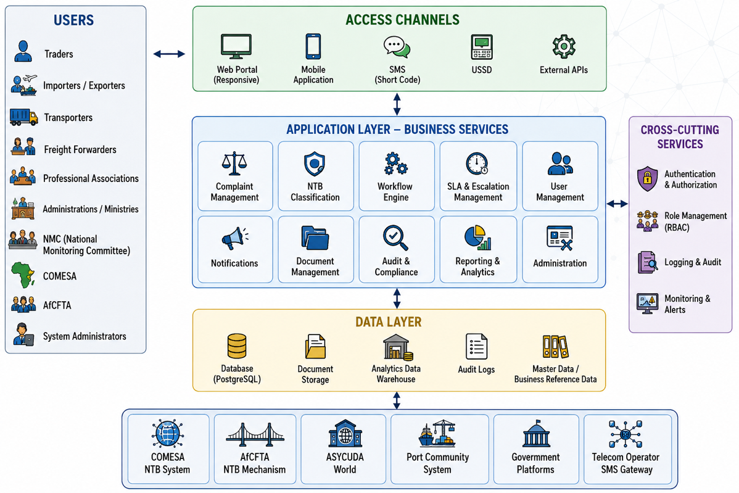
Figure 12: System architecture

9.3 Multi-Layer Architecture

The logical architecture of the system is organised into six interdependent functional layers.
- The user interface layer constitutes the entry point for all users.
- The application layer will manage the essential functionalities, notably the filing, classification, tracking and automated routing of complaints via a workflow engine. This layer executes all the business processes described in Section 5.
- The integration layer will enable interoperability with regional and national systems through standardised APIs, thus ensuring alignment with the COMESA/Tripartite NTB platform, the AfCFTA NTB reporting mechanism and the main national systems such as ASYCUDA and the Djibouti port community system.
- The data management layer will ensure the secure storage of data, real-time analysis and the production of reports, including disaggregated information to inform decision-making, while guaranteeing compliance with data protection requirements.
- The security layer will incorporate robust authentication, encryption and monitoring measures compliant with international standards in order to guarantee data integrity and the reliability of the system.
- Finally, the infrastructure layer provides the hardware and software resources needed to run the system.

Multi-layer view

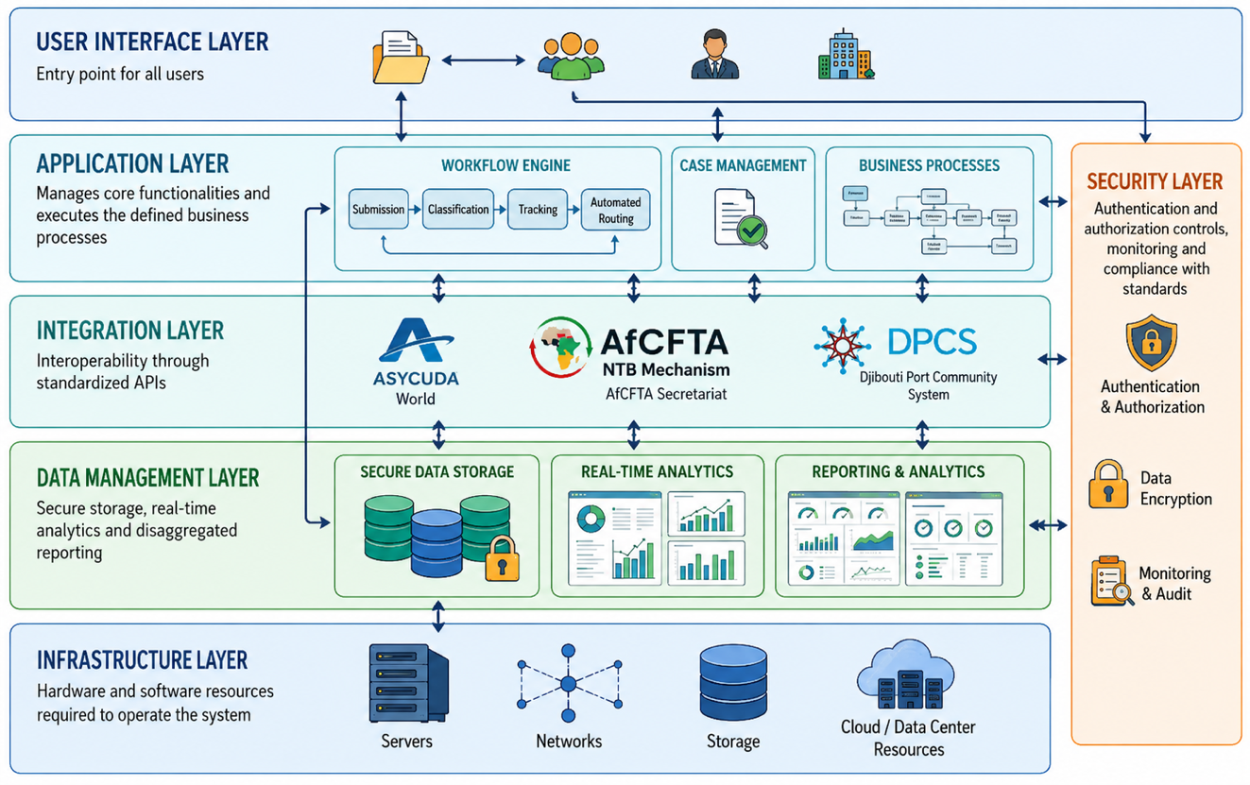
Figure 13: Multi-layer architecture

9.4 Deployment Architecture

The deployment follows a distributed architecture with several distinct environments.
- Development environment
Used by the technical teams for development, unit testing and initial validation.
- Pre-production environment
Used for integration testing, functional validation and user acceptance.
- Production environment
Operational environment used by all users.
- DevSecOps pipeline
The deployment relies on Git, GitLab or GitHub, automated CI/CD, quality controls and automated security testing.
This approach reduces the risk of error and accelerates production releases.

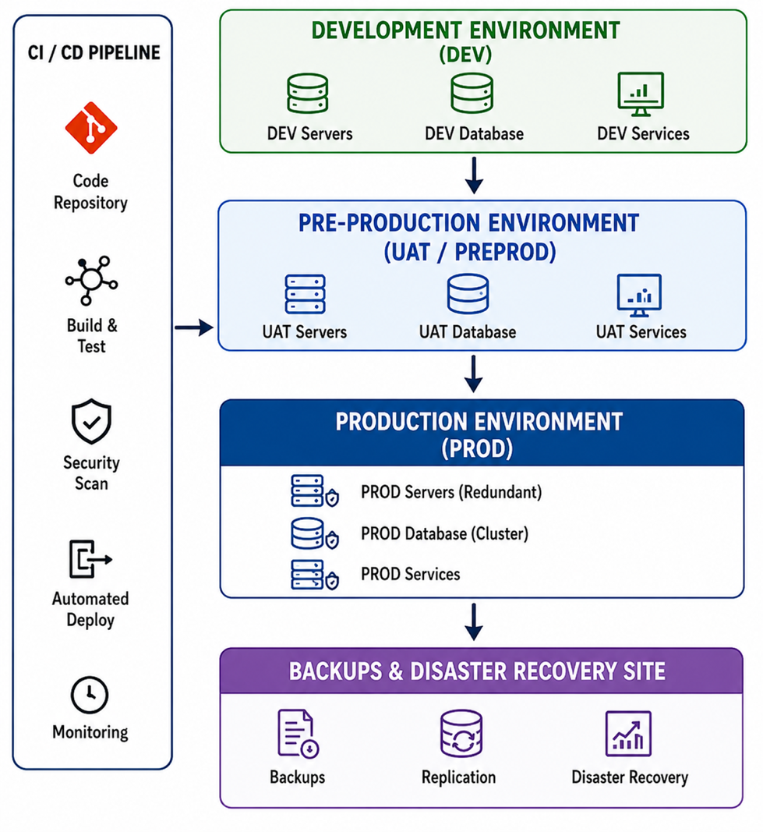
Figure 14: Deployment architecture

9.5 Infrastructure Architecture

The physical and logical infrastructure is designed to guarantee the performance and resilience of the system.
The main components include:

Front-End Tier
- Reverse Proxy;
- Load Balancer;
- Web Application Firewall (WAF).

Application Tier
- Application servers;
- Business services;
- Workflow engine;
- Notification services.

Data Tier
- PostgreSQL cluster;
- Analytical warehouse;
- Document storage;
- Audit logs.

Monitoring Tier
- Supervision;
- Alert management;
- Security monitoring;
- Performance analysis.

9.6 Cloud / Data Center Architecture
Hosting will be provided on a secure cloud infrastructure or a Tier III certified data centre meeting the availability requirements defined in Section 8.15.

Target architecture

Public zone
- Web portal;
- Public API;
- SMS gateways.

Secure application zone
- Business services;
- Workflow engine;
- Analytical engine;
- Document management.

Data zone
- PostgreSQL databases;
- Document storage;
- Backups;
- Archives.

9.7 Security Architecture
Security constitutes a cross-cutting component covering all layers of the platform. It rests on a defense-in-depth approach and remains aligned with the detailed requirements of Section 12 (Security and Cybersecurity) as well as with the ISO/IEC 27001 standards and the OWASP recommendations.

Perimeter and network security
- Web Application Firewall (WAF) applying the OWASP Top 10 rules, integrated into the NGINX/HAProxy reverse proxy (TLS termination);
- Intrusion detection and prevention system (IDS/IPS) monitoring inbound and outbound traffic;
- Anti-DDoS protection (volumetric and application filtering) upstream of the DMZ;
- Next-generation firewall (NGFW) and network segmentation into isolated zones (DMZ, application, data — see Section 9.8).

Identity and access management (IAM)
- Centralised identity management with multi-factor authentication (MFA);
- Role-based access control (RBAC) in accordance with Section 12.3;
- Delegated authentication via OAuth 2.0 / OpenID Connect and a secrets vault (secrets management).

Protection of communications and data
- Encryption in transit via TLS 1.3 on all channels (Web, API, SMS/USSD);
- Encryption of data at rest with AES-256, with key management by HSM/KMS module;
- Masking and pseudonymisation of sensitive data in non-production environments.

Application security
- Secure development life cycle (Secure SDLC) with SAST and DAST analyses integrated into the CI/CD pipeline (see Section 15.3);
- Systematic validation of inputs and protection against injections, XSS and CSRF attacks;
- Securing of APIs through rate limiting, quotas and OAuth 2.0 tokens.

Security monitoring, detection and audit
- Centralised SIEM platform (ELK stack or equivalent) ensuring log aggregation, event correlation and real-time alerting (see Section 12.9), operated by a Security Operations Centre (SOC);
- Endpoint detection (EDR) and behavioural monitoring;
- Timestamped and tamper-proof logging of access and sensitive actions (see Sections 8.14 and 12.6).

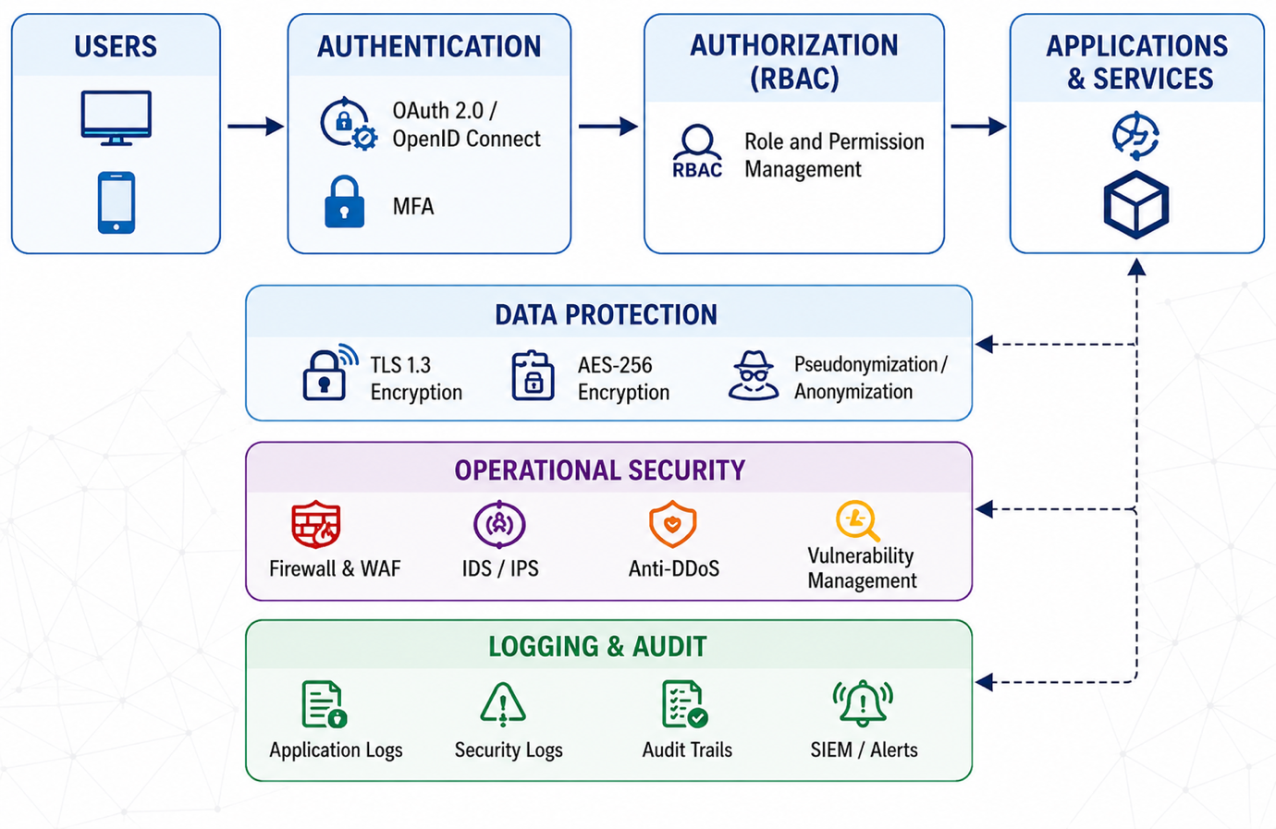
Figure 15: Security architecture of the system

9.8 Network Architecture
The network architecture aims to isolate critical services while facilitating secure exchanges.
The network is structured around several zones:
DMZ
- Web portal;
- Public API;
- SMS gateway.

Application network
- Business servers;
- Workflow services;
- Analytical engine.

Data networks
- Databases;
- Document storage;
- Backups.

9.9 API Architecture
The integration strategy rests on an API-First approach enabling standardised interconnection with internal and external partners: REST API;
- JSON;
- HTTPS;
- OpenAPI 3.0;
- OAuth 2.0.

9.10 Integration Architecture
The integration architecture ensures the interconnection between the national platform and the partner systems identified in Section 5.9.

Regional systems
- COMESA NTB Online System;
- AfCFTA NTB reporting mechanism;

External systems
- ASYCUDA World;
- Port Community System;

Telecom services
- Mobile operators;
- SMS gateways;
- USSD services.

Exchange mechanisms
- REST API;
- Webhooks;
- Scheduled synchronisation;
- Real-time synchronisation;
- Secure TLS exchanges.

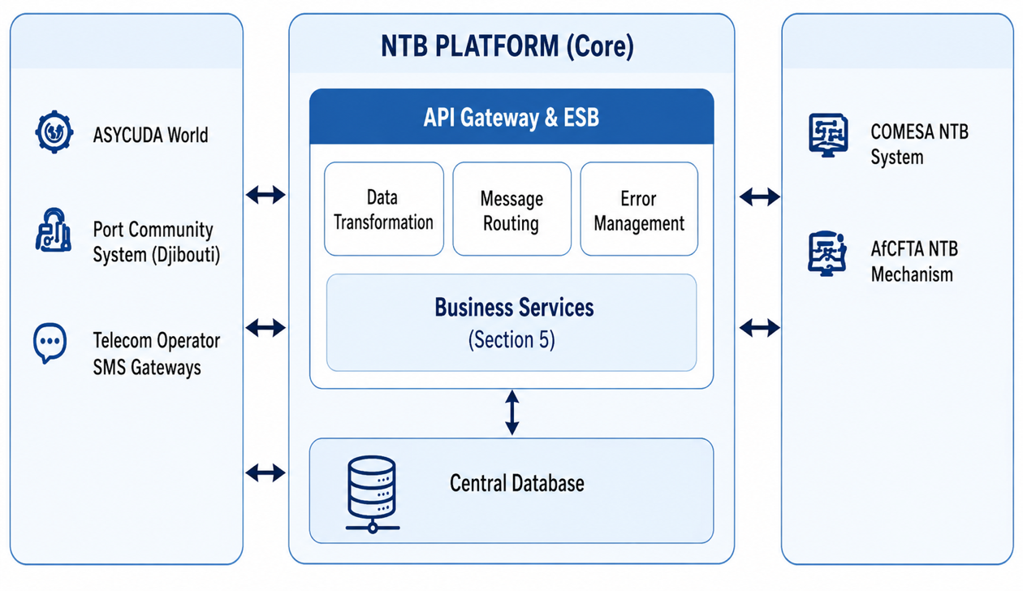
Figure 16: Integration architecture

9.11 Business Continuity Architecture

The business continuity architecture aims to guarantee the maintenance of critical services in the event of a major incident, in accordance with the availability objectives of Section 8.3 (target 99.9%) and the recovery procedures detailed in Section 17.6.
High availability (HA)
- Redundant architecture distributed across several availability zones within a Tier III or higher certified data centre (see Section 9.6);
- Web servers and reverse proxy in active-active configuration with load balancing (NGINX/HAProxy);
- Synchronous replication of the operational database to a replica node, eliminating any single point of failure (SPOF).

Disaster recovery (DR)
- Geographically distant secondary site maintained in active-passive configuration (warm standby);
- Asynchronous replication of data to the secondary site and automatic failover in the event of failure of the primary site;
- Failback controlled after restoration of the primary site.

Continuity objectives (RPO – Recovery Point Objective / RTO – Recovery Time Objective)
Service category | RPO | RTO
Critical operational data (complaints, workflows — synchronous replication) | ≤ 15 minutes | ≤ 4 hours
Analytical and documentary data | ≤ 1 hour | ≤ 8 hours
Secondary services (reporting, integrations) | ≤ 4 hours | ≤ 24 hours
Table 34: Business continuity objectives of the NTB management system

Backup and resilience
- Automated backups and off-site storage, in accordance with the procedures of Section 17.5;
- Failover tests and crisis simulations carried out at least once every six months in order to validate the RPO/RTO objectives.

DATA ARCHITECTURE

10.1 Data Governance Principles

The data architecture of the national platform for reporting and resolving Non-Tariff Barriers (NTBs) rests on a governance framework guaranteeing the quality, security, consistency and value of the data throughout its life cycle.

Given the strategic nature of the information collected from economic operators, public administrations, regional bodies and partner institutions, data governance constitutes a fundamental pillar of the platform.

Centralised governance with distributed responsibility
Data management is coordinated at national level under the supervision of the Ministry of Trade and Tourism (MTT) and the National Monitoring Committee (NMC), while each participating institution remains responsible for the accuracy and updating of the information within its area of competence.

Principle of uniqueness of information
Each reference data item must exist only once in the system in order to avoid inconsistencies and duplications.
This principle applies in particular to:
- NTB categories;
- Responsible institutions;
- Trade corridors;
- Border posts;
- Users;
- Processing statuses.

Data quality
The system must guarantee:
- Accuracy;
- Completeness;
- Consistency;
- Currency;
- Traceability.

Automatic validation and control mechanisms are applied from the point of data entry (see Section 10.8).

Security and confidentiality

All data is protected in accordance with the security requirements defined in Section 9.7.
The measures include, in particular:
- Role-based access control;
- Encryption of sensitive data;
- Access logging;
- Monitoring of critical operations;
- Audit mechanisms.

Transparency and traceability
Any modification of data must be logged in order to guarantee the transparency of the complaint-handling processes and institutional accountability.

Interoperability
The data structures are designed to enable the secure exchange of information with:
- The COMESA NTB system;
- The AfCFTA NTB reporting mechanism;
- ASYCUDA World;
- Port Community System;
- National government platforms.

Decision-data-oriented approach
The operational data must be usable for purposes that are:
- Statistical;
- Analytical;
- Decision-support;
- Regulatory;
- Regional.
This approach supports the reporting needs described in Sections 4.4 and 5.7.

10.2 Logical Data Model

The logical model represents the functional organisation of the data independently of any specific technology. It structures the flows from the user entry point (Web/SMS) through to the processing engine:

Domain | Main entity | Description
Complaint management | Complaint | Main NTB case
Classification | NTB_Category | Type of barrier
Location | Location | Geographic point concerned
Corridor | Corridor | Trade corridor concerned
Users | User | System user
Organisations | Institution | Responsible institution
Workflow | Workflow_Case | Processing process
Notifications | Notification | Generated messages
Escalation | Escalation | Management of SLA overruns
Documents | Attachment | Attachments
Audit | Audit_Log | History of actions
Reporting | Analytics_Record | Analytical data
Table 35: Conceptual data model of the NTB management system

10.3 Physical Data Model
The physical model translates the logical model into a PostgreSQL relational database as defined in Section 9.

Schema | Function | Tables
main | Operational data | Complaints  complaint_status  complaint_categories  corridors  locations  institutions  attachments
workflow | Process management | Workflows  workflow_steps  assignments  escalations  sla_tracking
analytics | Analytical warehouse | fact_complaints  fact_resolution  dim_time  dim_gender  dim_location  dim_category
security | Users and access | Users  Roles  Permissions  user_sessions
audit | Logging | audit_logs  login_logs  api_logs
integration | External synchronisation
Table 36: Logical architecture of the database schemas of the NTB management system

10.4 Entity Relationship Diagrams (ERD)
Tables | Relationship | Explanation
Users | Users → Roles (N → 1) | Several users may be associated with the same role. Each user has a single active role.
Users | Users → Institutions (N → 1) | Multiple users can belong to the same institution. A user may be attached to a specific institution.
Users | Users → NTB_Cases (1 → N) | A user may submit several NTB complaints. Each complaint is created by a single user.
Roles | Roles → Users (1 → N) | A role may be assigned to several users in order to manage system rights and permissions.
Institutions | Institutions → Users (1 → N) | An institution may contain several users (agents, managers, focal points).
Institutions | Institutions → NTB_Cases (1 → N) | An institution may be responsible for handling several NTB complaints.
Complaints | Complaints→ Users (N → 1) | Each NTB complaint is submitted by a single user.
Complaints | Complaints → Institutions (N → 1) | Each complaint is assigned to a competent institution responsible for handling it.
Complaints | Complaints → Case_History (1 → N) | A complaint may contain several history records corresponding to the various processing stages.
Complaints | Complaints → Notifications (1 → N) | A complaint may generate several notifications during its lifecycle.
Case_History | Case_History → NTB_Cases (N → 1) | Each history record is associated with a single NTB complaint.
Case_History | Case_History → Users (N → 1) | Each action recorded in the history is performed by a specific user.
Notifications | Notifications → Users (N → 1) | A notification is intended for a single user, but a user may receive several notifications.
Notifications | Notifications → NTB_Cases (N → 1) | A notification may be linked to a specific NTB complaint.
Table 37: Description of the relationships between the main tables of the NTB management system

10.5 Data Dictionary

Below is the technical structure of the master tables in PostgreSQL:
Table | Field | Type | Description
Users | id | BIGINT / UUID (PK) | Unique identifier of the user
Users | full_name | VARCHAR (255) | Full name of the user
Users | email | VARCHAR(255) | E-mail address
Users | phone | VARCHAR(50) | Phone number
Users | password | VARCHAR(255) | Encrypted password
Users | role_id | BIGINT (FK) | Reference to the user role
Users | institution_id | BIGINT (FK, nullable) | Reference to the institution
Users | status | VARCHAR(50) | Account status (active, suspended, etc.)
Users | created_at | TIMESTAMP | Creation date
Users | updated_at | TIMESTAMP | Modification date
Roles | id | BIGINT / UUID (PK) | Unique identifier of the role
Roles | name | VARCHAR(100) | Name of the role
Roles | description | TEXT | Description of the role
Roles | permissions | JSON / TEXT | List of permissions
Roles | created_at | TIMESTAMP | Creation date
Institutions | id | BIGINT / UUID (PK) | Unique identifier of the institution
Institutions | name | VARCHAR(255) | Name of the institution
Institutions | type | VARCHAR(100) | Type of institution
Institutions | country | VARCHAR(100) | Country concerned
Institutions | address | TEXT | Physical address
Institutions | contact_email | VARCHAR(255) | Official e-mail address
Institutions | contact_phone | VARCHAR(50) | Official phone number
Institutions | created_at | TIMESTAMP | Creation date
Complaints | Id | BIGINT / UUID (PK) | Internal case identifier
Complaints | complaints_code | VARCHAR(100) | Unique code of the NTB complaint
Complaints | title | VARCHAR(255) | Title of the complaint
Complaints | description | TEXT | Detailed description
Complaints | complaints_categorie | VARCHAR(100) | Type of NTB
Complaints | Status_id | VARCHAR(100) | Current status of the case
Complaints | priority | VARCHAR(50) | Priority level
Complaints | country_origin | VARCHAR(100) | Country of origin
Complaints | country_destination | VARCHAR(100) | Country concerned
Complaints | Corridor_id | VARCHAR(255) | Trade corridor concerned
Complaints | created_by | BIGINT (FK) | User who submitted the complaint
Complaints | assigned_institution_id | BIGINT (FK) | Responsible institution
Complaints | current_handler_id | BIGINT (FK, nullable) | Agent currently in charge
Complaints | submission_channel | VARCHAR(50) | Submission channel (Web/SMS/USSD)
Complaints | resolution_note | TEXT | Final resolution
Complaints | created_at | TIMESTAMP | Creation date
Complaints | updated_at | TIMESTAMP | Update date
Complaints | closed_at | TIMESTAMP | Closure date
Complaints | Field | Type | Description
Notifications | id | BIGINT / UUID (PK) | Unique identifier of the notification
Notifications | user_id | BIGINT (FK) | Notification recipient
Notifications | case_id | BIGINT (FK, nullable) | Reference to the complaint concerned
Notifications | title | VARCHAR(255) | Title of the notification
Notifications | message | TEXT | Notification content
Notifications | type | VARCHAR(50) | Notification type
Notifications | is_read | BOOLEAN | Read status
Notifications | created_at | TIMESTAMP | Send date
Notifications | read_at | TIMESTAMP | Read date
Table 38: Data dictionary of the NTB management system

10.6 Master Data

Reference data (Master Data) constitute the structuring elements of the system.

They are managed centrally in order to ensure their consistency.
Domain | Reference
NTB | NTB Categories
Institutions | Ministries, agencies, authorities
Geography | Regions, border posts, corridors
Workflow | Statuses, actions, escalation levels
Users | Roles and profiles
Notifications | Message types
SLA | Timeframe parameters
Languages | French, Arabic, English, Somali, Afar
Table 39: Data repository of the NTB management system

10.7 Metadata Standards

Metadata ensure the uniform interpretation of data across the entire system.

Each business object must be accompanied by standardised descriptive information.
Attribute | Description
ID | Unique identifier
Source | Origin of the data
Creation date | Initial timestamp
Creator | Initiating user
Last modification | Update date
Modified by | Modification owner
Version | Version number
Status | Current state
Classification | Sensitivity level
Table 40: Governance and traceability metadata of the NTB management system data

10.8 Data Validation Rules

Validation rules ensure the quality and integrity of data before it is recorded.

Complaint validation
Code | Rule
DV-001 | Description mandatory
DV-002 | NTB category mandatory
DV-003 | Location mandatory
DV-004 | Responsible institution mandatory
DV-005 | Corridor mandatory
DV-006 | Automatic unique reference
DV-007 | Anti-duplicate check
Table 41: Data validation rules of the complaint management system

User validation
Code | Rule
DV-101 | Valid e-mail address
DV-102 | Valid phone number
DV-103 | Role mandatory
DV-104 | Strong authentication
Table 42: User data and authentication validation rules of the NTB management system

Document validation
Code | Rule
DV-201 | Authorised formats only
DV-202 | Controlled maximum size
DV-203 | Mandatory antivirus scan
DV-204 | Compliant file name
Table 43: Attachment validation rules of the NTB management system

Integration validation
Code | Rule
DV-301 | JSON schema verification
DV-302 | OAuth validation
DV-303 | API signature control
DV-304 | Exchange error handling
Table 44: Integration validation rules of the NTB management system

10.9 Data Retention Policies
- The retention policy aims to meet the operational, regulatory and analytical obligations of the NTB programme.

Recommended retention periods

Type of data | Duration
NTB cases | 10 years
Full audit | 10 years
Workflow history | 10 years
Application logs | 3 years
User sessions | 1 year
Full backups | 1 year
Analytical reports | 10 years
API integration data | 5 years
Table 45: Data retention policy of the NTB management system

10.10 Data Archiving

Archiving ensures the secure preservation of historical information while maintaining the performance of the operational system.
Archiving policy

Data type | Trigger
Closed cases | 24 months after closure
Technical logs | 12 months
Notifications | 24 months
Workflow histories | 24 months
Old reports | 36 months
Table 46: Purge and archiving rules of the NTB management system

INTEROPERABILITY AND INTEGRATION

The interoperability architecture constitutes a strategic pillar of the Non-Tariff Barriers (NTB) management platform, ensuring smooth connectivity between national, regional and international systems. It guarantees the secure, standardised and traceable flow of data between the various stakeholders of the Djibouti trade corridor.

This section defines the principles, standards and technical mechanisms governing data exchange, system synchronisation and integration with external platforms.

11.1 Integration Principles
The integration approach is based on the following principles:
- API-First Architecture: all system functionalities are exposed via standardised APIs.
- Interoperability by Design: native compatibility with COMESA/Tripartite, AfCFTA and national systems.
- Loose Coupling: system independence to facilitate maintenance and evolution.
- Scalability: capacity for the progressive integration of new partners.
- Security by Design: secure integration from the design stage (encryption, authentication).
- Standardisation: adoption of international formats and protocols to ensure uniformity of exchanges.

11.2 External Systems
The platform must integrate with the following systems:
- COMESA NTB Online System
- AfCFTA NTB Monitoring Mechanism
- ASYCUDA
- Port Community Systems (Djibouti Port Authority) and customs

11.3 API Specifications
Data exchanges are based on a standardised API architecture:
- RESTful architecture
- Data format: JSON
- Secure protocol: HTTPS
- Documentation: OpenAPI 3.0 / Swagger
- API versioning to ensure backward compatibility
- Rate limiting to prevent abuse and guarantee performance

Each API is designed around the following resources:
- NTB Cases
- Users & Institutions
- Workflow Status
- Notifications
- Analytics & Reports

11.4 Authentication Standards
API access security is based on international standards and exchanges are protected by TLS 1.3 encryption.
- OAuth 2.0 (authentication and authorisation)
- JWT (JSON Web Tokens) for session management
- Role-Based Access Control (RBAC)
- Secure API Keys for partner systems
- Multi-Factor Authentication (MFA) for administrative users

11.5 Data Exchange Formats
Data exchange formats must guarantee interoperability and readability:
- JSON (primary format)
- XML (legacy system compatibility)
- CSV (analytical export)
- GeoJSON (geographic corridor data)
- ISO 8601 (standardised timestamping)
Data structures follow validated schemas in order to ensure consistency between systems.

11.6 Synchronization Methods
Synchronisation between systems is ensured by several mechanisms:
- Real-time synchronisation (API push/pull)
- Webhooks for instant notifications
- Batch synchronization for non-real-time systems
- Message queues (e.g. RabbitMQ/Kafka) for asynchronous processing
- Conflict resolution rules to avoid data duplication

11.7 Error Handling
The system incorporates robust error handling:
- Standardised error codes (HTTP status codes)
- Detailed API error logs
- Structured and readable error messages
- Traceability of integration failures
- Automatic alerting in the event of critical failure
- Fallback mechanism to temporary local storage

11.8 Retry and Recovery Logic
In order to guarantee the reliability of exchanges:
- Automatic exponential retry (Exponential Backoff)
- Configurable maximum number of attempts
- Queue of failed requests
- Manual reprocessing via administrator dashboard
- Temporary storage of transactions in the event of network failure
- Post-incident recovery mechanism (Recovery Queue)

These mechanisms ensure the continuity of exchanges even in the event of partial failure of partner systems.

SECURITY AND CYBERSECURITY

The security and cybersecurity strategy of the national NTB management platform constitutes a cross-cutting pillar of the overall architecture defined in Sections 9 (System Architecture) and 5 (Functional Requirements). It aims to guarantee the confidentiality, integrity, availability and traceability of data in a context of regional interconnection (COMESA/Tripartite, AfCFTA) and multi-channel exposure (Web, SMS/USSD, API).

12.1 Security Principles
The security design is based on guiding principles aligned with international standards (ISO 27001, OWASP):
- Zero Trust Architecture: no entity is considered trustworthy by default, whether internal or external.
- Least Privilege: each user and service has only the permissions strictly necessary.
- Defence in Depth: layering of security controls (network, application, data).
- Security by Design: integration of security requirements from the design phase (Section 9.1).
- Permanent auditability: full traceability of user and system actions.

12.2 IAM (Identity and Access Management)
The identity management system constitutes the central point of access control.
- Centralised management of user identities (institutions, private operators, regional partners)
- Authentication via OAuth 2.0 and secure tokens

12.3 RBAC Model
The RBAC model is adopted to structure permissions:
- Institutional roles: MTT, NMC, Customs, port authorities
- Technical roles: system administrators, support, analysts
- External roles: traders, transporters, freight forwarders, associations
- Regional roles: COMESA, AfCFTA, IGAD

Each role is associated with:
- Functional permissions (read, validation, escalation)
- Data perimeters (national, corridor, regional)
- Access levels to dashboards and APIs

12.4 MFA Requirements
Multi-factor authentication (MFA) is mandatory for all sensitive profiles:
- OTP via SMS or Email.
- Enhanced authentication for administrators and NMC focal points
- Automatic lockout after repeated failed attempts.

12.5 Encryption Standards
Data protection is based on advanced cryptographic standards:
- In transit: TLS 1.3 for all communications (Web, API, SMS gateway)
- At rest: AES-256 encryption for databases and backups
- Key management: periodic rotation and secure storage (KMS)
- API signing: validation of inter-system requests (COMESA, ASYCUDA)

12.6 Audit Logging
The audit system constitutes a mandatory component of compliance and transparency:
- Full logging of user and administrative actions
- Traceability of complaint status changes (cf. Section 5.3.4)
- Synchronised timestamping via secure time server (NTP)
- Log retention in accordance with the national digital governance policy
- Protection against unauthorised deletion of logs (append-only)

12.7 Vulnerability Management
A proactive approach to vulnerability management is implemented:
- Regular scans of application components and open source dependencies
- Automatic vulnerability analysis (SAST / DAST)
- Patch management according to criticality
- Permanent inventory of software components (Software Bill of Materials - SBOM)
- Monitoring of critical vulnerabilities with remediation SLA

12.8 Penetration Testing
Penetration tests are integrated into the development cycle:
- Periodic tests before each production release
- Attack simulations on API, web portal and SMS gateway
- OWASP Top 10 tests (injection, XSS, authentication, etc.)
- Assessment of the resilience of authentication mechanisms and RBAC

12.9 SIEM and Monitoring
A centralised security monitoring system (SIEM) ensures real-time detection:
- Aggregation of application, system and network logs
- Behavioural anomaly detection (AI-based alerting)
- Real-time alerts on critical incidents
- Event correlation (access attempts, escalations, API abuse)
- SOC (Security Operations Center) dashboards

12.10 Incident Response
A structured incident response mechanism is defined:
- Incident classification (minor, major, critical)
- Escalation procedures to technical and institutional teams
- Communication plan in the event of an incident (internal and external)
- Post-incident analysis (Root Cause Analysis)
- Implementation of corrective and preventive measures
This mechanism is aligned with the continuity requirements defined in Sections 9.11 and 17.6

12.11 Security Compliance
The platform complies with a multi-level compliance framework:
- International standards: ISO/IEC 27001, ISO 27005
- OWASP best practices for secure web applications
- Compliance with national data protection policies
- COMESA and AfCFTA regional requirements regarding secure interoperability
- Compliance with data retention and audit obligations

REPORTING AND ANALYTICS

The Reporting and Analytics module constitutes a strategic component of the NTB management platform, as defined in Section 5.7 and reinforced by the data architecture requirements presented in Section 9. It transforms operational data from the complaint management system into actionable information for decision-making, institutional performance and the steering of trade policies.

This module is designed according to a data-driven governance approach, enabling national and regional stakeholders to access a consolidated, disaggregated and real-time view of corridor performance.

13.1 Dashboard Requirements

Dashboards constitute the main interface for visualising analytical data. They are designed according to a role-based access control (RBAC) logic in order to adapt the information displayed according to the user profile (ministries, technical committees, regional partners, private sector). They constitute a central operational steering tool for the National Monitoring Committee (NMC) and the coordination authorities.
- Dynamic real-time dashboards with automatic data updates
- Multi-level visualisation (national, corridor, institutional, sectoral)
- Summary indicators (KPIs) and detailed indicators (drill-down)
- Customisation of views according to institutional roles
- Display of critical alerts (SLA delays, escalations, bottlenecks)
- Mobile and web responsive compatibility
- Quick export of analytical views

13.2 KPI Framework
The performance indicator (KPI) framework is structured around 4 levels of analysis: operational, institutional and strategic.
- Resolution time,
- Recurrence rates,
- Compliance costs
- Estimated economic impacts
- Total number of registered complaints
- Resolution rate of NTB

13.3 Reporting Catalogue
The reporting catalogue defines all the standardised reports generated by the platform. These reports are automated, scheduled or generated on demand.

Types of reports:
- Operational reports
  - List of complaints by status
  - Monitoring of active cases
  - Workflow history
- Analytical reports
  - Analysis of NTB trends
  - Breakdown by barrier category
  - Temporal analysis of incidents
- Institutional reports
  - Performance of ministries and agencies
  - Comparative inter-institutional analysis
  - Monitoring of SLA commitments
- Strategic reports
  - Impact of NTBs on trade corridors
  - Evolution of overall system performance
  - Summary for national and regional reports

13.4 Export Requirements
The system incorporates advanced export capabilities in order to facilitate the use of data outside the platform.

The supported formats include:
- PDF for official and institutional reports
- Excel for in-depth analysis and external processing
- CSV for integration into third-party systems
- API export for regional systems

The specific requirements include:
- Secure export based on user rights
- Prior filtering of data before export
- Generation of custom reports on demand
- Automatic timestamping of exported files
- Traceability of exports in the audit logs (linked to Section 5.3.4)

13.5 Geographic Analysis
The geographic analysis module enables a spatial visualisation of non-tariff barriers across the entire corridor.

Main features:
- Interactive mapping of NTBs
- Analysis by border posts, ports and logistics zones
- Identification of critical zones with a high concentration of barriers
- Correlation between location and processing times
- Visualisation of impacted trade flows

This capability enables a better understanding of structural bottlenecks and supports decisions on investment and logistics reform

TESTING AND QUALITY ASSURANCE

The testing and quality assurance strategy aims to guarantee that the delivered system complies with the functional (Section 5) and non-functional (Section 8) requirements, while ensuring a high level of security, performance and user acceptability.

14.1 Testing Strategy
The overall testing strategy is based on a progressive and incremental approach, integrated into the Agile-DevOps development cycle (cf. Workstream 2 Inception Report).
It aims to:
- Validate each functional component from its design stage (shift-left testing)
- Ensure compliance with business and technical requirements
- Reduce risks related to deployment in a real environment
- Guarantee reliable interoperability with external systems (COMESA/Tripartite, AfCFTA, ASYCUDA)

The strategy combines automated and manual tests, executed at each development iteration.

14.2 Unit Testing
Unit tests cover each functional module in isolation in order to guarantee its technical compliance.
They concern in particular:
- Complaint management module (Section 5.3)
- Workflow engine (Section 5.4)
- Notifications (Section 5.6)
- Integration API (Section 9.9)

14.3 Integration Testing
Integration tests validate the interactions between the various modules of the system.
They cover:
- Interaction between web portal and backend
- SMS/USSD synchronisation and database
- Communication between internal APIs and external systems
- Transmission of data to the analytical modules

14.4 System Testing
System tests assess the platform as a whole in an environment close to production.
They verify:
- The proper functioning of the complete lifecycle of an NTB (from submission to closure)
- Compliance with business rules (Section 5.3.2)
- The management of multi-institutional workflows
- The overall stability of the system under normal load

14.5 Security Testing
Security tests are essential to guarantee the protection of sensitive data and compliance with international standards (Section 8.5 and 9.7).
They include:
- Vulnerability tests (OWASP Top 10)
- Penetration Testing
- Verification of TLS 1.3 and AES-256 encryption
- Validation of role-based access control (RBAC)
- OAuth 2.0 authentication tests

14.6 UAT
User acceptance tests (UAT) are carried out with key stakeholders taking into account the table below.

Indicator type | Indicator | Target | Method
Output | NTB platform developed and tested | 1 functional platform | Deployment and user acceptance test reports
Output | Number of NTBs identified | More than 200 | Platform logs
Result | % increase in private sector reports | +40% | Platform analytics
Result | Reduction in NTB resolution time | −30% | Timestamped complaint resolution logs
Result | Stakeholder satisfaction with the platform | ≥85% | Focus groups, surveys
Table 47: UAT user acceptance test matrix

14.7 Performance Testing

Performance tests assess the system's capacity to meet the load and responsiveness requirements defined in Section 8.1.
They cover:
- Load Testing
- Stress Testing
- Soak Testing

14.8 Test Environment
The test environment will faithfully reproduce the production environment in order to guarantee the validity of the results.

It comprises:
- Development environment (Dev)
- Continuous integration environment (CI)
- Pre-production environment (Staging)
- Anonymised or simulated data

14.9 Defect Management
Anomaly management follows a structured process based on defect criticality:
Classification:
- Critical: system blockage
- Major: significant functional impact
- Minor: limited impact
- Cosmetic: interface or ergonomics

Process:
- Detection and recording of defects
- Prioritisation and assignment
- Correction and re-test
- Validation and closure

A tracking tool (such as Jira or an open source equivalent) will be used to ensure full traceability.

14.10 Acceptance Criteria

The platform's go-live will be conditional on meeting the following criteria:
- 100% of critical cases tested and validated with no blocking defect
- Functional test success rate ≥ 95%
- Full compliance with security requirements
- UAT validation by the main institutional stakeholders
- Performance compliant with the defined SLAs (availability ≥ 99.9%)
- Operational integration with key external systems (COMESA, ASYCUDA, PCS)

DEPLOYMENT AND DEVOPS

The deployment and DevOps model of the NTB platform follows a logic of continuous, secure and controlled delivery, in accordance with the availability, performance and resilience requirements defined in the sections relating to system architecture (Section 9) and non-functional requirements (Section 8). The objective is to guarantee a smooth, reproducible and controlled production release cycle, while minimising operational risks.

15.1 Deployment Strategy

The deployment strategy is based on a progressive and controlled approach, combining automation and human validation at critical stages.
It follows the following principles:
- Incremental deployment of features (feature-based deployment)
- Blue/Green or Rolling Deployment strategy to limit service interruptions
- Strict separation of environments in order to avoid any contamination between testing and production
- Automation of deployments via CI/CD pipeline
- Systematic validation before production release

15.2 Environment Strategy
The deployment architecture is based on four distinct environments, each meeting a specific objective in the application lifecycle.

• DEV (Development)
- Environment used by the technical teams
- Feature development and initial fixes
- Simulated or anonymised data
- Continuous integration of changes
• TEST (Integration and technical testing)
- Validation of technical components
- Unit tests, integration tests and automated tests
- Simulation of API and SMS/USSD interactions
- Early detection of anomalies

• UAT (User Acceptance Testing)
- Functional validation by stakeholders (MTT, NMC, key users)
- Verification of compliance with business requirements (Section 5)
- Simulation of real corridor usage scenarios

• PROD (Production)
- Operational environment in real-world use
- Official data and real transactions
- Controlled and secure access
- Continuous monitoring and high availability

15.3 CI/CD Pipeline
The platform adopts a CI/CD approach (Continuous Integration / Continuous Deployment) in order to ensure fast, reliable and traceable software delivery.

The pipeline comprises the following stages:
- Source code commit
- Automatic build
- Quality analysis (linting, automated code review)
- Execution of unit and integration tests
- Security validation (vulnerability scan)
- Deployment to TEST environment
- UAT validation
- Deployment to production

The recommended tools include:
- GitHub Actions / GitLab CI
- Jenkins (alternative enterprise)
- Docker for containerisation
- Kubernetes for orchestration (if advanced scalability is required)

15.4 Version Control
The version control system is based on Git, allowing strict governance of the source code.
Principles adopted:
- Branch management (feature, develop, release, hotfix)
- Mandatory code review before merging (pull requests)
- Full history of changes
- Traceability of contributions by developer
- Standardisation of commits (conventional commits)

Recommended platforms:
- GitHub
- GitLab

15.5 Release Management
Version management is based on a structured software release model.
Each release comprises:
- A standardised version number (e.g. v1.0.0)
- A detailed changelog
- Mandatory UAT validation

Types of releases:
- Major release: major new features
- Minor release: functional improvements
- Patch release: bug fixes and security
A release schedule is defined in order to ensure system stability and the predictability of changes.

15.6 Rollback Procedures
In order to guarantee service continuity, a rollback mechanism is integrated so that the system can revert to the last stable version without prolonged service interruption.

The principles include:
- Automatic backup before each production deployment
- Retention of previous stable versions
- Possibility of rapid restoration (point-in-time recovery)
- Automated rollback scripts
- Post-rollback validation

15.7 Monitoring and Observability
The system incorporates an advanced monitoring and observability layer enabling real-time tracking of performance and application health.

Main components:
- Performance monitoring
  - API response time
  - Server load
  - Resource usage

- Centralised logs
  - Logging of system events
  - Tracking of application errors
  - Traceability of NTB transactions

- Real-time alerting
  - Notifications in the event of a critical incident
  - Configurable performance thresholds
  - Automatic escalation to the technical teams

- Business observability
  - Real-time complaint tracking
  - Bottleneck analysis
  - SLA indicators (Section 5.13)

CHANGE MANAGEMENT AND CAPACITY BUILDING

Change management constitutes a strategic component of the project to design a digital NTB (Non-Tariff Barriers) management platform, aiming to guarantee the appropriation, sustainability and optimal operation of the system by all public and private stakeholders.

It encompasses user training, the provision of structured and accessible documentation, as well as a communication and progressive adoption plan fostering trust, collaboration and institutional performance.

16.1. User Training
User training aims to equip each category of actor with the skills necessary for the effective use, management and sustainability of the NTB system.

The design of the programmes is based on a blended pedagogy integrating:
- Guided demonstrations and practical workshops based on real cases.
- In-person training sessions, supported by digital resources.

The training courses are structured around four components:
- Institutional and governance training for senior officials and members of the National Monitoring Committee.
- Operational training for technical and administrative reference persons, targeting complaint lifecycle management, escalation procedures, performance indicator analysis and dashboard usage.
- User training for private sector actors (companies, professionals, cross-border traders), focused on complaint submission, case tracking and understanding of resolution timeframes and mechanisms.
- Training of trainers to ensure the continuity and sustainability of skills, a training-of-trainers programme will be implemented.
- IT technician training on NTB system maintenance;

These internal trainers will become the vectors of sustainability, guaranteeing the autonomy of national institutions without dependence on external stakeholders.

16.2 Monitoring and Performance Indicators
The measurement of training effectiveness will be based on quantitative and qualitative indicators:
- Participation and completion rates by user category;
- Results of post-training assessments (theoretical and practical tests);
- Level of stakeholder satisfaction (satisfaction questionnaires).

16.3. User Documentation
User documentation constitutes a central pillar of assistance and knowledge transfer. Its development will be based on the Dokiel software, dedicated to the production of technical content, interactive manuals and digitised training materials.

The user documentation covers all categories of users:

- General user manual: guides for entry, submission and tracking of complaints via web or SMS.
- Administration manual: procedures for validation, role assignment, escalation, reporting, backup and configuration.
- Quick reference guides and FAQ: concise and practical formats for frequent tasks.
- Technical documentation: architecture diagrams, API specifications, data models, maintenance and restoration procedures.

16.4. Communication and Adoption
Communication and progressive adoption constitute the essential levers of a sustainable institutional appropriation of the NTB mechanism. The objective is to build a common understanding, foster trust between actors and create the conditions for organisational success.

This strategy is structured around the following axes:
- Promotion of the system's benefits: highlighting the impact of the NTB system in terms of transparency, reduction of processing times, improvement of competitiveness and trade facilitation.
- Feedback mechanisms: implementation of information feedback channels (surveys, feedback) to integrate user input in a logic of continuous improvement.

OPERATIONS, SUPPORT, AND MAINTENANCE

This section defines the operational framework guaranteeing service continuity, technical stability and the sustainability of the NTB management platform.

17.1 Support Model
The support model is structured according to a tiered approach (L1–L3) enabling efficient handling of incidents and user requests.
- Level 1 (Operational support) : user assistance (forms, SMS/USSD, navigation, simple errors).
- Level 2 (Application support) : resolution of functional incidents related to workflows, notifications and reporting.
- Level 3 (Expert technical support) : intervention on code, infrastructure, APIs and external integrations.

17.2 SLA Framework
The SLA framework defines the service commitments guaranteeing the performance and availability of the system.
- Target availability : ≥ 99.9% (aligned with Section 8.15 Hosting Requirements)

17.3 Incident Management
Incident management follows a structured process based on detection, qualification, prioritisation and resolution.
Key stages:
- Detection (automatic via monitoring or by user)
- Recording in the ticketing system
- Classification (critical, major, minor)
- Assignment to the appropriate support level
- Resolution and user validation
- Closure and knowledge capitalisation

17.4 Maintenance Procedures
Maintenance is organised into three categories:
- Corrective maintenance : correction of anomalies detected in production
- Preventive maintenance : performance optimisation and failure prevention
- Evolutionary maintenance : addition of new features and regulatory adaptations

Updates are scheduled in order to minimise the impact on end users (controlled maintenance windows).

17.5 Backup Procedures
Backup procedures guarantee the protection and recoverability of the platform's critical data. In addition to the requirements defined in Section 8.9.
Backups will cover all the critical components of the platform:
Component | Backed-up content
Operational database | NTB complaints, users, workflows, notifications, SLA
Analytical database | Statistical and reporting data
Documents and attachments | Files uploaded by users
Application configuration | System parameters and repositories
Audit logs | Audit logs, application logs and security logs
Integration interfaces | API parameters and interconnection configurations
Application environments | Servers, containers and system configurations
Table 48: Scope of components covered by the backup strategy of the NTB management system

The following operational procedures apply:
- Automatic daily backup: performed every night (between 00:00 and 04:00 UTC+3) including databases, attached files and system logs. Retention: 30 days.
- Weekly backup: performed every Sunday, including a full system backup. Retention: 12 weeks.
- Monthly backup: full archiving performed on the first day of each month. Retention: 12 months (in accordance with Section 8.13).
- Integrity verification: each backup is subject to an automated integrity check (checksum). Alerts are generated in the event of a detected anomaly.
- Off-site storage: backups are replicated to a geographically distant secondary site in order to guarantee resilience in the event of a major disaster.
- Restoration tests: restoration procedures are tested at least once every six months in order to validate their effectiveness and the RPO/RTO objectives defined in Section 17.6.

17.6 DR Procedures
The disaster recovery plan aims to ensure the continuity of critical services in the event of a major failure.

Main characteristics:
- Redundant multi-zone architecture with a geographically distant secondary site (cf. Section 9.6 Cloud/Data Center Architecture);
- Automatic failover to the secondary site in an active-passive configuration, with a controlled failback procedure;
- Recovery objectives quantified by service criticality level (see table below):

Service level | RPO (max. data loss) | RTO (max. recovery time)
Critical services (operational database, complaint management) | ≤ 15 minutes (synchronous replication) | ≤ 4 hours
Standard services (analytics, documents) | ≤ 1 hour | ≤ 8 hours
Secondary services (reporting, regional integrations) | ≤ 4 hours | ≤ 24 hours
Table 49: Service continuity level of the NTB management system
For synchronous replication components, the RPO is near zero (data loss close to zero). These objectives are consistent with the target availability of 99.9% and the unplanned downtime ceiling of < 24 hours/year defined in Section 8.3.

Crisis simulations are carried out periodically in order to test the resilience of the system.

17.7 Sustainability Strategy

The sustainability strategy guarantees the continuity of the system beyond the project phase.
Main axes:

- Progressive transfer of skills to national institutions (MTT, NMC)
- Adoption of an open-source architecture to reduce maintenance costs
- Establishment of local technical governance
- Continuous training of administrators and key users
- Regional pooling of infrastructure via the COMESA/Tripartite and AfCFTA platforms

IMPLEMENTATION ROADMAP

The implementation roadmap structures the progressive deployment of the system in order to limit risks, ensure user adoption and guarantee the quality of deliverables

18.1 Implementation Phasing

The project is structured into several successive phases:
- Phase 1: Initialisation and scoping
  - Validation of requirements
  - Establishment of project governance
- Phase 2: Design and prototyping
  - System architecture
  - Functional prototype (UI/UX and workflow)
- Phase 3: Development and integration
  - Application modules
  - API and SMS/USSD
- Phase 4: Testing and validation
  - Unit, integration and UAT tests
  - SLA validation
- Phase 5: Deployment and stabilisation
  - Production release
  - Enhanced monitoring

18.2 Pilot Deployment
A pilot deployment will be carried out in a controlled environment in order to:
- Validate the real NTB processing flows
- Test interoperability with external systems
- Measure adoption by end users
- Identify the necessary functional adjustments

The pilot will serve as the basis for national rollout

18.3 Rollout Strategy
The deployment strategy follows a progressive approach:
- Deployment by priority corridors
- Extension to strategic border posts
- National rollout
- Regional integration (COMESA/Tripartite and AfCFTA)
This approach makes it possible to control risks and ensure a progressive scale-up.

18.4 Milestones
The main project milestones are:
- Validation of functional and technical requirements
- Delivery of the prototype
- Beta version of the system
- Initial production release
- Completion of regional API integration
- Finalisation of national deployment
- Project closure and handover

18.5 Dependencies
The success of the project depends on several critical factors:
- Availability of the SMS short code from the telecom operators
- Institutional validation by the national authorities
- Availability of external systems (ASYCUDA, PCS, COMESA NTB)
- Active participation of stakeholders
- Operational cloud or data center infrastructure

18.6 Risks and Mitigation

A proactive risk management mechanism is integrated throughout the project lifecycle.
Risk | Description | Mitigation strategy
Limited political buy-in | Weak institutional support | Early engagement, steering committee and formal protocols
Technical delays | Development or integration difficulties | Agile methodology and iterative validations
Low user adoption | Resistance to change | Awareness-raising, simplified UX and training
Complex interoperability | Conflicts with external systems | API alignment and regional standards
Data confidentiality | Risk of information leakage | Encryption, RBAC and security compliance
Limited institutional capacity | Low NMC maturity | Capacity-building programme
Language barriers | Difficulty accessing the system | Multilingual interface and SMS/USSD
Table 50: Risk matrix of the NTB management system project

CONCLUSION

The system specification document (SDS/SRS) constitutes a structuring step in the transformation of business and institutional requirements into a coherent, scalable technical architecture aligned with the strategic objectives of the Non-Tariff Barriers (NTB) management project for the Djibouti–Ethiopia corridor.

Through the various sections developed, the system has been designed as an integrated platform, based on a modular and multi-layered approach, guaranteeing both functional robustness, data security, and regional interoperability. This architecture makes it possible to respond operationally to the needs expressed in the sections relating to functional and non-functional requirements, as well as workflow and integration specifications.

The detailed analysis of the system architecture highlights a clear structuring around several complementary levels:
- A user interface layer ensuring multi-channel accessibility (web, SMS/USSD);
- An application layer centralising critical business processes such as complaint management, workflows, notifications and reporting;
- A data layer guaranteeing the traceability, integrity and analytical exploitation of information;
- An integration layer ensuring communication with national and regional systems such as ASYCUDA and the COMESA/Tripartite and AfCFTA NTB reporting platforms;
- A cross-cutting security layer ensuring the protection, compliance and governance of data;
- An infrastructure layer based on certified cloud or data center environments, guaranteeing the high availability and resilience of the system.

This approach makes it possible not only to ensure the continuity and reliability of the service, but also to support the future evolution of the system in a regional context undergoing constant digital transformation.

Furthermore, the API-first orientation, the adoption of open standards, as well as the integration of modern DevOps and monitoring practices reinforce the system's capacity to adapt to the interoperability and performance requirements expected by partner institutions.
In conclusion, the SDS defines a sustainable, secure and interconnected technological solution, capable of effectively supporting the management, monitoring and resolution of NTBs. It constitutes a solid technical foundation for the deployment, operation and sustainability of the system, while ensuring its alignment with national trade facilitation policies and regional economic integration frameworks.

APPENDICES

Appendix A – Detailed Data Dictionary

A.1 Table: Complaints (NTB Complaints)
Field | Type | Constraint | Mandatory | Description
id | UUID / BIGINT (PK) | UNIQUE, NOT NULL | Yes | Unique identifier generated automatically for each NTB case
complaints_code | VARCHAR(100) | UNIQUE, NOT NULL | Yes | Unique alphanumeric code in the format NTB-YYYY-NNNNN assigned upon submission
title | VARCHAR(255) | NOT NULL | Yes | Short, descriptive title of the reported barrier
description | TEXT | NOT NULL | Yes | Detailed description of the NTB as reported by the declarant
complaints_categorie | VARCHAR(100) | FK → ntb_categories | Yes | Category of the NTB according to the COMESA/Tripartite and AfCFTA classification
status_id | VARCHAR(100) | FK → complaint_status | Yes | Current status of the case (Submitted, Under validation, Assigned, etc.)
priority | VARCHAR(50) | CHECK (LOW/MED/HIGH/CRIT) | Yes | Priority level determined automatically according to severity and SLA
country_origin | VARCHAR(100) | NOT NULL | Yes | Country of origin of the declaring operator
country_destination | VARCHAR(100) | NOT NULL | Yes | Destination country of the goods concerned
corridor_id | BIGINT (FK) | FK → corridors | Yes | Trade corridor affected by the barrier
location_id | BIGINT (FK) | FK → locations | No | Precise geographic point (border post, port, zone)
created_by | BIGINT (FK) | FK → users, NOT NULL | Yes | Identifier of the user who submitted the complaint
assigned_institution_id | BIGINT (FK) | FK → institutions | No | Institution responsible for handling the case
current_handler_id | BIGINT (FK) | FK → users, nullable | No | Institutional agent currently in charge of the case
submission_channel | VARCHAR(50) | CHECK (WEB/SMS/USSD/API) | Yes | Channel used for submission (Web, SMS, USSD or API)
gender | VARCHAR(20) | CHECK (M/F/NB/NA) | No | Gender of the declarant – data used for disaggregated statistics
resolution_note | TEXT | nullable | No | Closure note written by the responsible institution
created_at | TIMESTAMP WITH TZ | NOT NULL, DEFAULT NOW() | Yes | Timestamp of case creation
updated_at | TIMESTAMP WITH TZ | NOT NULL | Yes | Timestamp of the last modification
closed_at | TIMESTAMP WITH TZ | nullable | No | Timestamp of case closure
sla_deadline | TIMESTAMP WITH TZ | nullable | No | SLA deadline calculated automatically according to the category and institution
Table 51: Detailed specification of the data model of the “Complaints” table

A.2 Table: Case History (Case History)

Field | Type | Mandatory | Description
id | UUID / BIGINT (PK) | Yes | Unique identifier of the history record
case_id | BIGINT (FK → complaints) | Yes | Reference to the NTB case concerned
action_type | VARCHAR(100) | Yes | Action type: SUBMITTED, VALIDATED, ASSIGNED, STATUS_CHANGED, COMMENTED, ESCALATED, RESOLVED, CLOSED
from_status | VARCHAR(100) | No | Status before the transition
to_status | VARCHAR(100) | No | Status after the transition
performed_by | BIGINT (FK → users) | Yes | User or automated process that performed the action
institution_id | BIGINT (FK → institutions) | No | Institution concerned by the action
comment | TEXT | No | Observation or justification associated with the action
attachments | JSON | No | References to documents attached to this event
action_date | TIMESTAMP WITH TZ | Yes | Precise timestamp of the action
ip_address | VARCHAR(45) | No | IP address of the user for security traceability
Table 52: Specification of the data model of the “Case_History” table

A.3 Table: NTB_Categories (Barrier Categories)
Field | Type | Mandatory | Description
id | BIGINT (PK) | Yes | Unique identifier of the category
code | VARCHAR(20) | Yes | Standardised code compliant with the COMESA repository (e.g.: SPS, TBT, CUST, LIC, TAX, TRN)
name_fr | VARCHAR(255) | Yes | Label in French
name_ar | VARCHAR(255) | No | Label in Arabic
name_en | VARCHAR(255) | No | Label in English
name_so | VARCHAR(255) | No | Label in Somali
parent_id | BIGINT (FK self-ref) | No | Reference to the parent category (3-level hierarchy)
default_sla_days | INTEGER | Yes | Standard SLA timeframe in business days for this category
responsible_institution_id | BIGINT (FK → institutions) | No | Default institution responsible for this category
is_active | BOOLEAN | Yes | Indicator of activation of the category in the system
created_at | TIMESTAMP WITH TZ | Yes | Creation timestamp
Table 53: Specification of the data model of the “NTB_Category” table

A.4 Table: ESCALATIONS
Field | Type
id | UUID
complaint_id | UUID
escalation_level | INTEGER
escalation_reason | TEXT
escalated_to | UUID
escalation_date | TIMESTAMP
resolution_date | TIMESTAMP
Table 54: Structure of the escalations table of the NTB management system

A.5 Table: SLA Tracking

Field | Type | Mandatory | Description
id | BIGINT (PK) | Yes | Unique identifier of the SLA tracking
case_id | BIGINT (FK → complaints) | Yes | Associated NTB case
stage | VARCHAR(100) | Yes | Stage concerned (VALIDATION, ASSIGNMENT, FIRST_RESPONSE, RESOLUTION)
sla_target_hours | INTEGER | Yes | Target timeframe in business hours
started_at | TIMESTAMP WITH TZ | Yes | Start of the SLA counter
deadline_at | TIMESTAMP WITH TZ | Yes | Calculated deadline
completed_at | TIMESTAMP WITH TZ | No | Date of actual completion of the stage
is_breached | BOOLEAN | Yes | SLA breach indicator (TRUE if timeframes not met)
breach_hours | INTEGER | No | Number of hours of overrun (if applicable)
alert_sent_at | TIMESTAMP WITH TZ | No | Date of dispatch of the preventive alert
institution_id | BIGINT (FK → institutions) | No | Institution responsible for the monitored stage
Table 55: Specification of the SLA tracking data model

A.6 Table: USERS

Field | Type | Constraints | Description
id | UUID | PK | Unique user identifier
username | VARCHAR(100) | UNIQUE, NOT NULL | Login name
full_name | VARCHAR(255) | NOT NULL | Full name
gender | VARCHAR(20) | NULL | User's sex
email | VARCHAR(255) | UNIQUE | Electronic mail address
phone_number | VARCHAR(30) | UNIQUE | Phone number
password_hash | VARCHAR(500) | NOT NULL | Encrypted password
role_id | UUID | FK | User profile
institution_id | UUID | FK | Institution of affiliation
preferred_language | VARCHAR(10) | DEFAULT FR | Preferred language
status | VARCHAR(30) | Active / Inactive / Suspended | Account status
last_login | TIMESTAMP | NULL | Last login
created_at | TIMESTAMP | NOT NULL | Creation date
updated_at | TIMESTAMP | NOT NULL | Modification date
Table 56: Specification of the data model of the “Users” table

A.7 Table : ROLES

Field | Type | Description
id | UUID | Role identifier
role_name | VARCHAR(100) | Name of the role
role_code | VARCHAR(50) | Code of the role
description | TEXT | Detailed description
permissions | JSONB | Set of permissions
created_at | TIMESTAMP | Creation date
Table 57: Specification of the data model of the “Roles” table

A.8 Table: INSTITUTIONS

Field | Type
id | UUID
institution_name | VARCHAR(255)
institution_type | VARCHAR(100)
country_code | VARCHAR(10)
contact_email | VARCHAR(255)
contact_phone | VARCHAR(50)
address | TEXT
status | VARCHAR(20)
created_at | TIMESTAMP
Table 58: Specification of the data model of the “Institutions” table

A.9 Table: CORRIDORS
Field | Type
id | UUID
corridor_code | VARCHAR(50)
corridor_name | VARCHAR(255)
origin_country | VARCHAR(100)
destination_country | VARCHAR(100)
active | BOOLEAN
Table 59: Specification of the data model of the “Corridors” table

A.10 Table: LOCATIONS
Field | Type
id | UUID
location_name | VARCHAR(255)
country | VARCHAR(100)
region | VARCHAR(100)
latitude | NUMERIC
longitude | NUMERIC
border_post | BOOLEAN
Table 60: Specification of the data model of the “Locations” table

A.11 Table : WORKFLOW_HISTORY_COMPLAINT
Field | Type
id | UUID
complaint_id | UUID
previous_status | VARCHAR(50)
new_status | VARCHAR(50)
action_taken | VARCHAR(255)
comments | TEXT
performed_by | UUID
performed_at | TIMESTAMP
Table 61: Specification of the data model of the “Workflow_history_complaint” table

A.12 Table : ATTACHMENTS
Field | Type
id | UUID
complaint_id | UUID
file_name | VARCHAR(255)
file_type | VARCHAR(50)
file_size | BIGINT
storage_path | TEXT
uploaded_by | UUID
uploaded_at | TIMESTAMP
Table 62: Specification of the data model of the “Attachments” table

A.13 Table : NOTIFICATIONS
Field | Type
id | UUID
recipient_id | UUID
complaint_id | UUID
notification_type | VARCHAR(50)
delivery_channel | VARCHAR(20)
subject | VARCHAR(255)
message | TEXT
delivery_status | VARCHAR(30)
sent_at | TIMESTAMP
read_at | TIMESTAMP
Table 63: Specification of the data model of the “Notifications” table

A.14 Table: AUDIT_LOGS
Field | Type
id | UUID
user_id | UUID
event_type | VARCHAR(100)
entity_name | VARCHAR(100)
entity_id | UUID
old_value | JSONB
new_value | JSONB
ip_address | VARCHAR(100)
user_agent | TEXT
event_timestamp | TIMESTAMP
Table 64: Specification of the data model of the “Audit_logs” table

Appendix B – API Catalogue
This catalogue lists all the RESTful API endpoints exposed by the NTB platform. All APIs are documented in OpenAPI 3.0 format and secured via OAuth 2.0.
Base URL: https://api.ntb.djibouti.gov.dj/v1

Element | Standard
Architecture | REST API
Data format | JSON
Encoding | UTF-8
Transport | HTTPS/TLS 1.3
Authentication | OAuth 2.0
Authorisation | RBAC
Logging | Mandatory audit
Documentation | OpenAPI 3.0
Versioning | URI Versioning
Table 65: Technical interoperability and architecture standards of the NTB management system

B.1 Complaint Management API
Method | Code | Endpoint | Description
GET | 200 | GET /complaints | Returns the paginated list of complaints filtered according to the user's RBAC rights
POST | 201 | POST /complaints | Creates a new NTB case. Required JSON body: title, description, category_id, corridor_id, location.
GET | 200 | GET /complaints/{id} | Returns the full details of a case: information, status, history and attachments
PUT | 200 | PUT /complaints/{id} | Updates the information of a case. Reserved for the declarant and the responsible institution
PATCH | 200 | PATCH /complaints/{id}/status | Modifies the status of a case. Records the transition in the audit log
POST | 201 | POST /complaints/{id}/attachments | Attaches supporting documents (PDF, JPG, PNG, DOCX ≤ 10 MB)
GET | 200 | GET /complaints/{id}/history | Returns the full log of actions performed on the case
POST | 200 | POST /complaints/{id}/close | Closes the case. Requires a resolution_note. Triggers a final notification to the declarant
POST | 200 | POST /complaints/{id}/reopen | Reopens a closed case. Creates a new history record with justification
GET | 200 | GET /complaints/{id}/sla | Returns the SLA status of the case: deadline, time remaining, compliance status
Table 66: Specification of the API endpoints of the NTB management system

B.2 Workflow and Escalation API
Method | Code | Endpoint | Description
POST | 200 | POST /complaints/{id}/assign | Manually assigns the case to a competent institution
POST | 200 | POST /complaints/{id}/escalate | Triggers a manual escalation with level and justification
GET | 200 | GET /escalations | Lists the cases currently escalated, filterable by institution and level
GET | 200 | GET /escalations/{id} | Details of an escalation: history, timeframe, institutions concerned
PUT | 200 | PUT /escalations/{id}/resolve | Marks the escalation as resolved with a closure note
GET | 200 | GET /sla/breaches | Returns the list of cases in SLA breach
GET | 200 | GET /workflows/transitions | Returns the matrix of validated transitions for the current status of the case
Table 67: Specification of the NTB management system API endpoints dedicated to case assignment

B.3 Analytics and Reporting API
Method | Code | Endpoint | Description
GET | 200 | GET /analytics/kpis | Returns the global KPIs: volume, resolution rate, average timeframe
GET | 200 | GET /analytics/trends | Trend analysis by period, category and corridor
GET | 200 | GET /analytics/by-institution | Comparative performance by institution
GET | 200 | GET /analytics/by-corridor | Statistics of barriers by trade corridor
GET | 200 | GET /analytics/gender | Statistics disaggregated by declarant gender
GET | 200 | GET /reports | List of reports available according to profile
POST | 202 | POST /reports/generate | Generates a report on demand. Asynchronous response with job_id
GET | 200 | GET /reports/{job_id}/download | Downloads a generated report (PDF or Excel)
GET | 200 | GET /dashboard/{role} | Returns the dashboard data for the specified role
Table 68: Specification of the analytics and reporting API endpoints of the NTB management system

B.4 User and Authentication API
Method | Code | Endpoint | Description
POST | 200 | POST /auth/login | User authentication. Returns access_token JWT and refresh_token
POST | 200 | POST /auth/refresh | Renewal of the access token via valid refresh_token
POST | 204 | POST /auth/logout | Invalidation of the current session
GET | 200 | GET /users | List of users (reserved for administrators)
POST | 201 | POST /users | Creation of a user account
GET | 200 | GET /users/{id} | Detailed profile of a user
PUT | 200 | PUT /users/{id} | Update of the user profile
PATCH | 200 | PATCH /users/{id}/status | Activation / suspension of an account
GET | 200 | GET /roles | List of available roles and their permissions
POST | 200 | POST /auth/mfa/setup | Configuration of multi-factor authentication (OTP SMS or e-mail)
Table 69: Specification of the security and user management API endpoints of the NTB management system

B.5 Notifications and Regional Integration API
Method | Code | Endpoint | Description
GET | 200 | GET /notifications | List of notifications of the logged-in user
PATCH | 200 | PATCH /notifications/{id}/read | Marks a notification as read
POST | 200 | POST /notifications/send | Manual sending of a targeted notification (administrators only)
POST | 200 | POST /sms/submit | Submits an NTB complaint received by SMS/USSD
GET | 200 | GET /sms/status/{ref} | Consults the status of a case via SMS reference
POST | 200 | POST /integration/comesa/sync | Synchronises eligible cases with the COMESA NTB system
POST | 200 | Synchronises continental cases with the AfCFTA platform | Synchronises continental cases with the AfCFTA platform
GET | 200 | GET /integration/asycuda/declarations/{ref} | Queries ASYCUDA for the associated customs declarations
POST | 200 | POST /webhooks/register | Registers an external webhook for real-time notifications
Table 70: Specification of the communication and integration API endpoints of the NTB management system

B.6 Standardised Error Codes
HTTP Code | Business code | Description
400 | ERR_VALIDATION | Invalid or missing request data. Detail provided in the errors[] field
401 | ERR_UNAUTHORIZED | Authentication token absent, expired or invalid
403 | ERR_FORBIDDEN | Access denied: insufficient RBAC rights for the requested operation
404 | ERR_NOT_FOUND | Resource not found (case, user, institution)
409 | ERR_CONFLICT | Data conflict (duplicate detected, invalid transition)
422 | ERR_UNPROCESSABLE | Status transition not authorised according to the workflow matrix
429 | ERR_RATE_LIMIT | Request limit exceeded. Retry-After header included in the response
500 | ERR_INTERNAL | Internal server error. Logged automatically in the SIEM
503 | ERR_UNAVAILABLE | Service temporarily unavailable (scheduled maintenance)
Table 71: API response codes of the NTB management system

Appendix C – Workflow State Matrix

The following matrix exhaustively defines all the authorised transitions between the lifecycle states of an NTB case, the conditions of application and the actors authorised to perform each transition.
Initial state | Final state | Action | Condition(s) | Authorised actor | Notification sent
New | Submitted | Submission of the complaint | Form validated (mandatory fields completed) | Economic operator | Submission confirmation to the user; alert to the National Focal Point
Submitted | Under validation | Receipt by the Focal Point | Case recorded in the system | Automatic | Acknowledgement of receipt sent to the declarant
Under validation | Validated | Validation of the complaint | Completeness and admissibility confirmed | National Focal Point / NMC | Validation notification to the declarant
Under validation | Further information required | Request for information | Insufficient or ambiguous information | National Focal Point | E-mail / SMS to the declarant with the list of missing elements
Under validation | Rejected | Rejection of the complaint | Out of scope or inadmissible | National Focal Point | Reasoned notification of rejection to the declarant
Further information required | Under validation | Submission of additional information | Information received from the declarant | Declarant | Alert to the Focal Point of receipt of the information
Validated | Assigned | Institutional assignment | Competent institution identified by the rules engine | Automatic (system) | Notification to the responsible institution; information to the NMC and the declarant
Assigned | Under analysis | Handling of the case | Institutional agent logged in and case opened | Institutional agent | Status update visible to the declarant
Under analysis | In processing | Launch of the investigation | Agent has initiated the verifications | Institutional agent | Progress notification to the declarant
In processing | Further information required | Request for additional information | Agent needs clarifications from the declarant | Responsible institution | E-mail / SMS to the declarant
In processing | Co-processing | Involvement of a partner institution | Resolution requiring inter-institutional coordination | NMC / Responsible institution | Notification to the partner institution
Co-processing | In processing | End of co-processing | Partner institution has transmitted its elements | Institutions concerned | Summary of contributions to the main case manager
In processing | Resolution proposed | Proposed resolution | Corrective measures identified and documented | Responsible institution | Notification of proposed resolution to the NMC and the declarant
Resolution proposed | Under review | Review of the resolution | NMC consults the case and the proposed solution | NMC | Start of the review period
Under review | Resolved | Acceptance of the resolution | Solution deemed satisfactory by the NMC | NMC | Closure notification to the declarant and the institution
Under review | Reopened | Contestation of the resolution | Unsatisfactory or incomplete solution | NMC or Declarant | Reopening notification to the responsible institution
Resolved | Closed | Confirmation of satisfaction | Declarant confirms the resolution or 5-day deadline exceeded | Declarant or automatic | Notification of final closure
Closed | Archived | Automatic archiving | Operational retention period reached (24 months after closure) | Automatic system | No external notification
In processing | Level 1 escalation | Time-based escalation L1 | 1st-level SLA exceeded | Automatic system | Alert to the responsible agent
Level 1 escalation | Level 2 escalation | Hierarchical escalation L2 | Additional timeframe exceeded after L1 | Automatic system | Alert to the manager hierarchical level of the institution
Level 2 escalation | Level 3 escalation | Management escalation L3 | Additional timeframe exceeded after L2 | Automatic system | Alert to the Management of the institution
Level 3 escalation | NMC arbitration | Referral to the NMC | Complex case or persistence of the blockage | NMC | Convening of the arbitration committee
NMC arbitration | In processing | Corrective decision | NMC has issued its decision | NMC | Notification of decision to all parties
In processing | COMESA regional escalation | Regional transmission | Barrier of a regional nature involving a COMESA member State | NMC | Automatic notification via COMESA NTB API
In processing | AfCFTA escalation | Continental transmission | Barrier falling within the framework of the African Free Trade Area | NMC | Notification via AfCFTA API
Table 72: State transition of the NTB management system

Simplified lifecycle workflow
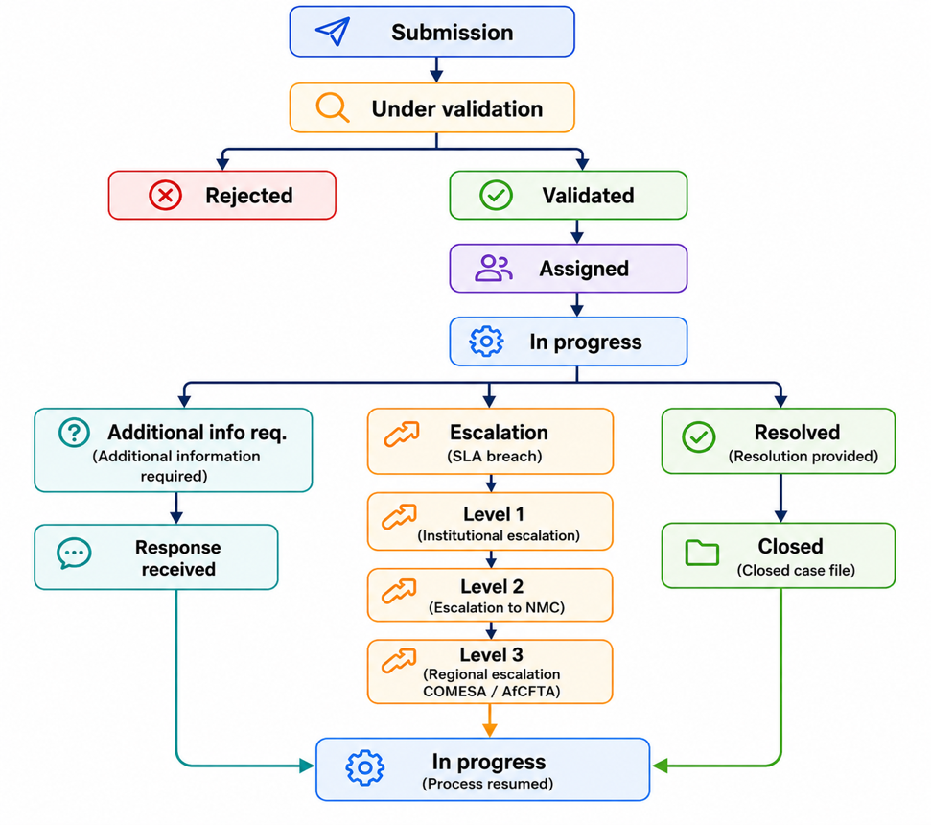
Figure 17: Simplified lifecycle workflow

Automatic actions of the workflow engine

Event | Automatic action
Submission of a complaint | Generation of the case number
Validation of the complaint | Automatic assignment according to the NTB category
Assignment | Notification of the responsible institution
State change | SMS and e-mail notification
SLA breach L1 | Automatic level 1 escalation
SLA breach L2 | Automatic escalation to the NMC
SLA breach L3 | Regional escalation COMESA/Tripartite and AfCFTA
Resolution | Notification of the declarant
Closure | Automatic archiving
Reopening | Creation of a new workflow sequence
Any modification | Recording in the audit log
Table 73: Events and automations of the NTB management system

Transition control rules
Reference | Rule
WSM-001 | A complaint can only be assigned after validation.
WSM-002 | A rejected complaint cannot be directly closed.
WSM-003 | Only the NMC can validate or reject a complaint.
WSM-004 | Only the responsible institution can declare a resolution.
WSM-005 | Only the NMC can officially close a case.
WSM-006 | Any escalation must be recorded in the audit log.
WSM-007 | A closed complaint cannot be modified without formal reopening.
WSM-008 | Any transition must be timestamped.
WSM-009 | The notifications associated with transitions are mandatory.
WSM-010 | Transitions not defined in this matrix are prohibited by the workflow engine.
Table 74: Management rules of the workflow engine of the NTB management system

Appendix D – UML Diagrams

D.1.1 Main Use Case Diagram
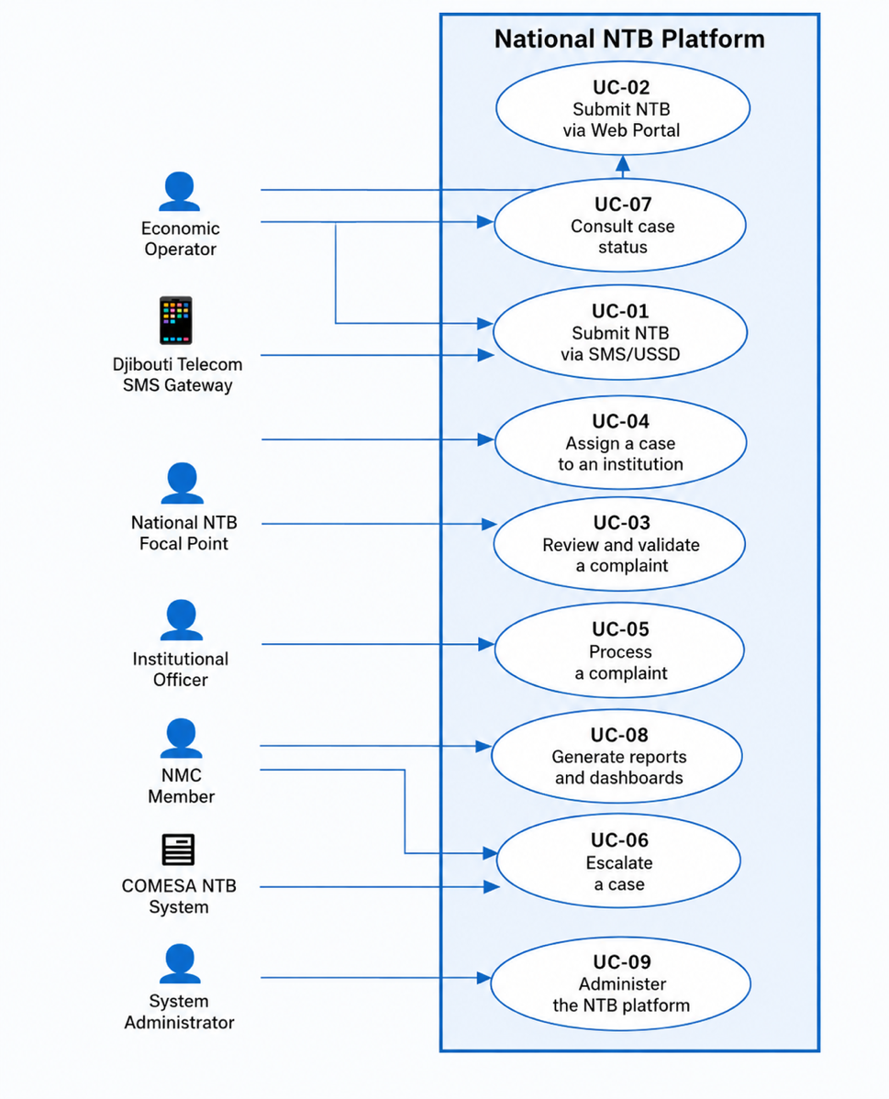
Figure 18: Use case diagram of the NTB platform

Identified actors:
- Economic operator (external primary actor)
- National NTB Focal Point (internal actor)
- Institutional agent (Customs, SPS, Ports, MTT)
- NMC member
- System administrator
- COMESA NTB system (external system actor)
- AfCFTA system (external system actor)
- SMS gateway / Djibouti Telecom
Main use cases included:
- UC-01 Report an NTB by SMS/USSD
- UC-02 Report an NTB via the Web portal
- UC-03 Verify and validate a complaint
- UC-04 Assign a case to the competent institution
- UC-05 Process a complaint
- UC-06 Escalate a case
- UC-07 Consult the status of a case
- UC-08 Generate reports and dashboards
- UC-09 Administer the NTB platform

D.1.2 Use Case Diagram – Report a Non-Tariff Barrier (NTB) via SMS/USSD
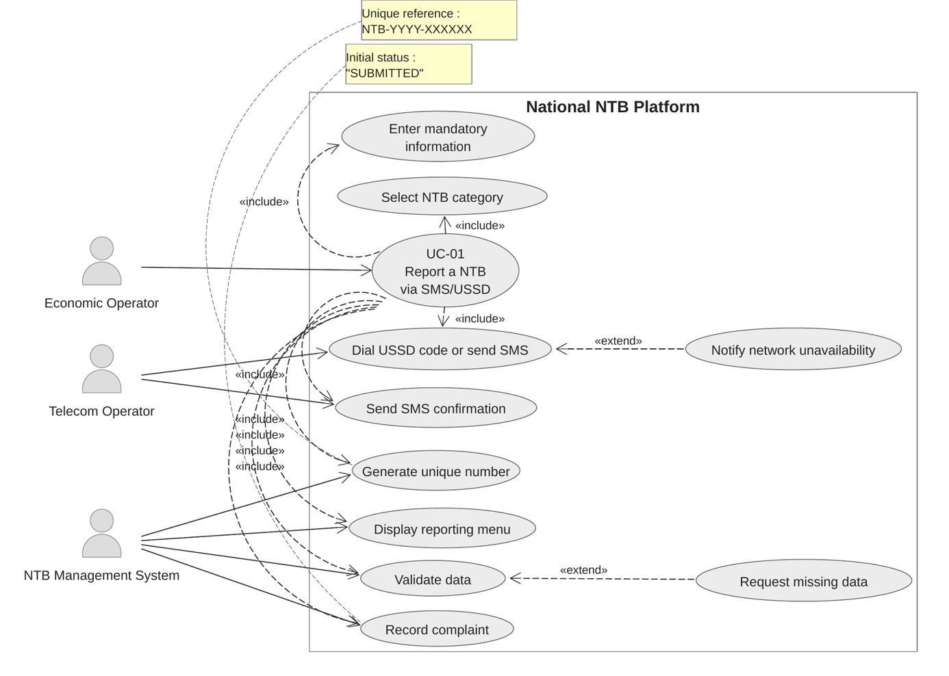
Figure 20: Report a Non-Tariff Barrier (NTB) by SMS/USSD

D.1.3 Use Case Diagram – Report an NTB via the Web Portal
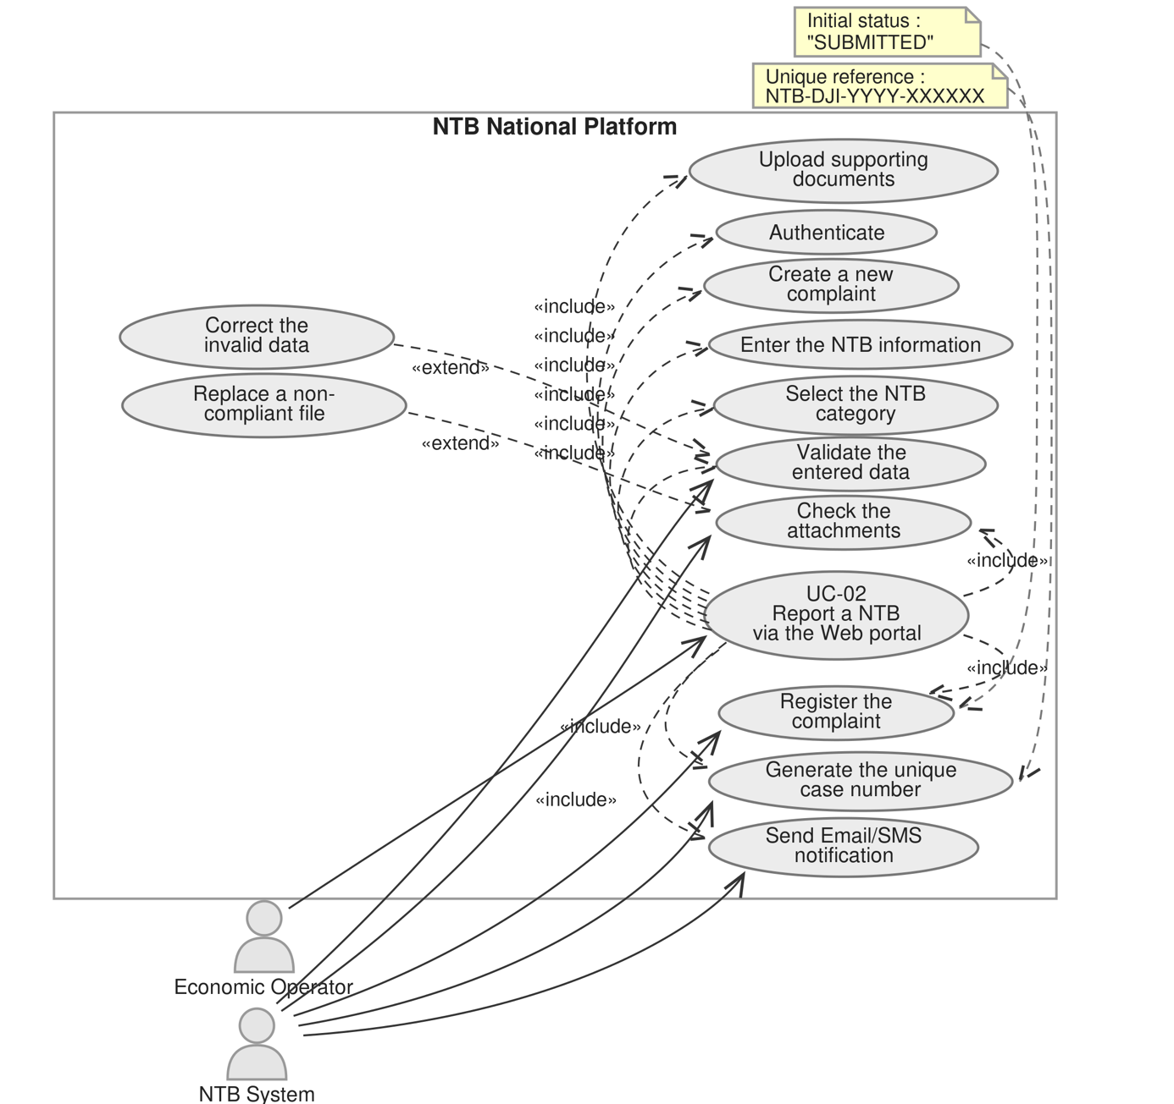
Figure 21: Report an NTB via the Web portal

D.1.4 Use Case Diagram – Report an NTB via the Web Portal
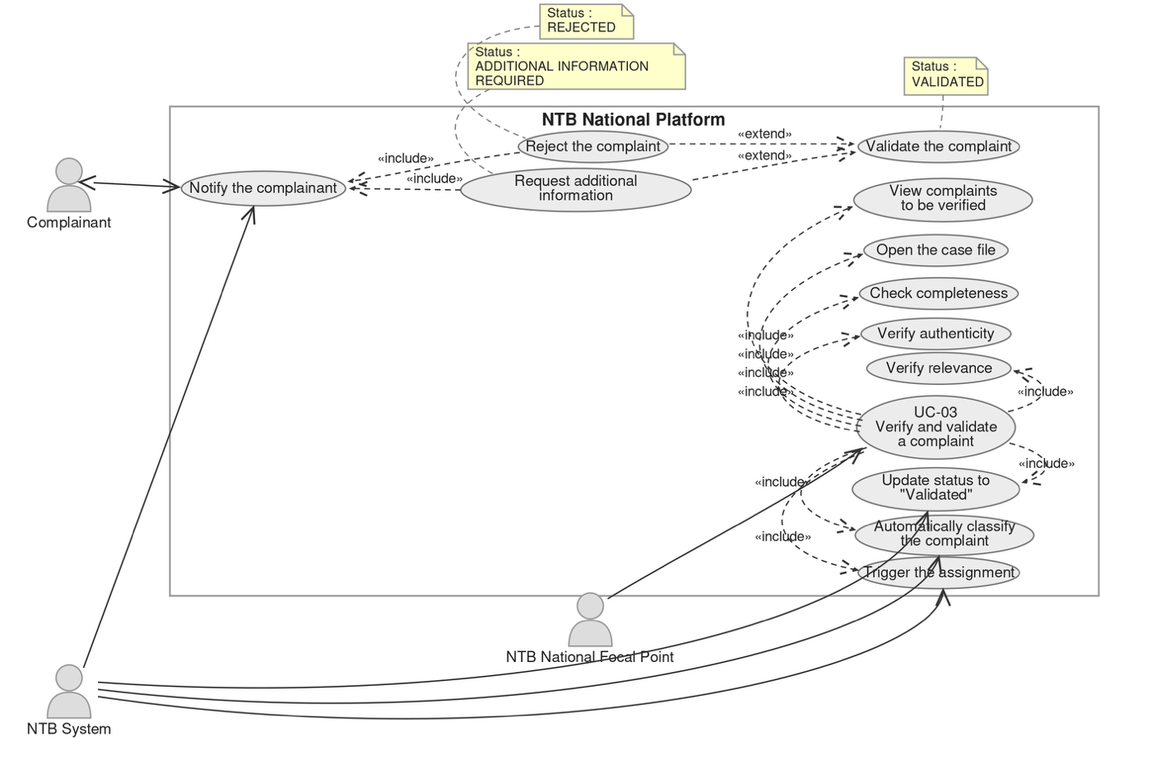
Figure 22: Verify and validate a complaint

D.1.5 Use Case Diagram – Assign a Case to the Competent Institution
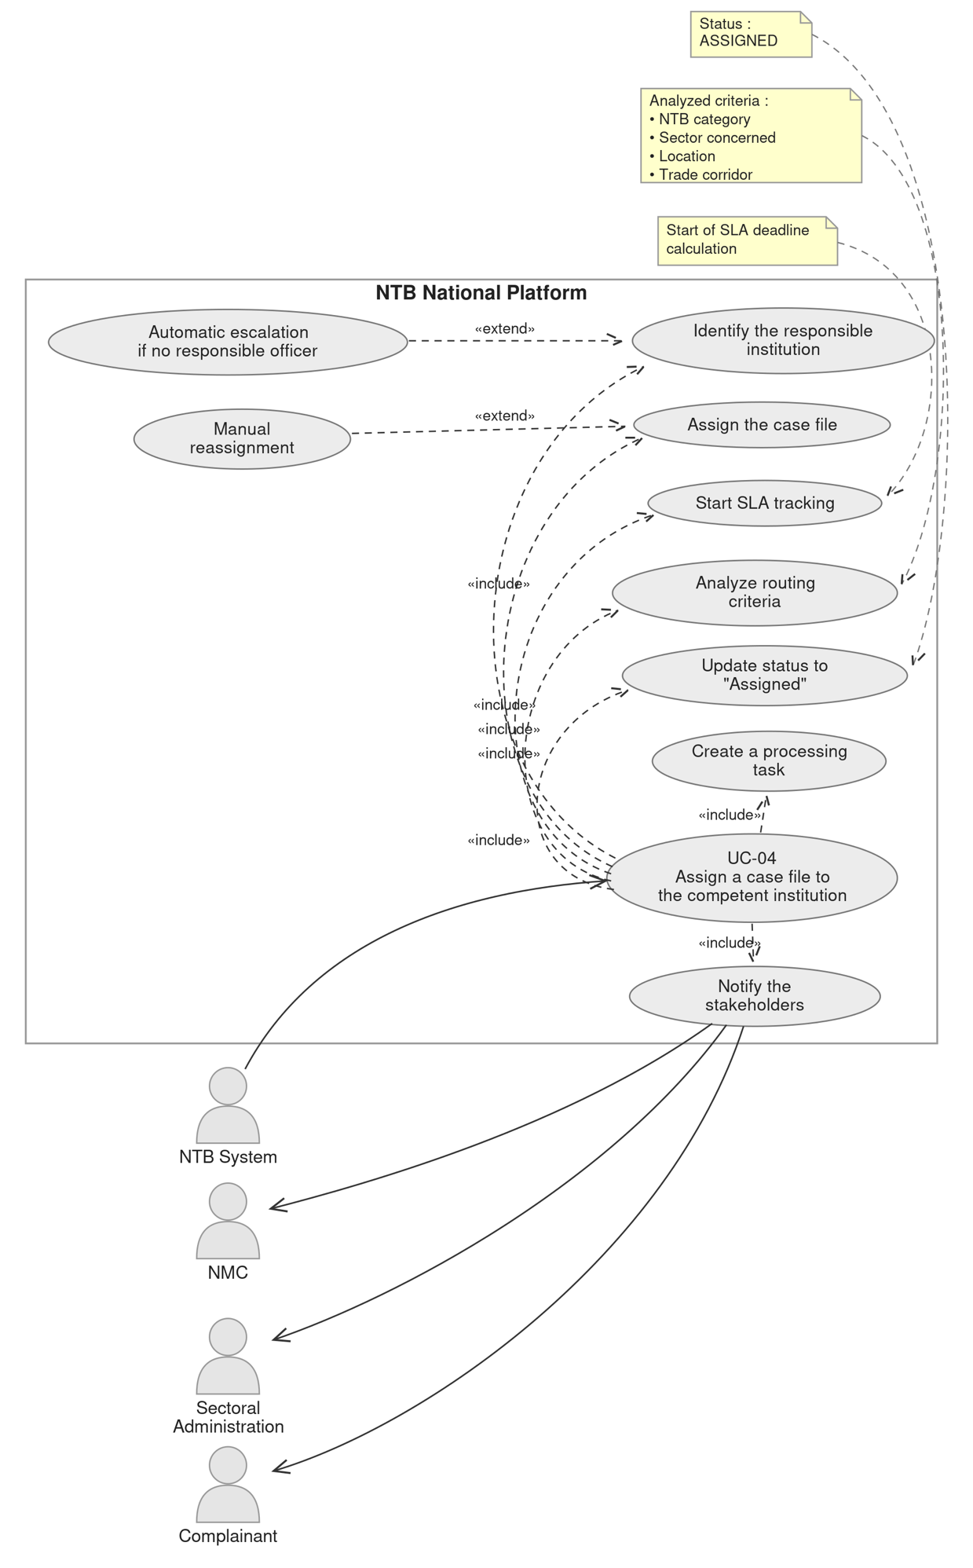
Figure 23: Assign a case to the competent institution

D.1.6 Use Case Diagram – Process a Complaint
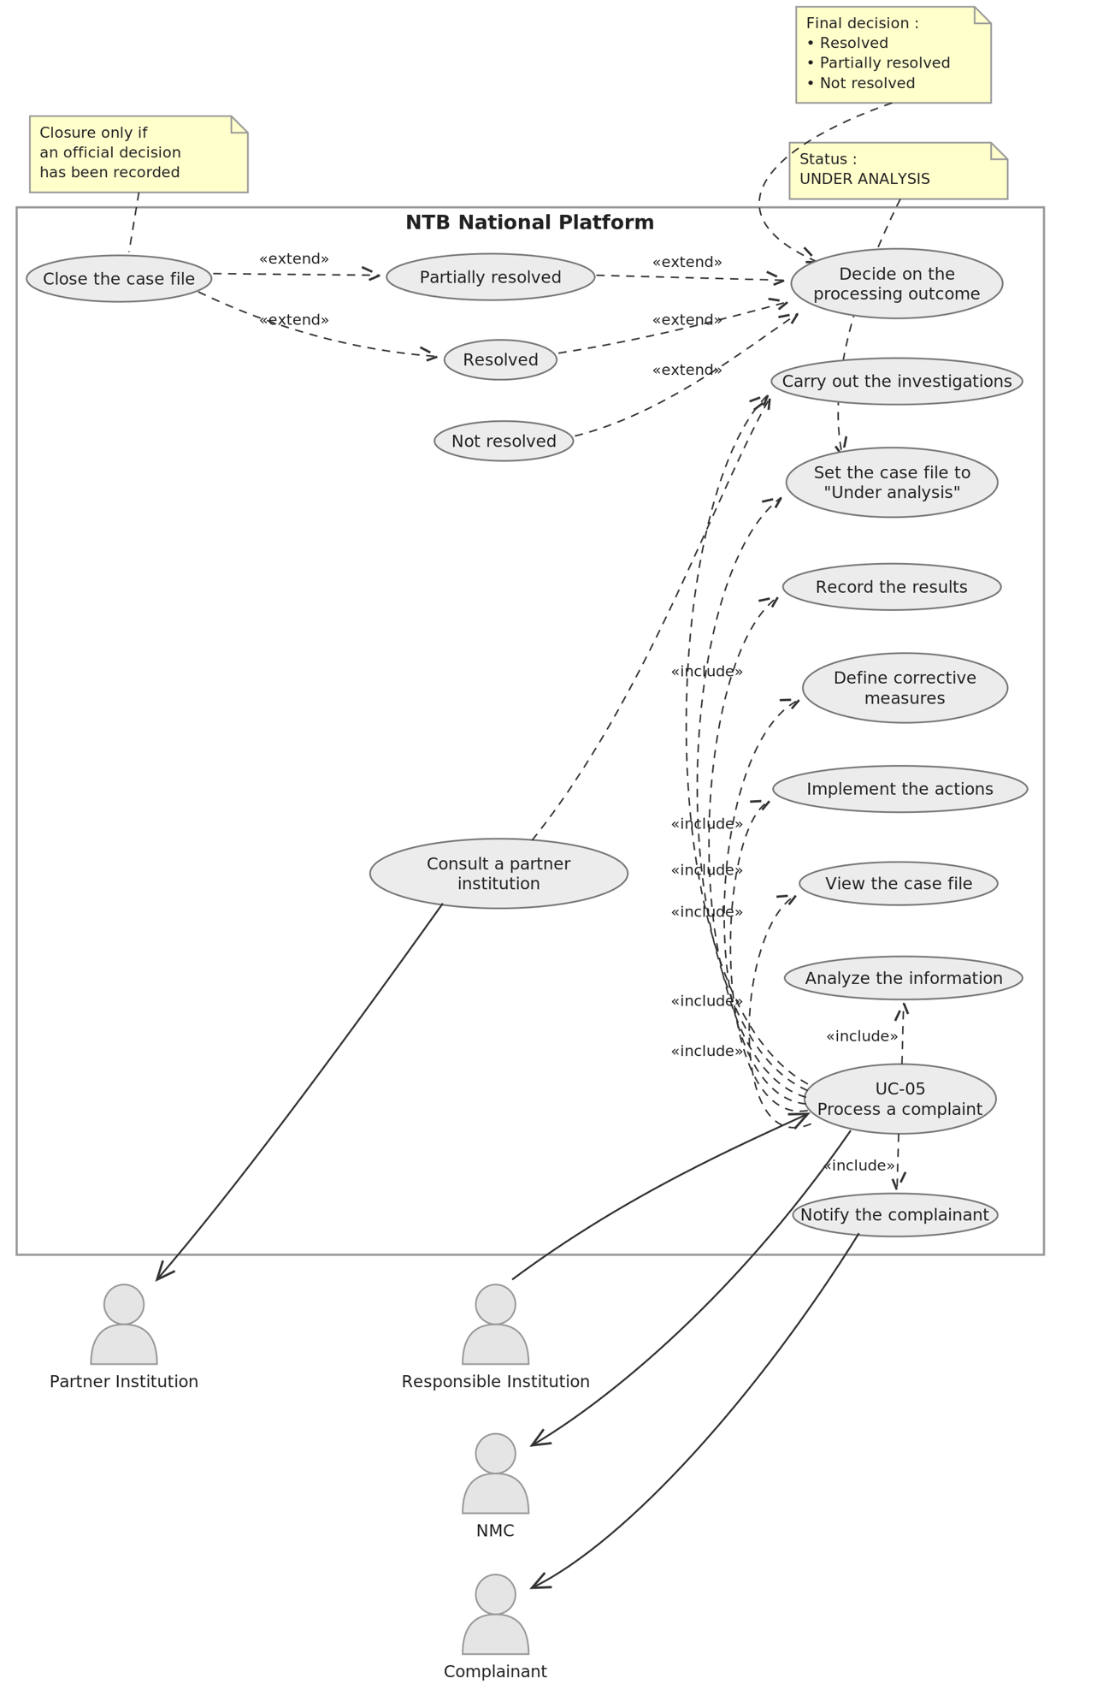
Figure 23: Process a complaint

D.1.7 Use Case Diagram – Escalate a Case
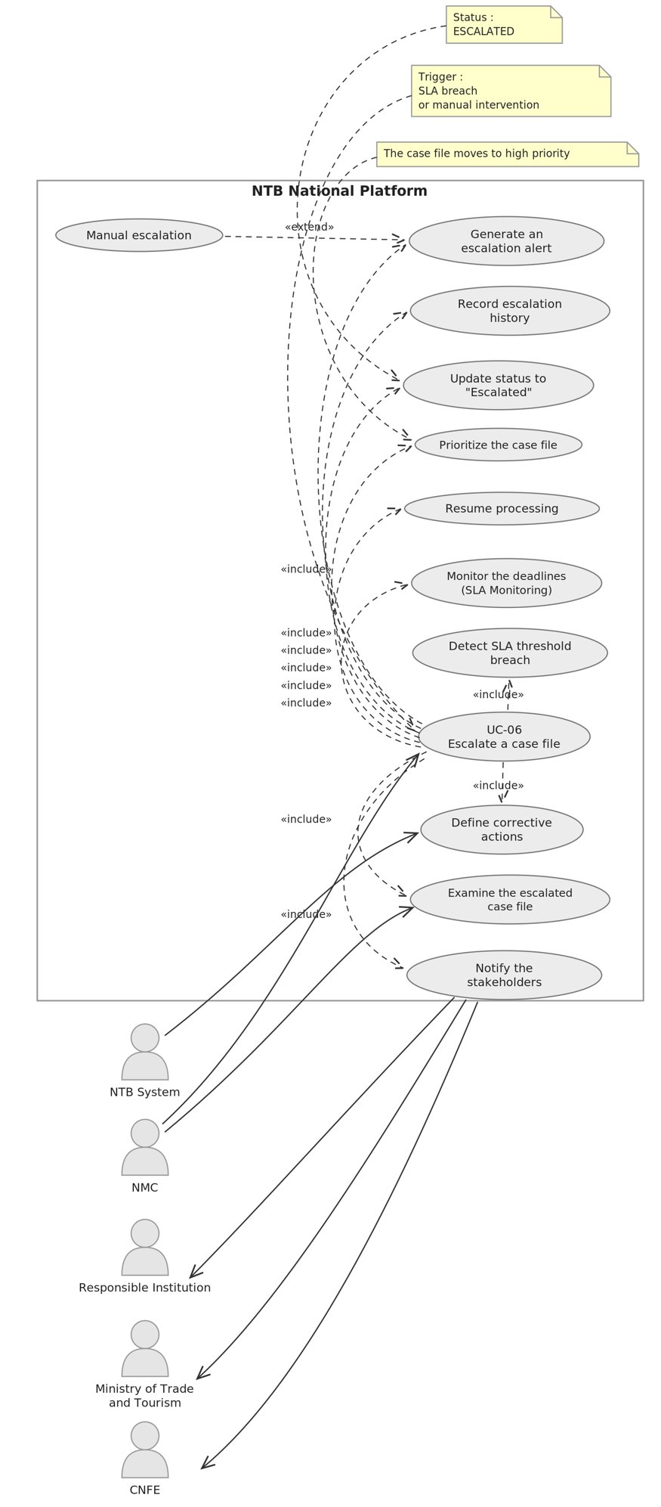
Figure 24: Escalate a case

D.2 Sequence Diagram

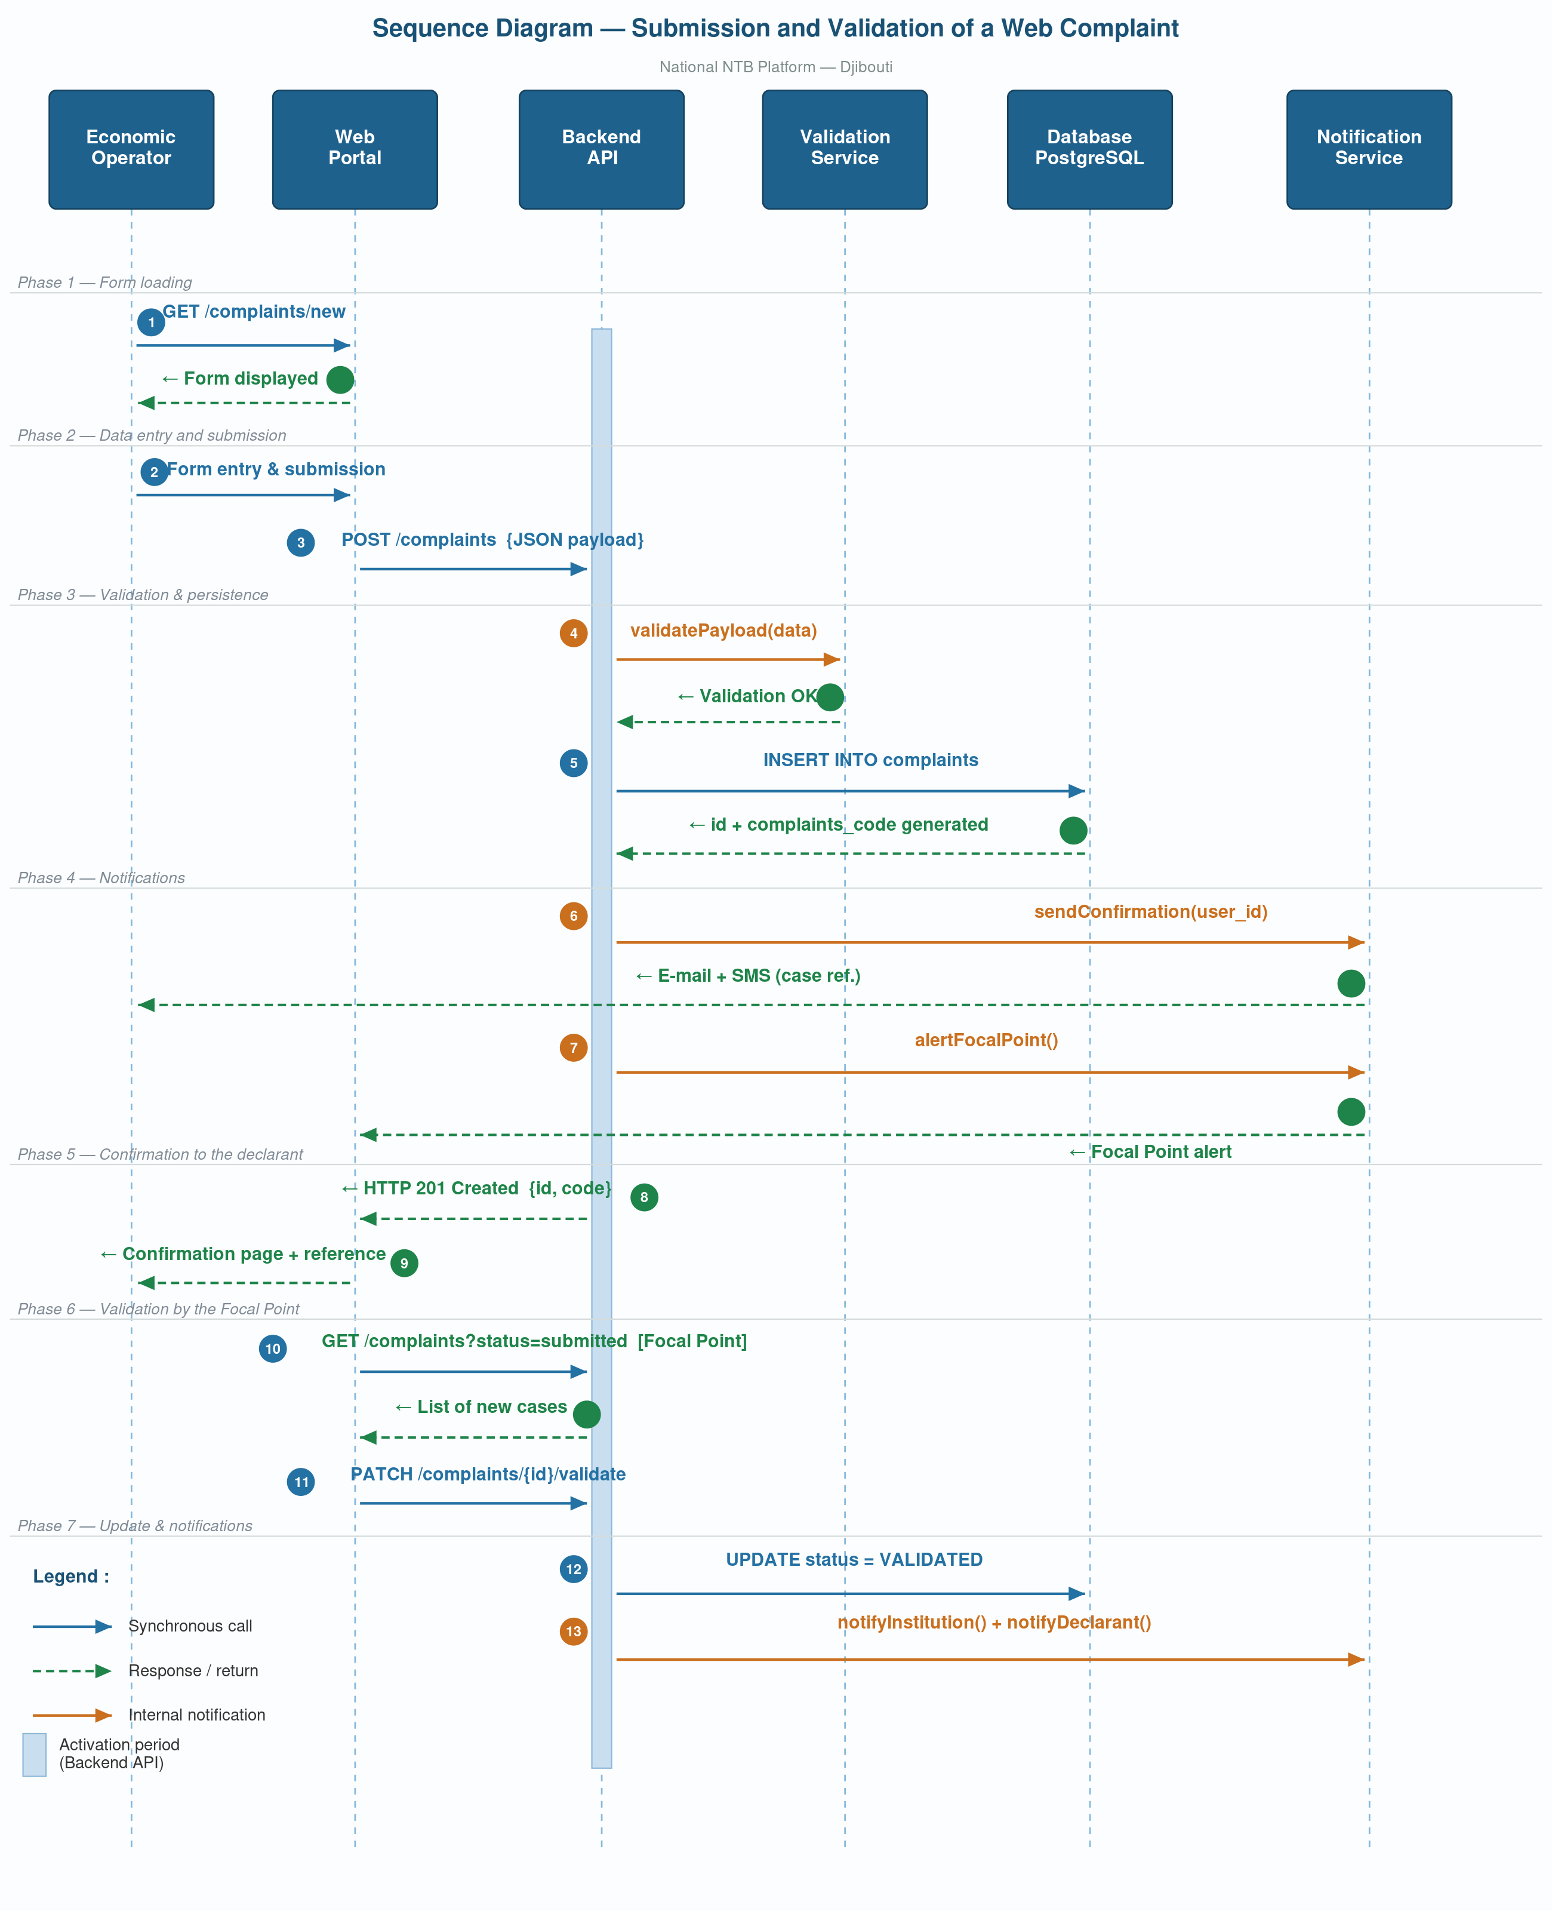
Figure 25: Sequence diagram: submission and validation of a Web complaint

# | Source actor → Target | Message / Call | Description
1 | Operator → Web Portal | GET /complaints/new | Loading of the submission form
2 | Web Portal → Backend API | POST /complaints | Sending of the completed form data
3 | Backend → Validation Service | validatePayload(data) | Verification of mandatory fields and formats
4 | Backend → Database | INSERT complaints | Recording of the case with SUBMITTED status
5 | Backend → Notification Service | sendConfirmation(user) | Sending of e-mail and SMS confirmation to the declarant
6 | Backend → Notification Service | alertFocalPoint() | Notification to the National Focal Point
7 | Focal Point → Portal (Dashboard) | GET /complaints?status=submitted | Consultation of the list of new cases
8 | Focal Point → Backend API | PATCH /complaints/{id}/validate | Validation of the case after examination
9 | Backend → Workflow Engine | transition(VALIDATED) | Status update and triggering of assignment
10 | Workflow Engine → Rule Engine | assignInstitution(complaint) | Identification of the competent institution
11 | Workflow Engine → Notification Service | notifyInstitution() + notifyDeclarant() | Simultaneous notifications to the institution and the declarant
Table 75: Functional sequence identification of the NTB management system

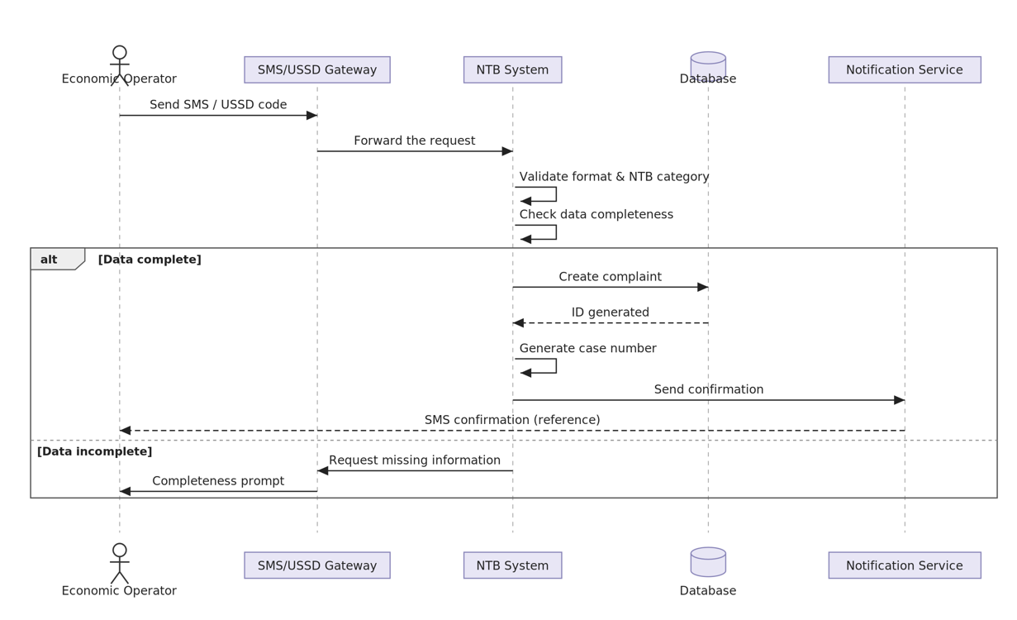
Figure 26: Report an NTB by SMS/USSD
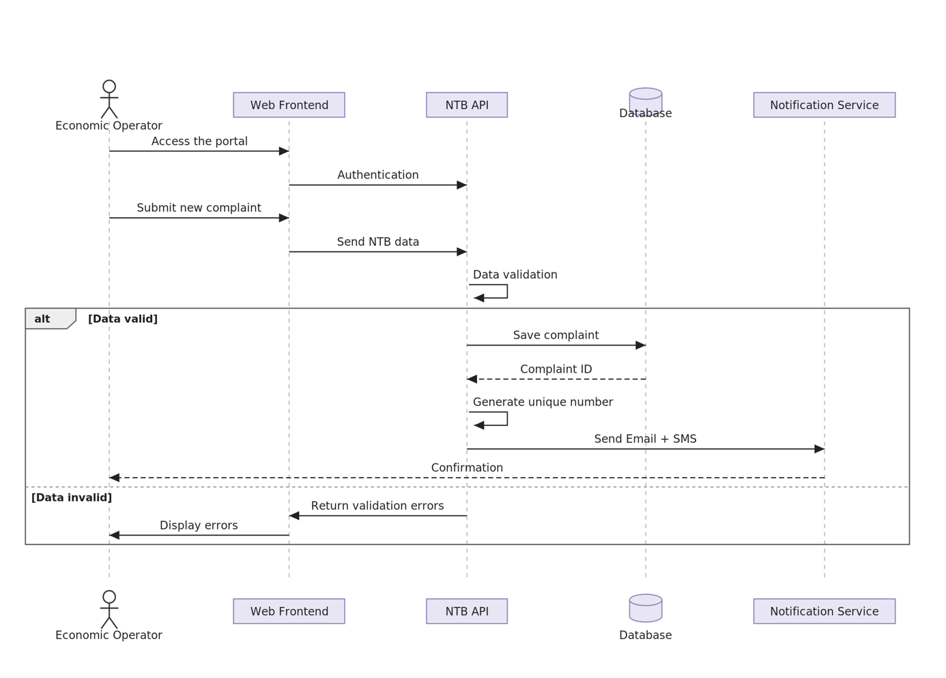
Figure 27: Report an NTB via Web portal

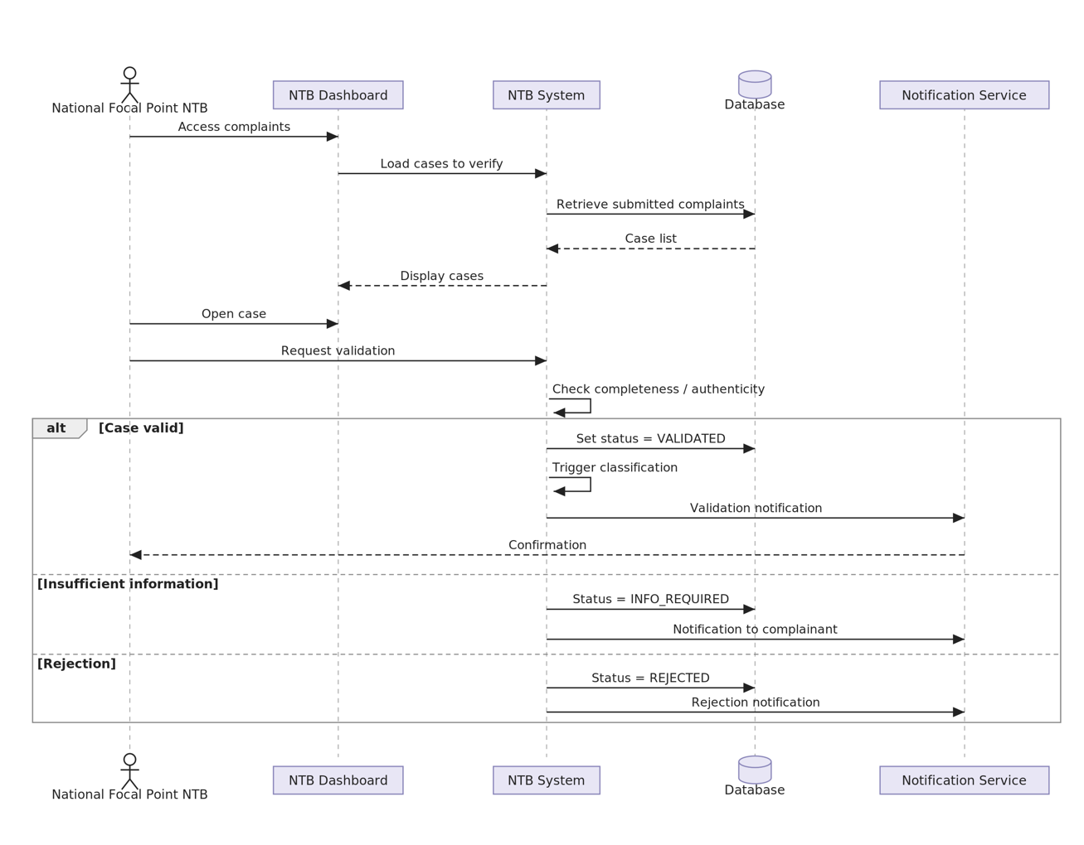
Figure 28: Verify and validate a complaint
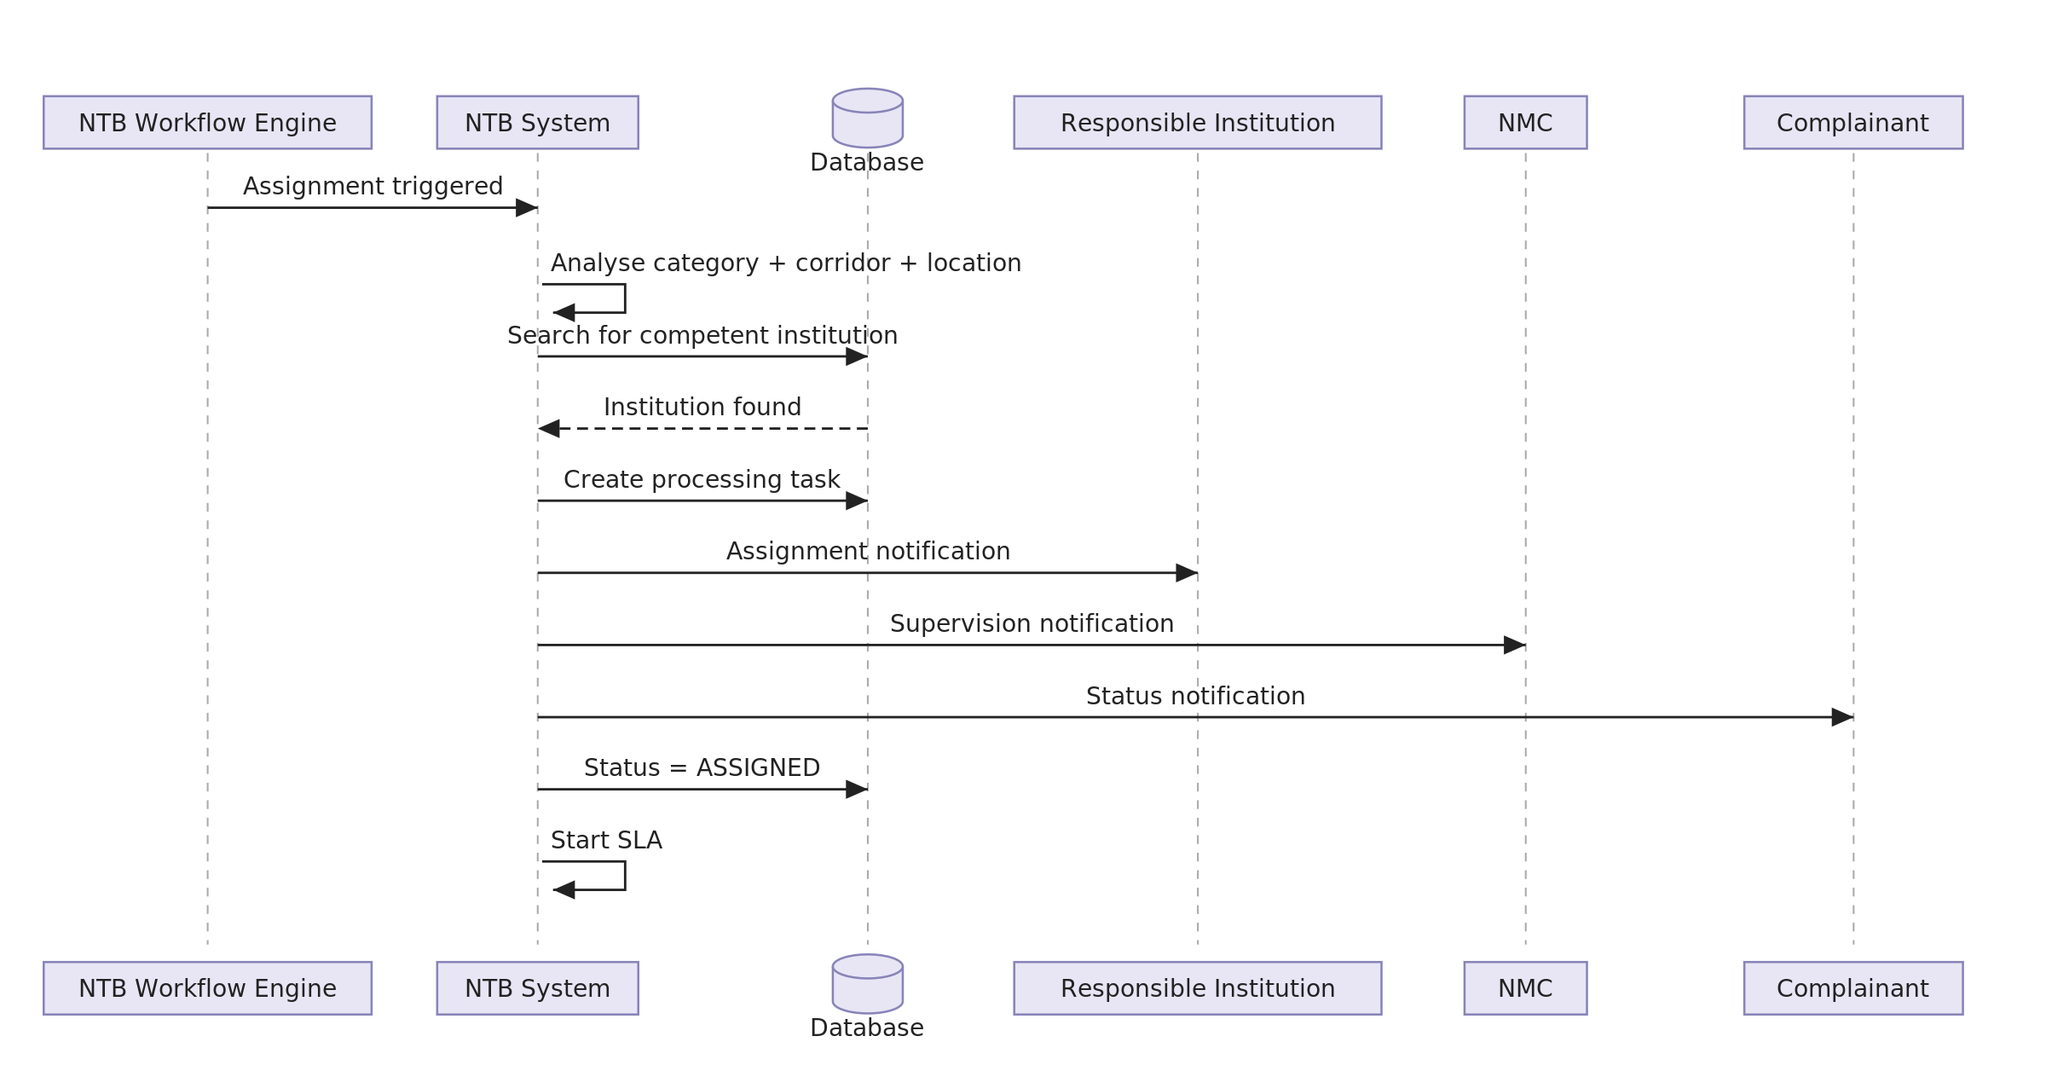
Figure 29: Automatic assignment of a case

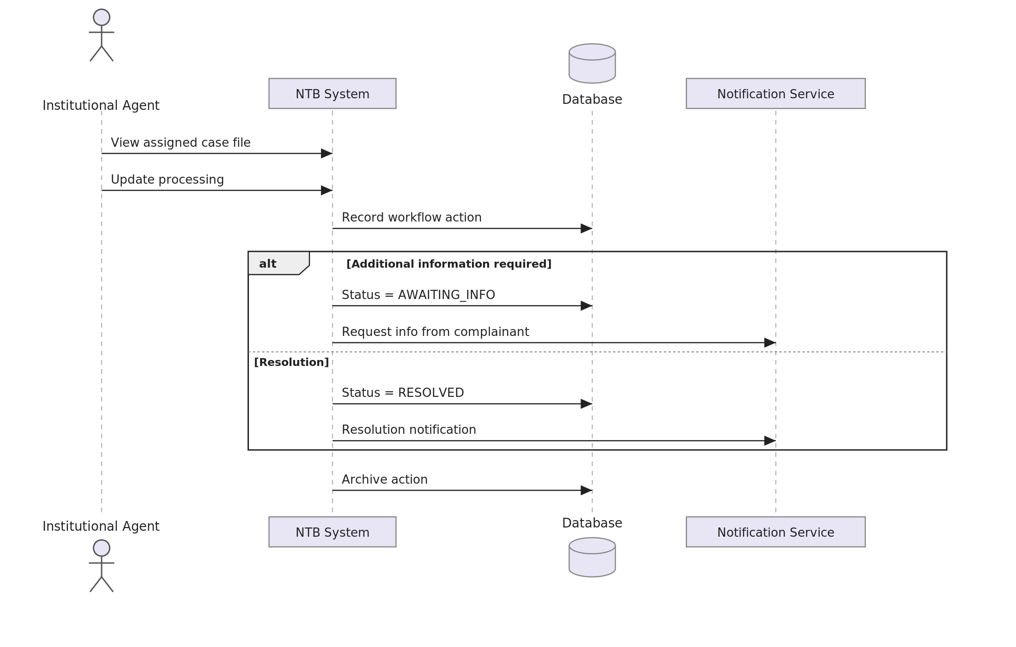
Figure 30: Processing of a complaint

D.3 Activity Diagram: Lifecycle of an NTB Case
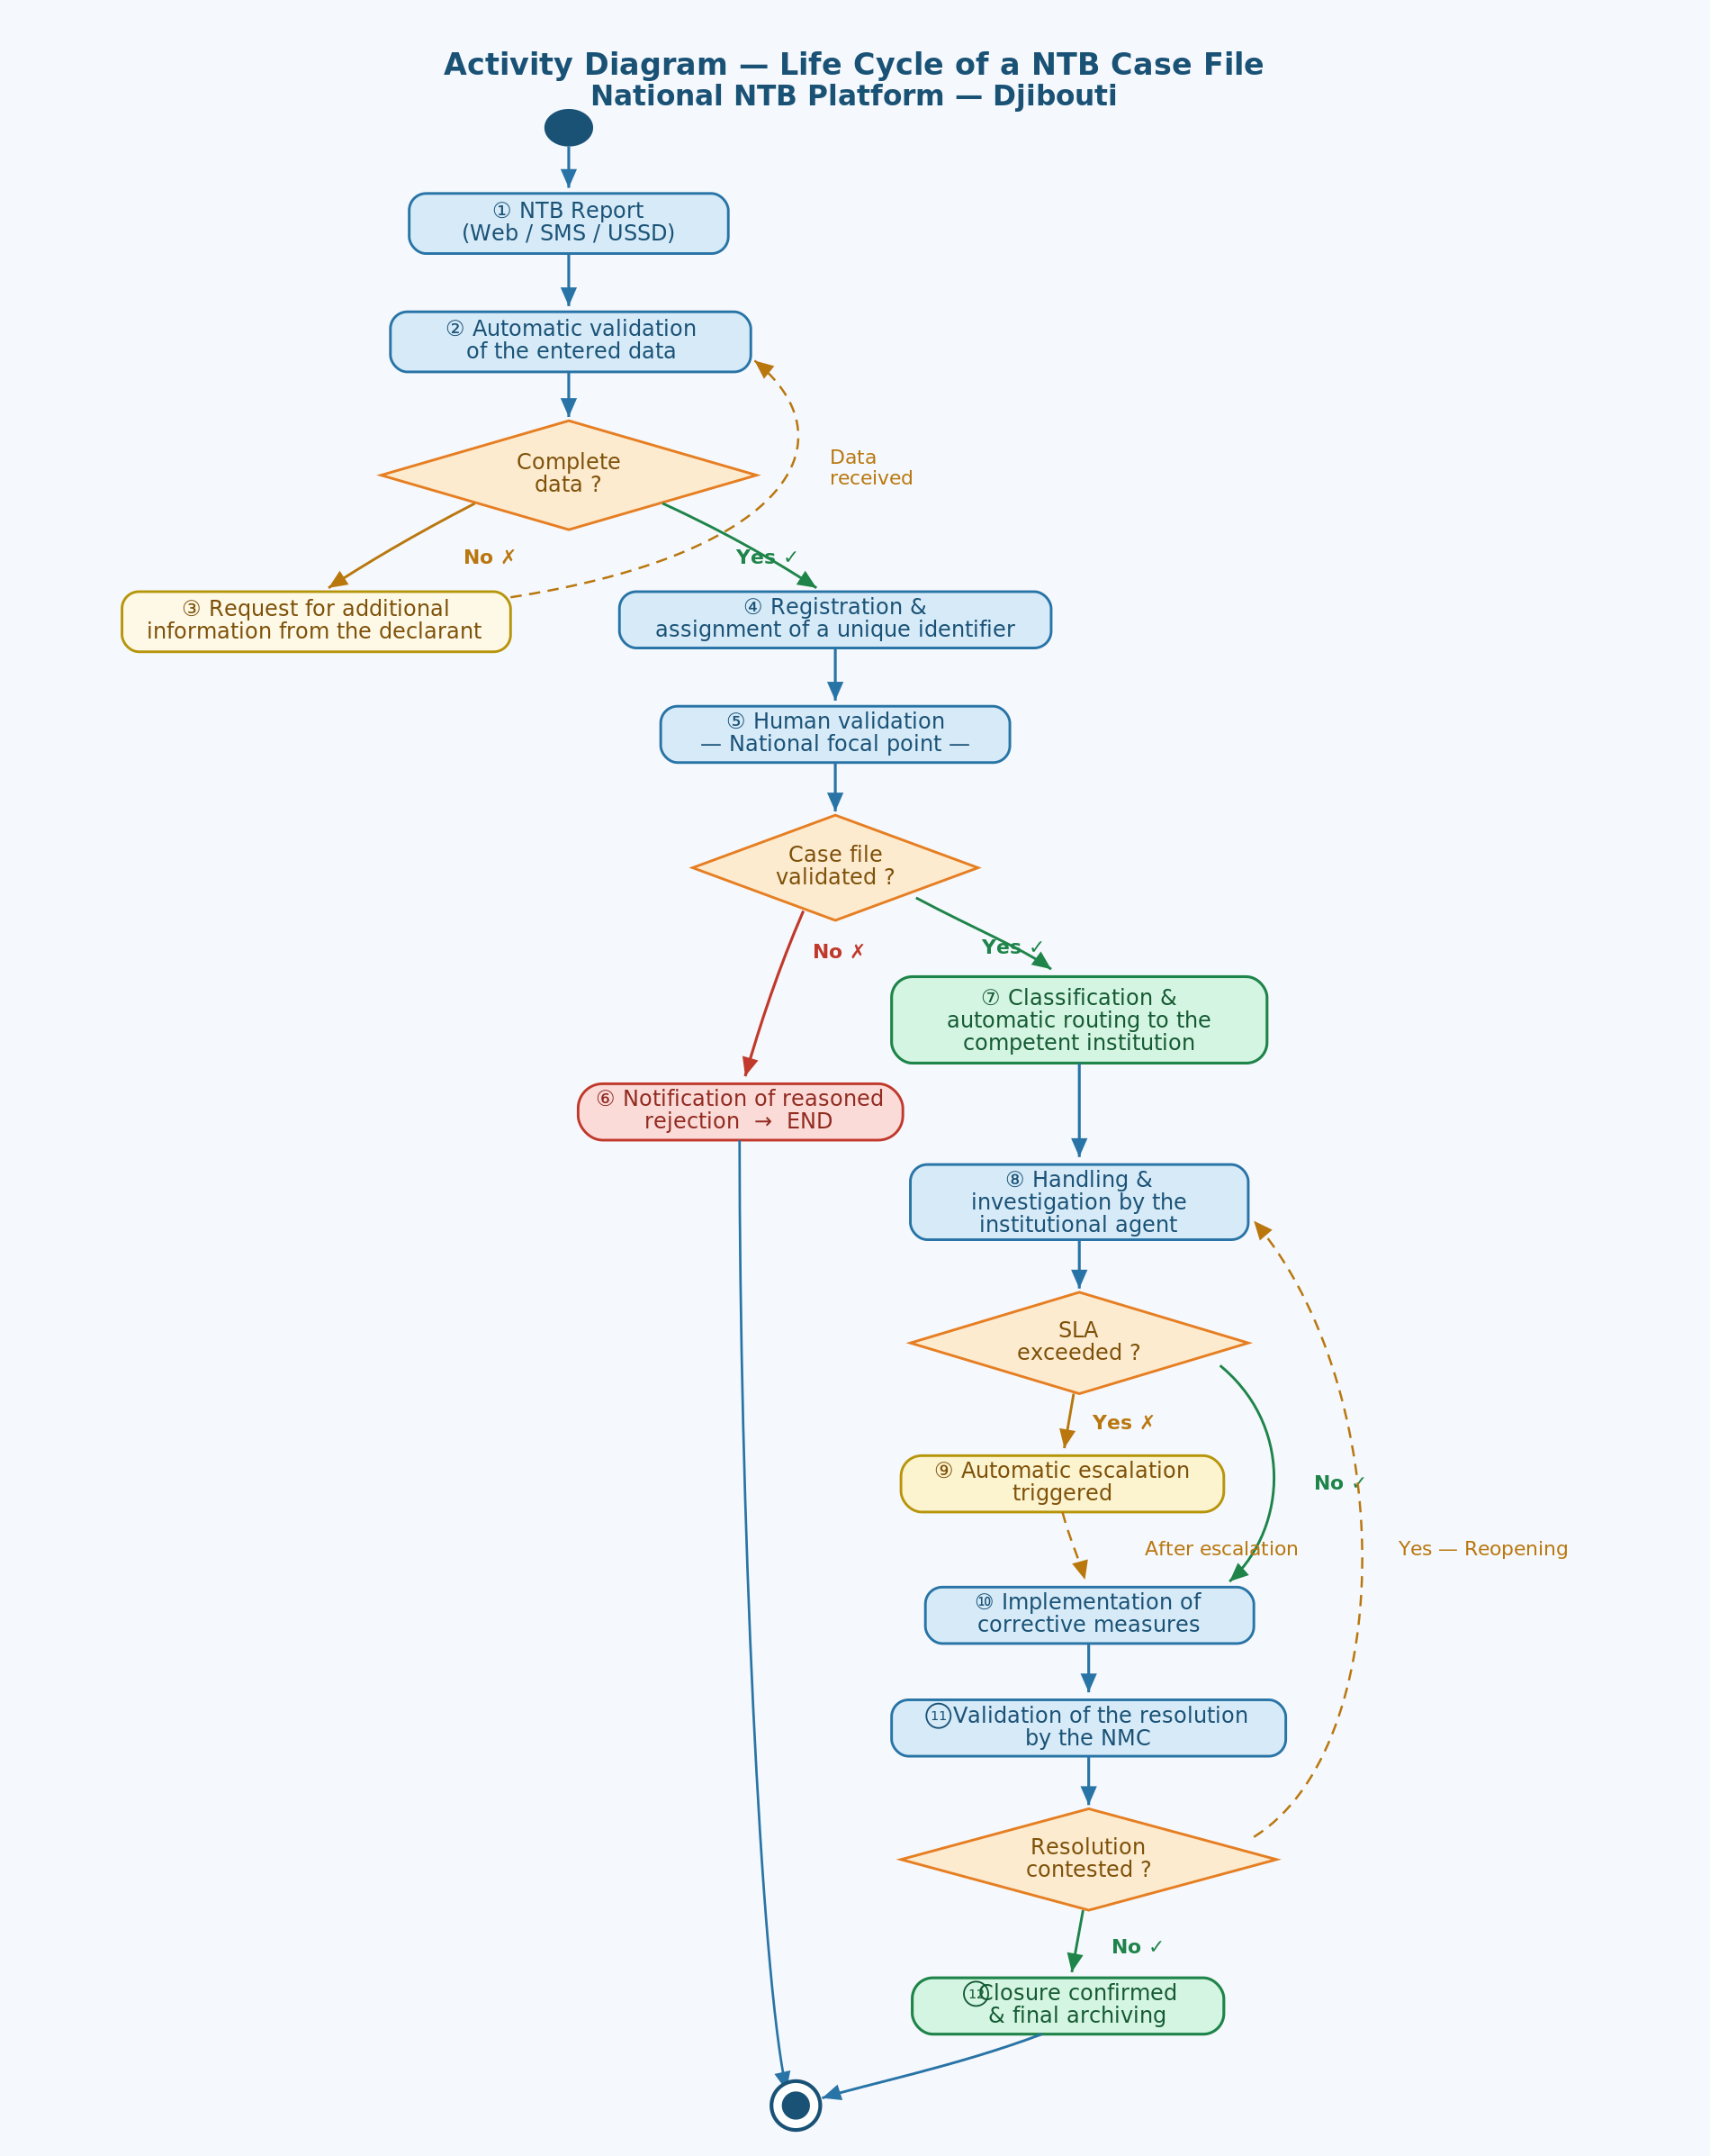
Figure 31: Activity diagram: lifecycle of an NTB case

Stage | Description of the activity
1 | Start: Reporting of the NTB (Web, SMS, USSD)
2 | Automatic validation of the entered data
3 | [If incomplete] Request for additional information from the declarant
4 | [If complete] Recording and assignment of a unique identifier
5 | Human validation by the National Focal Point
6 | [If rejected] Reasoned notification to the declarant — End
7 | Classification and automatic routing to the competent institution
8 | Handling and investigation by the institutional agent
9 | [If SLA exceeded] Automatic triggering of escalation
10 | Implementation of corrective measures
11 | Validation of the resolution by the NMC
12 | [If contested] Reopening of the case → return to step 8
13 | Closure confirmed and archiving — End
Table 76: Flow identification of the NTB management process

D.4 Diagram of the main classes
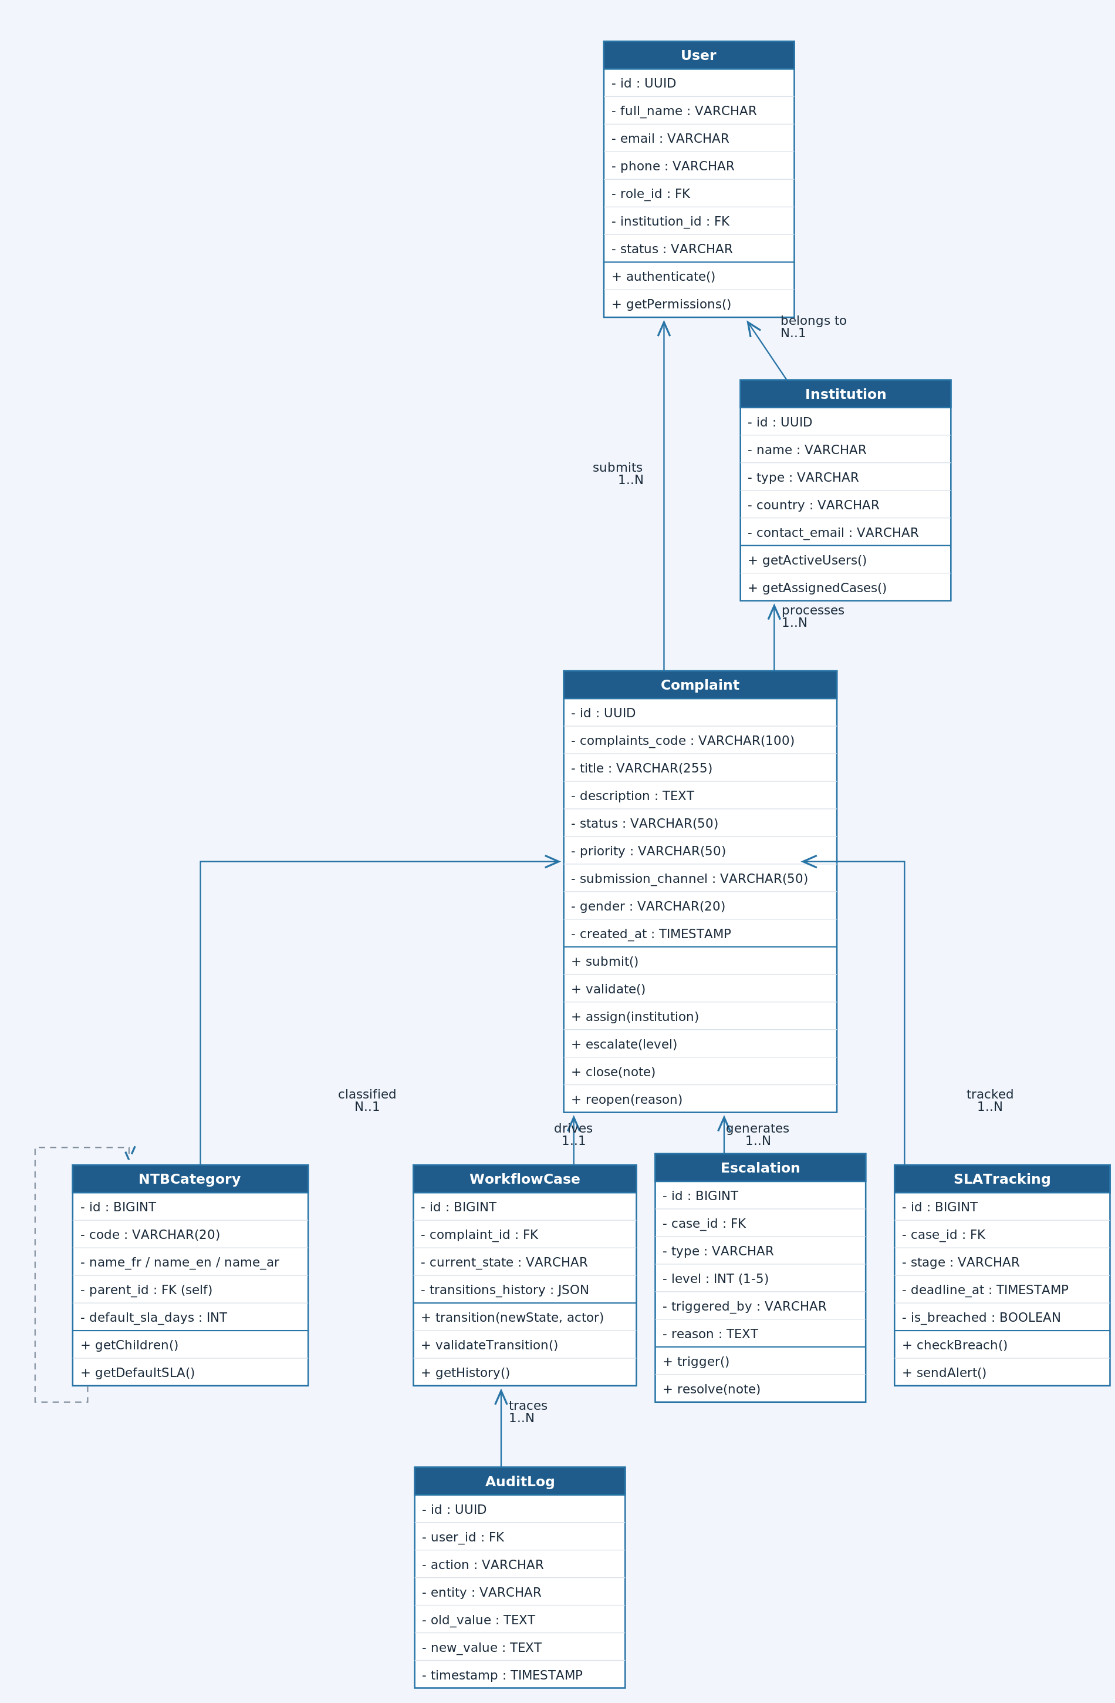
Figure 32: Main class diagram of the NTB platform
Key classes and relationships:
Class | Description and relationships
Complaint | Central class. Attributes: id, code, title, description, status, priority, channel. Methods: submit(), validate(), assign(), escalate(), close(), reopen()
User | Represents any user of the system. Attributes: id, name, email, phone, role, institution. Inherited into: Operator, FocalPoint, InstitutionAgent, NMCMember, Admin
Institution | Public or private body participating. Attributes: id, name, type, country, contact. 1-N relationship with User and Complaint
NTBCategory | 3-level hierarchy. Attributes: code, name_fr, parent, sla_days, responsible_institution
WorkflowCase | Manages state transitions. Attributes: complaint_id, current_state, transitions_history. Method: transition(new_state, actor)
Escalation | Escalation of a case. Attributes: type, level, triggered_by, reason, institutions. Method: trigger(), resolve()
SLATracking | Timeframe tracking. Attributes: stage, target_hours, started_at, deadline_at, is_breached. Method: checkBreach(), sendAlert()
Notification | Message sent to the parties. Attributes: type, channel, recipient, content, sent_at, is_read
AuditLog | Immutable log. Attributes: user_id, action, entity, old_value, new_value, ip, timestamp
Table 77: UML class identification of the NTB management system

Appendix E – Report Catalogue

This catalogue lists all the reports available on the NTB platform, their generation frequency, the authorised recipients and the export formats.

ID | Report title | Category | Frequency | Recipients | Format(s)
RPT-01 | Daily operational dashboard | Operational | Daily (auto) | Focal point, NMC | Web, PDF
RPT-02 | List of open cases by institution | Operational | Weekly (auto) | MTT, NMC, Institutions | Excel, PDF
RPT-03 | Cases in SLA breach | Operational | Daily (auto) | NMC, Institutions | Web, PDF, Email
RPT-04 | Escalated cases in progress | Operational | Real time | NMC | Web
RPT-05 | Full history of a case | Operational | On demand | Stakeholders concerned | PDF
RPT-06 | Monthly activity report | Strategic | Monthly (auto) | MTT, NMC, TMA | PDF, Excel
RPT-07 | Quarterly evaluation report | Strategic | Quarterly (auto) | MTT, Government, TMA | PDF
RPT-08 | National annual NTB report | Strategic | Annual (auto) | MTT, COMESA, AfCFTA | PDF
RPT-09 | Sectoral report by NTB type | Strategic | Quarterly | MTT, NMC | PDF, Excel
RPT-10 | COMESA regional report | Strategic | Monthly | COMESA NTB Unit | PDF, JSON
RPT-11 | AfCFTA continental report | Strategic | Quarterly | AfCFTA NTB Unit | PDF, JSON
RPT-12 | Analysis of NTB trends | Analytical | Monthly | MTT, NMC, Decision-makers | Web, PDF
RPT-13 | Analysis of recurring causes | Analytical | Quarterly | NMC, MTT | PDF
RPT-14 | Evolution of resolution timeframes | Analytical | Monthly | NMC, Institutions | Web, Excel
RPT-15 | Performance analysis by institution | Analytical | Monthly | NMC, Institutions | Web, PDF, Excel
RPT-16 | Geographic mapping of NTBs | Analytical | Monthly | MTT, Decision-makers | Web (interactive map), PDF
RPT-17 | Analysis of affected corridors | Analytical | Monthly | MTT, NMC | Web, PDF
RPT-18 | Estimated economic impact of NTBs | Analytical | Quarterly | Government, TMA | PDF
RPT-19 | Statistics disaggregated by gender | Gender and inclusion | Monthly | MTT, TMA, UNFD | Excel, PDF
RPT-20 | Share of NTBs reported by women traders | Gender and inclusion | Quarterly | MTT, TMA | PDF
RPT-21 | Analysis of NTBs by informal sector | Gender and inclusion | Quarterly | MTT, TMA | PDF
RPT-22 | MTT executive dashboard | Dashboard | Real time | Minister, Secretary General | Web
RPT-23 | NMC dashboard | Dashboard | Real time | NMC members | Web
RPT-24 | Institutional dashboard | Dashboard | Real time | Agents and managers | Web
RPT-25 | SLA compliance report | Audit / Compliance | Weekly | NMC, MTT | PDF, Excel
RPT-26 | Security audit logs | Audit / Compliance | Monthly | ISS Officer | Secure PDF
RPT-27 | Penetration test report | Audit / Compliance | Half-yearly | ISS Officer, MTT | Confidential PDF
RPT-28 | API and integrations activity report | Technical | Weekly | ICT Team | Excel, PDF
RPT-29 | System availability report | Technical | Monthly | MTT, ICT Team | PDF
RPT-30 | Export of raw NTB data | Data export | On demand | RBAC authorised | CSV, Excel, JSON
Table 78: Report catalogue of the NTB management system

Appendix F – Security Matrix
The security matrix defines the permissions assigned to each application role for all the platform's features. It constitutes the reference for the RBAC (Role-Based Access Control) model implemented in the system.
Legend: C = Create | R = Read | M = Modify | D = Delete | E = Execute | — = No access
Feature / Resource | Operator | Focal point | NTB Agent | NMC | Analyst | SYS Admin | MTT Admin
Submit an NTB complaint | C | — | — | — | — | — | —
Consult one's own cases | R | R | R | R | R | R | R
Modify a complaint (before validation) | M | M | — | — | — | — | —
Validate / reject a complaint | — | E | — | E | — | — | —
Assign a case | — | E | — | E | — | — | —
Process / update a case | — | — | M | M | — | — | —
Close a case | — | — | E | E | — | — | —
Reopen a case | — | E | — | E | — | — | —
Trigger a manual escalation | — | E | E | E | — | — | E
Consult all cases | — | R | R | R | R | R | R
Access the audit logs | — | — | — | R | R | R | R
Consult the operational dashboards | — | R | R | R | R | R | R
Access the executive dashboard | — | — | — | R | — | — | R
Generate reports | — | R | R | R | R | — | R
Export data (CSV/Excel) | — | — | — | E | E | E | E
Manage users | — | — | — | — | — | CLMS | C
Manage roles and permissions | — | — | — | — | — | CLMS | —
Configure institutions | — | — | — | — | — | CLMS | CLMS
Configure NTB categories | — | — | — | — | — | CLMS | CLMS
Configure SLAs | — | — | — | — | — | CLMS | CLMS
Configure notifications | — | — | — | — | — | CLMS | CLMS
Manage API integrations | — | — | — | — | — | CLMS | —
Access system logs | — | — | — | — | — | R | —
Configure workflows | — | — | — | — | — | CLMS | CLMS
Manage backups | — | — | — | — | — | E | —
Consult the infrastructure | — | — | — | — | — | R | —
COMESA / AfCFTA synchronisation | — | — | — | E | — | E | E
Table 79: Access control (RBAC) of the NTB management system

Appendix G – Requirements Traceability Matrix (RTM)

The Requirements Traceability Matrix (RTM) ensures that each business requirement is covered by corresponding functional requirements, use cases and test cases.

BR ID | Business requirement (summary) | FR ID / Module | Use case | Test case | Status
BR-001 | Single national reporting mechanism | CM-001, CM-002, CM-003 | UC-01, UC-02 | TC-001, TC-002, TC-003 | Validated
BR-002 | Multi-channel reporting (Web, SMS, Mobile) | CM-001, CM-002, SMS module | UC-01, UC-02 | TC-001, TC-010 | Validated
BR-003 | SME and informal sector accessibility | ACC module, SMS/USSD | UC-01 | TC-010, TC-011 | Validated
BR-004 | Full lifecycle traceability | CM-013, Audit AC-001 to 006 | UC-03 to UC-07 | TC-020 | Validated
BR-005 | Reduction of timeframes through automation | WF module, SLA module | UC-04, UC-06 | TC-030, TC-031 | Validated
BR-006 | Automatic assignment of cases | WF-001, Rule engine | UC-04 | TC-030 | Validated
BR-007 | Automatic escalation of overdue cases | SLA-003, Escalation module | UC-06 | TC-031, TC-032 | Validated
BR-008 | Real-time visibility on cases | DB-001, DB-002 | UC-07, UC-08 | TC-040 | Validated
BR-009 | Reliable national statistics | Analytics module, RPT-06 to RPT-11 | UC-08 | TC-041, TC-042 | Validated
BR-010 | COMESA, AfCFTA, ASYCUDA integration | INT-001 to INT-005 | UC-09 | TC-050, TC-051 | In progress
BR-011 | Standardised COMESA categorisation | CM-004, NTB_Categories | UC-03 | TC-005 | Validated
BR-012 | Gender-disaggregated data | CM-008, RPT-19 to 21 | UC-08 | TC-043 | Validated
BR-013 | Institution dashboards | DB-001, DB-002, DB-003 | UC-08 | TC-040 | Validated
BR-014 | Advanced analysis capabilities | Analytics module, DB-004 | UC-08 | TC-041 to 045 | Validated
BR-015 | Data confidentiality and protection | Sec reqs 8.5, IAM 12.1–12.4 | UC-09 | TC-060, TC-061 | Validated
BR-016 | Automatic follow-up notifications | Notif module, 5.3.3 | UC-04, UC-05, UC-06 | TC-070 | Validated
BR-017 | Full history of exchanges | CM-013, AuditLog | UC-07 | TC-020 | Validated
BR-018 | 24/7 availability | NFR 8.3, Hosting 8.15 | — | TC-080 | Validated
BR-019 | Accessibility for people with disabilities | ACC module, WCAG 2.1 | UC-01, UC-02 | TC-090 | In progress
BR-020 | Two-way communication | Notif module, CM-010 | UC-05, UC-07 | TC-071 | Validated
BR-021 | Interoperability of national systems | INT module, 5.9 | — | TC-050 | In progress
BR-022 | Scalability to other corridors | NFR 8.2, Architecture 9.2 | — | TC-081 | Planned
BR-023 | NTB programme monitoring-evaluation | Analytics, RPT-07, RPT-08 | UC-08 | TC-044 | Validated
Table 80: Requirements traceability of the NTB management system

RTM statuses: Validated = requirement covered and tested | In progress = partial coverage | Planned = scheduled in later phases

Appendix H – Test Cases
This catalogue presents the representative test cases for the critical features of the NTB platform. Exhaustive test cases are formalised in the test management tool (Jira or equivalent).
TC ID | Title | Precondition | Main steps | Expected result | Priority
TC-001 | Submission of a valid Web complaint | User logged in, categories configured | 1. Access the form  2. Complete all fields  3. Upload a PDF document 4. Submit | Case created with unique identifier, confirmation e-mail sent, status “Submitted” | Critical
TC-002 | Submission with a missing mandatory field | User logged in | 1. Access the form  2. Omit the description  3. Attempt to submit | Error message displayed indicating the missing field, submission blocked | Critical
TC-003 | Submission of a file exceeding the size limit | User logged in | 1. Upload a file > admin max size  2. Submit | Format/size error message, file rejected, case not created | High
TC-010 | Reporting by SMS via short code | SMS service active, short code configured | 1. Send SMS to the short number  2. Follow the USSD menu  3. Enter the requested information | Case created in the system, confirmation SMS with reference returned | Critical
TC-011 | Status consultation by SMS | Existing case with known reference | 1. Send SMS with the case reference | Reply SMS with current status and responsible institution | High
TC-020 | Full traceability of a case | Case having gone through all stages | 1. Consult the history of the closed case | All transitions timestamped, actors identified, no gaps in the log | Critical
TC-030 | Automatic assignment after validation | Case validated, routing rules configured | 1. Validate a complaint of category CUSTOMS | Case assigned to the customs authority within 10 min, notification sent | Critical
TC-031 | Automatic triggering of L1 escalation | Case in processing, SLA configured | 1. Simulate SLA breach | Level 1 escalation triggered automatically, alert sent to the responsible agent | Critical
TC-032 | NMC notification on L3 escalation | L1 and L2 escalations elapsed | 1. Allow the L2 timeframes to elapse | Alert sent to the NMC, status updated to “NMC Arbitration” | Critical
TC-040 | NMC dashboard display | NMC account logged in | 1. Access the NMC dashboard | Real-time display of KPIs: volumes, rates, escalations, timeframes | High
TC-041 | Monthly PDF report generation | Analyst or MTT rights | 1. Select report RPT-06  2. Choose the period | PDF report generated and downloadable in less than 10 seconds | High
TC-043 | Statistics filtering by gender | Data with gender field completed | 1. Access the analytical module  2. Filter by gender F | Correct disaggregated statistics displayed | High
TC-050 | Synchronisation with COMESA NTB | COMESA API available and token validated | 1. Trigger the manual synchronisation | Eligible cases transmitted, acknowledgement received, statuses updated | Critical
TC-060 | Unauthorised access attempt | User account based on Operator role | 1. Attempt to access user management | Access denied (HTTP 403), attempt logged in the audit log | Critical
TC-061 | Lockout after 5 login attempts | Existing account | 1. Enter an incorrect password 5 times | Account temporarily locked, notification to the administrator | Critical
TC-070 | SMS notification on status change | Existing case with phone completed | 1. Modify the status of a case | SMS sent to the declarant within 60 seconds with the new status | High
TC-080 | 99.9% availability test | Production environment | 1. Measure availability over 30 days | Availability ≥ 99.9% calculated excluding scheduled maintenance | Critical
TC-081 | Load test 1,000 simultaneous users | Production-like environment | 1. Simulate 1,000 simultaneous connections with submissions | Response time ≤ 3 seconds, no 5XX error | Critical
TC-090 | Full keyboard navigation | Web interface open | 1. Navigate the entire form using the keyboard only | All functions accessible without a mouse, focus visible on each element | High
Table 81: Test case catalogue of the NTB management system

Appendix I – Infrastructure Sizing
This appendix presents the infrastructure sizing recommendations for the initial deployment of the NTB platform, based on the load estimates defined in Section 8.2.

I.1 Initial Load Assumptions
Indicator | Initial value | Calculation basis
Registered users | 20 000 | Economic operators of the corridor, institutional agents, NMC members
Max simultaneous sessions | 1 000 | Peak usage expected during periods of high commercial activity
Complaints submitted / month | 1,000 to 2,000 | Estimate based on the corridor's traffic volumes
Documents attached / month | 5 000 | Average of 2 to 3 attachments per complaint
Notifications sent / month | 500 000 | Lifecycle events and SLA alerts
COMESA API calls / day | 500 | Daily synchronisations with the regional mechanism
Expected annual growth | +30 % | Potential extension to other corridors and new users
Active database retention period | 24 months | Operational data before archiving
Table 82: Sizing and load indicators of the NTB management system

I.2 Server Sizing (Production Environment)
Component | Number of nodes | vCPU | RAM (Go) | Role
Web Server / Reverse Proxy | 2 (active-active) | 4 | 8 | NGINX or HAProxy – TLS termination, load balancing, WAF
Application server (Backend API) | 3 (scalable) | 8 | 16 | Business logic, workflow engine, session management
Analytical server | 2 | 8 | 32 | Reporting engine, analytical warehouse, KPI calculation
Primary database node | 1 | 8 | 32 | PostgreSQL – operational and transactional data
Replica database node | 1 | 8 | 32 | Synchronous replication for high availability and failover
File server / Storage | 2 | 4 | 16 | Attached documents, exports, hot backups
Notification server | 1 | 4 | 8 | SMS, e-mail and push notification sending service
Monitoring server / SIEM | 1 | 8 | 16 | ELK Stack or equivalent – logs, alerts, monitoring
API gateway / ESB | 1 | 4 | 8 | Management of COMESA, AfCFTA, ASYCUDA, PCS integrations
Table 83: Technical infrastructure sizing of the NTB management system

I.3 Storage Sizing
Type of data | Estimated size (year 1) | Growth/year | Notes
Operational database | 50 Go | + 25 Go/an | Complaints, histories, workflows, users
Attached documents | 200 Go | + 150 Go/an | Attachments (PDF, JPG, PNG, DOCX ≤ 10 MB)
Audit logs | 80 Go | + 40 Go/an | Immutable logs – encrypted and signed
Analytical warehouse | 100 Go | + 50 Go/an | Aggregated and historical data for reporting
Hot backups (30 d) | 450 Go | proportional | Daily on-site backups
Cold backups (archiving) | 2 TB | + 500 Go/an | Off-site / cloud storage – 10-year retention
System and application logs | 150 Go | + 80 Go/an | Centralised in the SIEM / monitoring layer
Table 84: Estimated Storage Requirements and Growth Projections

I.4 Network Bandwidth
Flow | Recommended bandwidth | Comment
Web user access (inbound) | 100 Mbps minimum | With CDN optimisation for static assets
Partner APIs (COMESA, AfCFTA, ASYCUDA) | 10 Mbps dedicated | Secure VPN / TLS connection with guaranteed QoS
SMS gateway (Djibouti Telecom) | 1 Mbps | SMPP traffic – low volume but high priority
Database replication | 10 Mbps (private network) | Dedicated link between primary node and replica
Off-site backups | 50 Mbps | Nightly backup window (00:00–04:00)
Table 85: Bandwidth requirements specification of the NTB management system

Appendix J – Wireframes and Mockups

J.1 Public Home Page (NTB Portal)
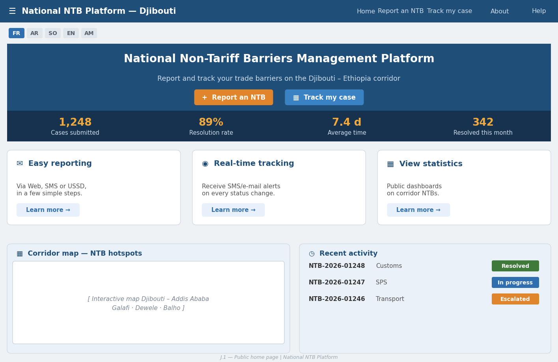
Figure J.1 — Public home page of the NTB portal

Element | Description
Screen content | Header: MTT logo + “National NTB Platform” banner + language selector (FR/AR/SO/AF/EN/AM). Body: main “Report an NTB” button (quick access without an account), “Track my case” box (reference entry), real-time public statistics (X cases submitted, Y resolved this month), interactive map of the Djibouti–Ethiopia corridor with indicators. Footer: MTT links, contact, legal notices, accessibility.
Table 86: Public home page of the NTB portal - Description

J.2 NTB Submission Form (Web)
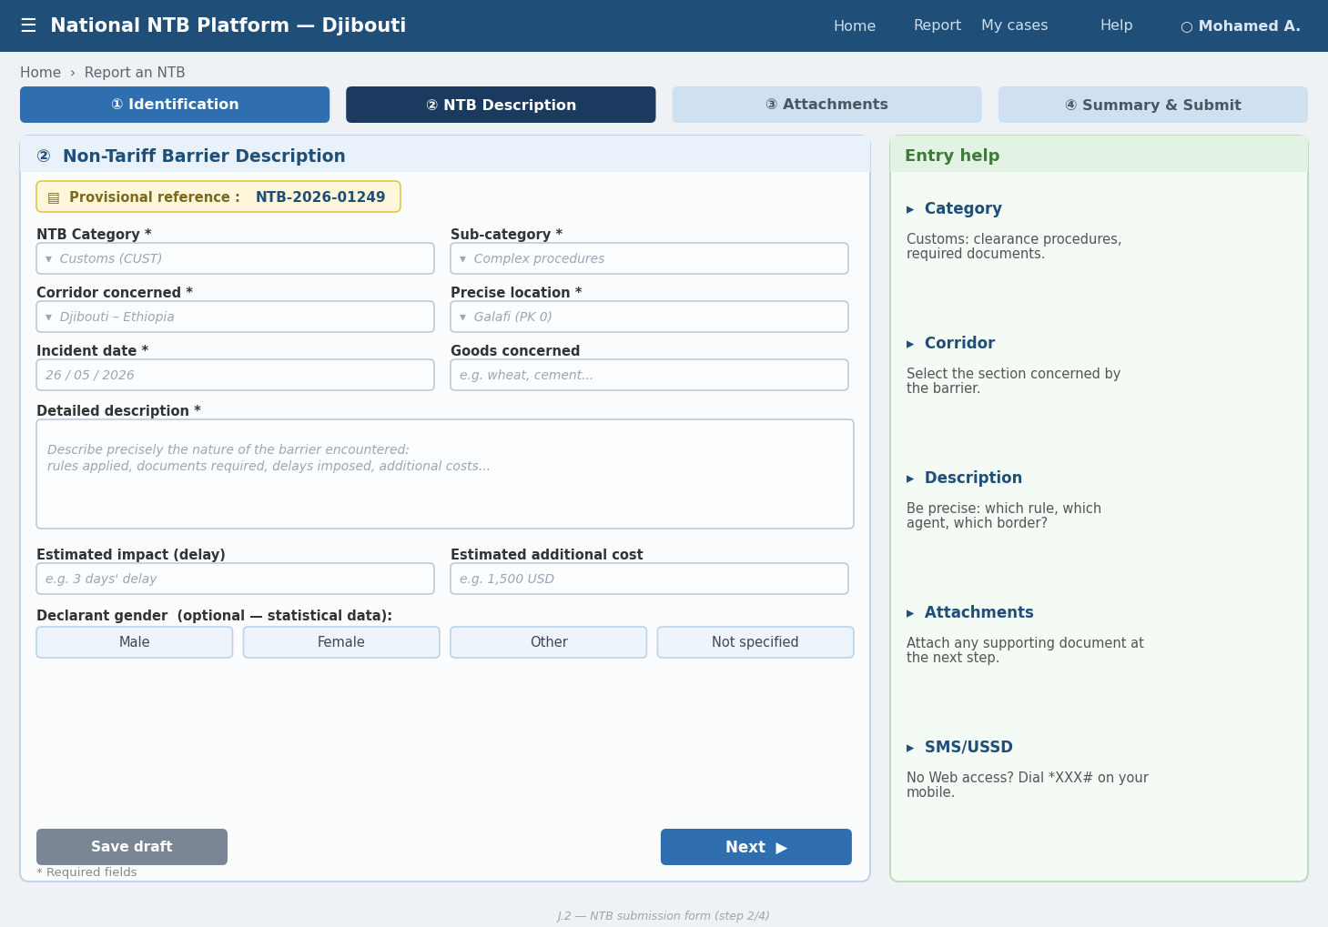
Figure J.2 — NTB submission form (step 2/4)
Element | Description
Screen content | Form header: reference number generated in real time. Steps (horizontal stepper): (1) Operator identification (name, contact, optional gender) → (2) NTB description (COMESA category, sub-category, corridor, location, date, free-text description) → (3) Attachments (multi-file drag & drop) → (4) Summary and confirmation. Progress bar visible at each step. “Save as draft” button available.
Table 87: NTB submission form (step 2/4) - Description
J.3 National Focal Point Dashboard
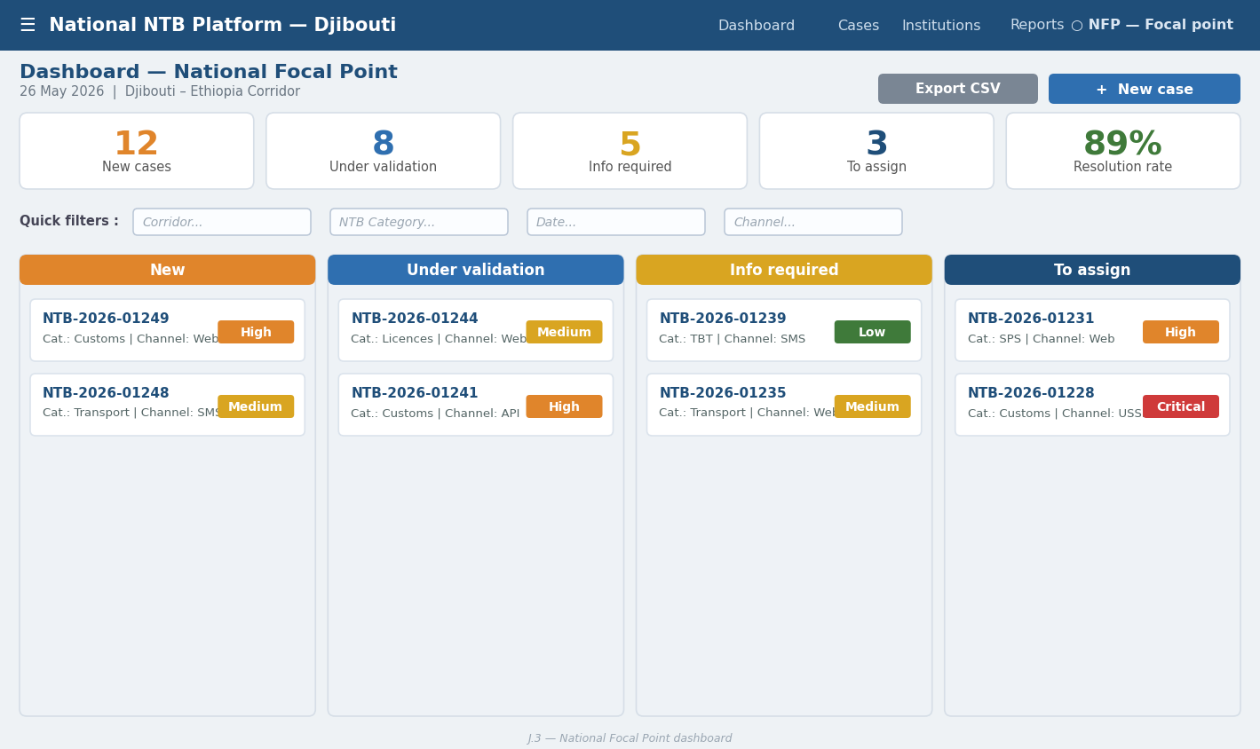
Figure J.3 — National Focal Point dashboard (Kanban view)
Element | Description
Screen content | 4-column Kanban view: New | Under validation | Further information required | To be assigned. Each case card displays: reference, category (coloured badge), submission channel, timestamp, priority indicator. Quick filters by corridor, NTB category and date. Quick action button “Validate” / “Request further information” / “Reject” directly from the list.
Table 88: Figure J.3 — National Focal Point dashboard (Kanban view) - Description

J.4 Institutional Dashboard (Agent)
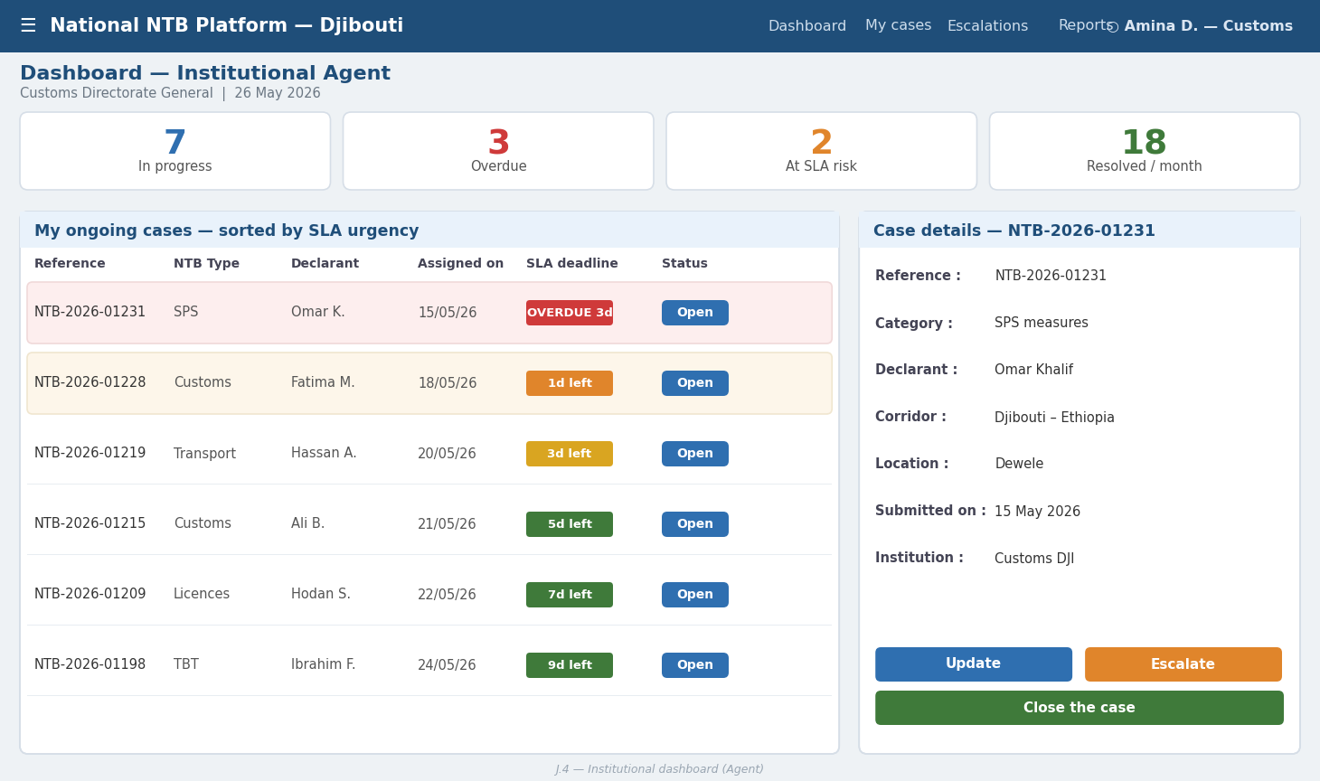
Figure J.4 — Institutional dashboard — Agent (sortable SLA list)

Element | Description
Screen content | List view sorted by SLA urgency (red = overdue, orange = at risk, green = within timeframes). Columns: reference, NTB type, declarant, assignment date, SLA deadline, status. Sliding details thread (side panel): full description, downloadable attachments, comment area, status transition buttons. Summary counters at the top: In progress | Overdue | Resolved this month.
Table 89: Figure J.4 — Institutional dashboard — Agent (sortable SLA list) - Description

J.5 NMC Dashboard
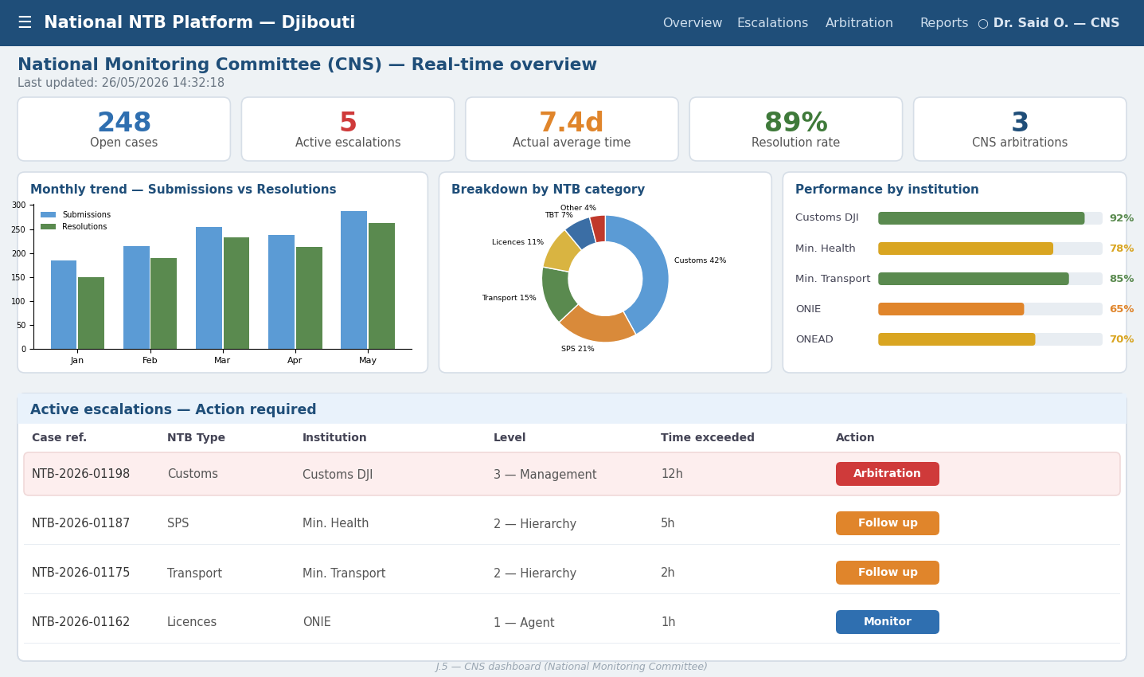
Figure J.5 — NMC dashboard (real-time indicators)

Element | Description
Screen content | Real-time KPI indicators (large tiles): total open cases, resolution rate (circular gauge), average timeframe (sparkline), cases in escalation (red badge). Interactive charts: monthly evolution of submissions (bars) + resolution rate (line). Table of the most solicited institutions with SLA performance bar. Thread of active escalations with a direct intervention button.
Table 90: Figure J.5 — NMC dashboard (real-time indicators) - Description

J.6 MTT Executive Dashboard
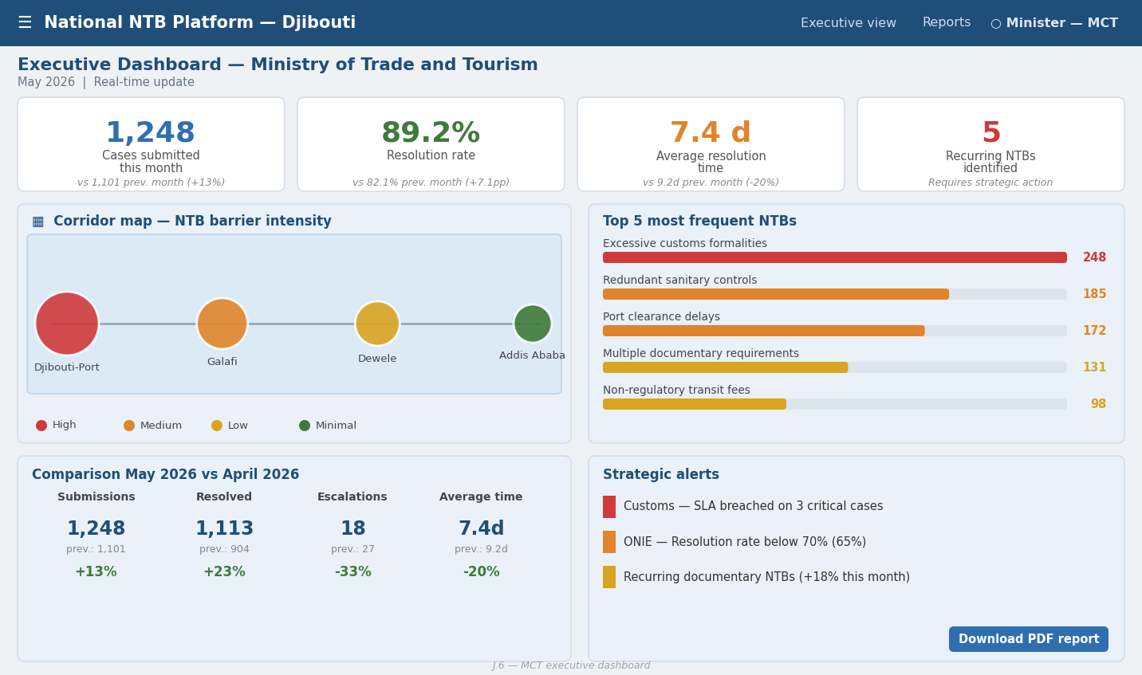
Figure J.6 — MTT executive dashboard

Element | Description
Screen content | Simplified “management” view: 4 strategic KPIs (cases this month, resolution rate, average timeframe, recurring NTBs). Corridor map with intensity of barriers by zone. Chart of the top 5 most frequent NTBs. Performance comparison month N vs N-1. Monthly report PDF export button.
Table 91: Figure J.6 — MTT executive dashboard - Description

J.7 SMS/USSD Interface (Menu Tree)
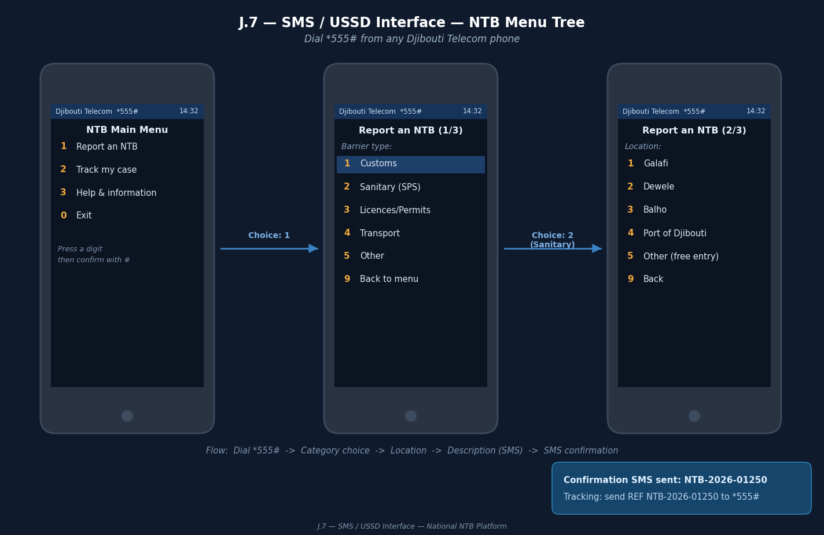
Figure J.7 — SMS / USSD interface — menu tree *555#
Element | Description
Screen content | Main menu (USSD *XXX#): 1. Report an NTB | 2. Track my case | 3. Help. Reporting: Category selection (1=Customs 2=SPS 3=Licences 4=Transport 5=Other) → Location entry → Short description entry (160 characters max) → Confirmation → Receipt of confirmation SMS with reference. Tracking: Case reference entry → Receipt of current status + institution + deadline.
Table 92: SMS / USSD interface — menu tree *555# - Description

J.8 Analytics Module and Exports
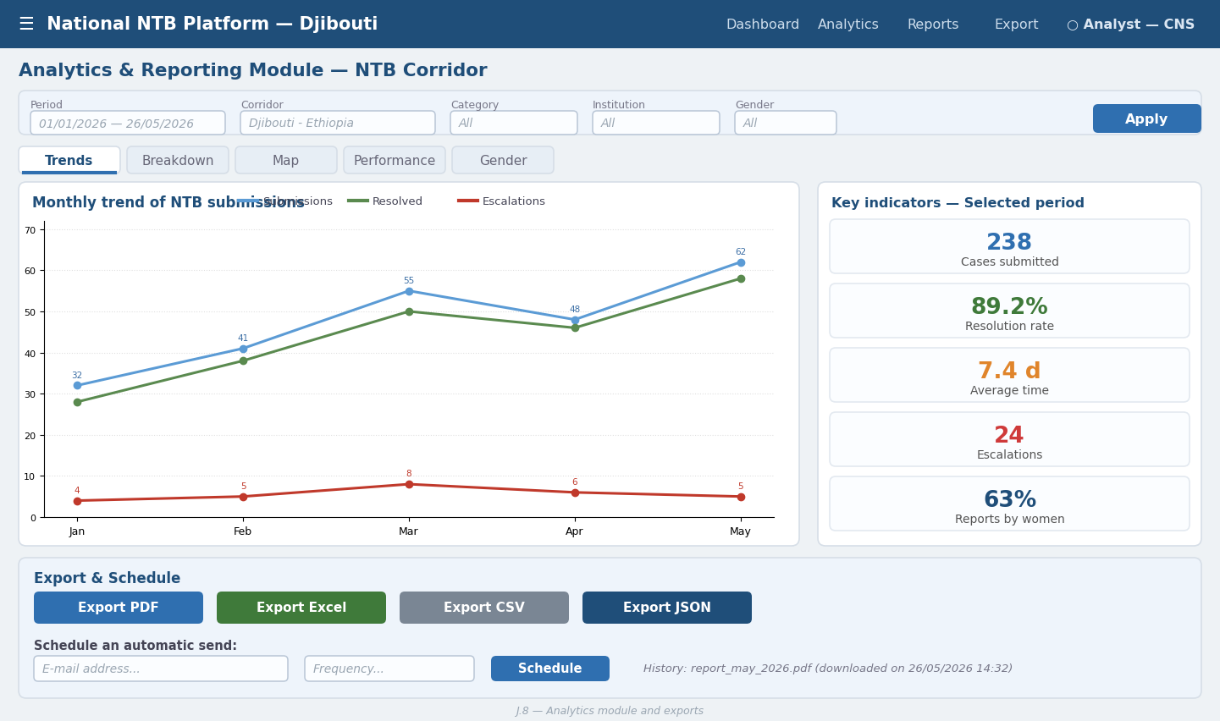
Figure J.8 — Analytical module and exports

Element | Description
Screen content | Selector for period (date picker), corridor, category and gender. Available visualisations (tabs): Trends (line graph), Breakdown (category pie chart), Map (corridor heat map), Performance (institution bars), Gender (stacked bars). Export buttons at the bottom: PDF | Excel | CSV. “Schedule a report” button for automatic sending by e-mail.
Table 93: Analytical module and exports - Description

J.9 System Administration Panel
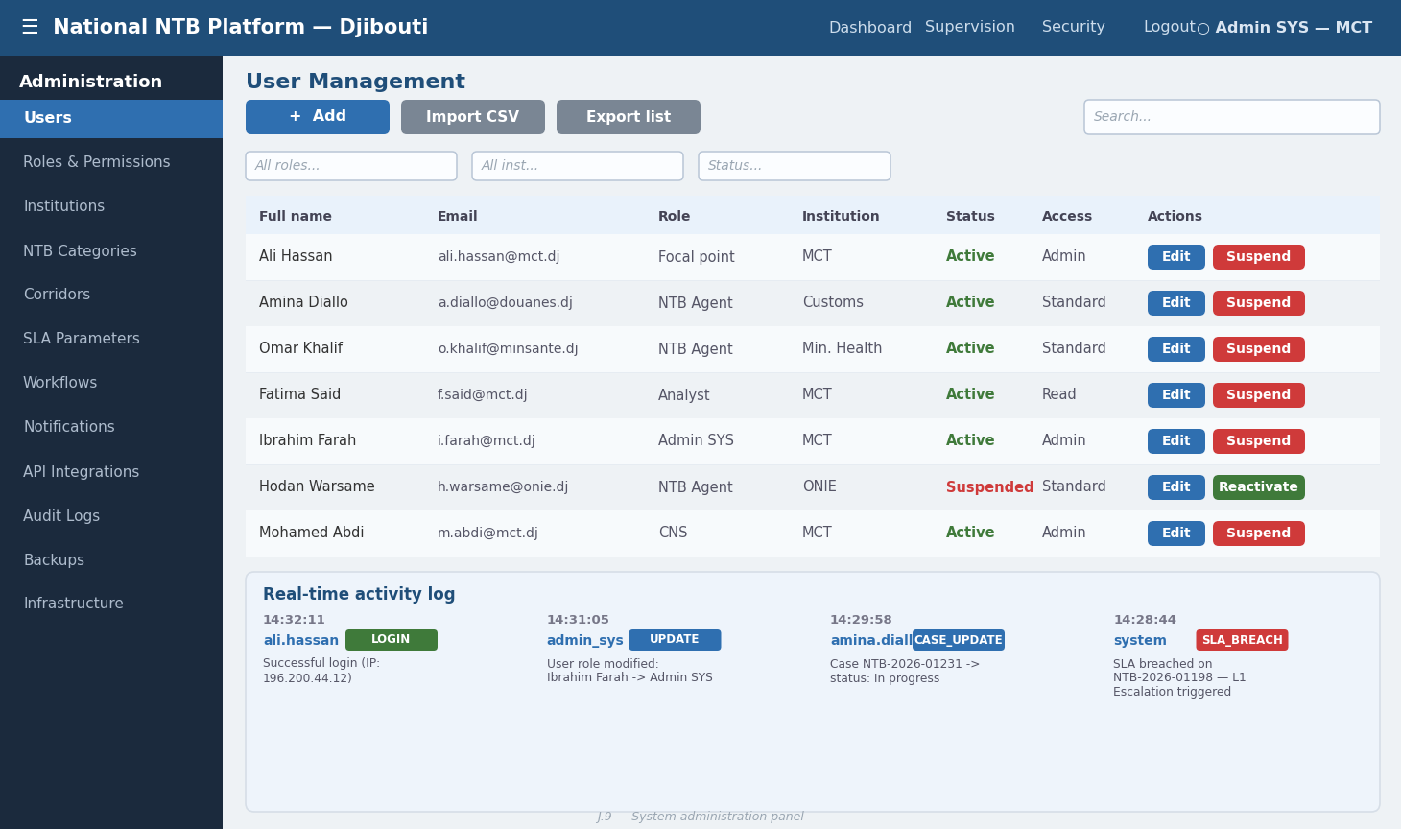
Figure J.9 — System administration panel

Element | Description
Screen content | Left-hand side navigation: Users | Roles | Institutions | NTB Categories | Corridors | SLA | Workflows | Notifications | Integrations | Logs | Backups. Central area: CRUD tables with search, filters, pagination and bulk actions. Real-time activity log visible in a right-hand side panel.
Table 94: System administration panel – Description

Appendix K – SLA Matrix

The SLA matrix defines the service level commitments applicable to each stage of the NTB case processing cycle, according to the barrier category, the responsible institution and the priority level.

K.1 SLA by Processing Stage
Stage | Critical Priority | High Priority | Medium Priority | Low Priority | Responsible actor
Initial validation | 4 business hours | 1 business day | 2 business days | 3 business days | National Focal Point
Institutional assignment | 10 min (auto) | 10 min (auto) | 10 min (auto) | 10 min (auto) | Automatic system
First institution response | 4 business hours | 1 business day | 2 business days | 3 business days | Responsible institution
Standard processing | 5 business days | 10 business days | 15 business days | 20 business days | Responsible institution
Complex processing | 10 business days | 15 business days | 20 business days | 30 business days | Institution + NMC
Level 1 escalation | Automatic D+1 | Automatic D+2 | Automatic D+3 | Automatic D+5 | Automatic system
Level 2 escalation | Automatic D+2 | Automatic D+4 | Automatic D+6 | Automatic D+10 | Automatic system
Level 3 escalation | Automatic D+3 | Automatic D+6 | Automatic D+10 | Automatic D+15 | Automatic system
NMC arbitration | 3 business days | 5 business days | 7 business days | 10 business days | NMC
COMESA regional escalation | — | 15 business days | 20 business days | 30 business days | COMESA NTB Unit
NMC resolution validation | 2 business days | 3 business days | 5 business days | 7 business days | NMC
Automatic closure (no declarant response) | 5 days after resolution | 5 days after resolution | 7 days after resolution | 7 days after resolution | Automatic system
Table 95: SLA timeframes of the NTB management system

K.2 SLA by NTB Category

Code | NTB Category | Standard timeframe (days) | Max timeframe (days) | Default institution | Max escalation level
SPS | Sanitary and phytosanitary measures | 7 | 20 | SPS Authority / Ministry of Health | 4 (NMC)
TBT | Technical barriers to trade | 10 | 25 | Directorate of Standards / MIC | 3 (Directorate)
CUST | Customs procedures | 5 | 15 | Directorate General of Customs | 4 (NMC)
LIC | Licences, permits and authorisations | 7 | 20 | Licence-issuing body | 3 (Directorate)
TAX | Taxes, fees and charges | 10 | 20 | Ministry of Finance / Customs | 4 (NMC)
TRN | Transport and logistics | 7 | 15 | Ministry of Transport / DPCS | 3 (Directorate)
ADM | General administrative barriers | 10 | 25 | MTT (national focal point) | 4 (NMC)
REG | Special regulatory measures | 15 | 30 | Competent regulatory institution | 5 (Regional)
Table 96: NTB category configuration of the NTB management system

K.3 Alert Thresholds and SLA Notification Mechanisms
Alert threshold | Trigger | Recipient(s) | Associated action
Preventive alert 1 | 70% of SLA elapsed | Responsible agent | Reminder e-mail to the agent with the remaining deadline
Preventive alert 2 | 90% of SLA elapsed | Agent + Institutional manager | Urgent e-mail + SMS to the agent and their line manager
Breach alert | 100% of SLA reached | Agent + Manager + NMC | Automatic L1 escalation + NMC notification + red marking on dashboards
L2 escalation alert | L1 SLA exceeded | Institution management + NMC | L2 escalation + possible NMC convening + incident report
Strategic alert | 3 cases from the same institution overdue simultaneously | NMC + MTT | MTT strategic alert + institutional corrective measure requested
Table 97: SLA alerts of the NTB management system

Appendix L – Integration Mapping
This appendix details the technical specifications of each integration between the national NTB platform and the national, regional and telecommunications partner systems.
Target system | Integration type | Protocol | Authentication | Description and data exchanged
DPCS (Djibouti Port Community System) | Bidirectional API | REST / HTTPS | OAuth 2.0 + API Key | Exchange of NTB incidents related to port operations; retrieval of customs clearance statuses of the goods concerned; sharing of port performance indicators with the NTB analytical platform
Customs (SYDONIA / ASYCUDA World) | Bidirectional API | REST / HTTPS | OAuth 2.0 + mTLS | Retrieval of customs declarations associated with NTB cases; sharing of customs procedure incidents; automatic enrichment of NTB cases with relevant import / export information
COMESA NTB Online System | Bidirectional API + webhooks | REST / HTTPS + webhook push | API Key + HMAC signature | Transmission of eligible national NTB cases for regional escalation; synchronisation of processing statuses; receipt of regional decisions; harmonisation of classifications according to the COMESA taxonomy; monthly exchange of statistical reports
AfCFTA NTB Monitoring Mechanism | Unidirectional API + batch | REST / HTTPS | OAuth 2.0 | Quarterly transmission of aggregated NTB data for continental consolidation; reporting of AfCFTA-scale barriers; synchronisation of classifications according to the AfCFTA taxonomy; receipt of continental trade facilitation guidance
Djibouti Telecom (SMS / USSD) | SMPP / REST gateway | SMPP 3.4 or REST | API Key + IP whitelist | Sending of confirmation SMS, status notifications and SLA alerts; receipt of incoming reporting SMS messages; management of interactive USSD menus; support for the single national NTB short code
National government portals | REST API (consultation) | REST / HTTPS | OAuth 2.0 | Access to reference databases (company registers, institution catalogue, regulatory repositories); pre-filling of information for connected operators
National statistical platform | Batch export | SFTP / REST | Mutual TLS certificate | Monthly transmission of aggregated NTB statistics for the national statistics system; contribution to the trade facilitation indicators of the national economic dashboard
Table 98: Integration interfaces of the NTB management system

L.2 Requirements Common to All Integrations
- TLS 1.3 encryption mandatory for all data exchanges.
- Full logging of each API call: timestamp, source system, payload hash, response code.
- Network error handling with exponential retry: 3 attempts maximum at 30 s, 2 min and 10 min.
- Failed message queue (Dead Letter Queue) with alert to the ICT team.
- JSON schema validation on each receipt before insertion into the database.
- API versioning (prefix /v1/, /v2/) to ensure backward compatibility.
- OpenAPI 3.0 documentation kept up to date for each integration point.
- Automatic smoke tests after each production release.
- Monthly integration availability reports transmitted to the partner systems.

L.3 Version Management and Regional Compatibility
In order to guarantee long-term compatibility with the regional mechanisms, data exchanges with COMESA and AfCFTA will comply with:
- The NTB classification nomenclature adopted by COMESA (6 main categories, 30 sub-categories).
- The standardised data exchange format defined by the COMESA NTB Secretariat.
- The authentication and security protocols prescribed by the AfCFTA for national NTB platforms.
- The synchronisation frequency agreed with each regional organisation.
The notification procedures in the event of a major modification of the national APIs.

NTBs refer to all the administrative, regulatory, procedural or technical measures which, without constituting customs duties, create obstacles or additional costs for trade. They may take the form of complex administrative procedures, multiple controls, excessive documentary requirements, delays at borders, technical restrictions or problems related to institutional coordination.
https://adi.dj/index.php/site/Plus/13723

